Coaching Education Program Requirements
(1) Required Coaching Education Program Levels for Ice Hockey
All coaches must have the required certification level by January 1 of the current season.
(a) All coaches must enter USA Hockey's Coaching Education Program at the 6U/8U clinic if coaching Learn To Skate, Learn To Play, and/or 6U/8U classifications or a Level 1 clinic if they are coaching 10U classification and above.
Coaches at the 6U/8U Level do not need to progress any further until one of the following occurs:
- The coach moves up to another age classification above 8U, or
- The coach returns to 6U/8U for the fifth consecutive season and the level is now expired.
Coaches at the 6U/8U must take the 6U/8U refresher education every five years if they are continuing to coach at 6U/8U classification or LTS/LTP.
Coaches in 6U/8U should not take Level 1 until they start coaching at the 10U classification and above level.
As of the 2025-26 season, Level 1 coaches must continue their education with a coaching clinic each year until such time as they are coaching any older age level of play or something other than disabled hockey.
A coach may attend only one certification clinic per year. This does not include continuing education clinics or modules. The 6U/8U clinic can be taken by coaches that are Level 1, 2, 3, 4, or 5 for continuing education credit.
(b) In addition to the training in paragraph (a) above, coaches must also complete online age-specific training modules specific to the level of play they are coaching, if they have not already taken that module. This requirement applies to all coaches at all levels, 6U/8U through 5. Coaches may complete more than one age-specific module in any given season. As of the 2023-24 season, all coaches must complete the Foundations for Player Development and the age-specific modules PRIOR to participating with a team.
(c) Effective in the 2022-23 season, Level 4 coaching certifications are valid for three (3) seasons, and Level 5 coaching certifications are valid for four (4) seasons, each as indicated by an expiration date.
(d) Grandfather Clause
For those coaches who received Level 4 or Level 5 PRIOR TO January 1, 2021, and who are coaching or begin to coach after this date, any Tier I or Tier II teams, will be required to do continuing education as required in (c) above.
Coaches who received a Level 1, 2, 3, 4, or 5 PRIOR to January 1, 2025 and who are coaching after this date, may coach at the 6U/8U classification or LTS/LTP classification with their current level, even if expired.
If a 6U/8U coach takes a higher level of education after January 1, 2025 they are no longer grandfathered in at the 6U/8U level and must remain current in education regardless of what age classification they are coaching.
(e) Previous/Expired Certifications
Coaches with any expired certification will retain their previous certification levels provided the certification can be verified. Coaches may re-enter the certification system at that previous level and be subject to the certification guidelines in (a) through (c) above and/or (f) below.
CEP Progression Guidelines
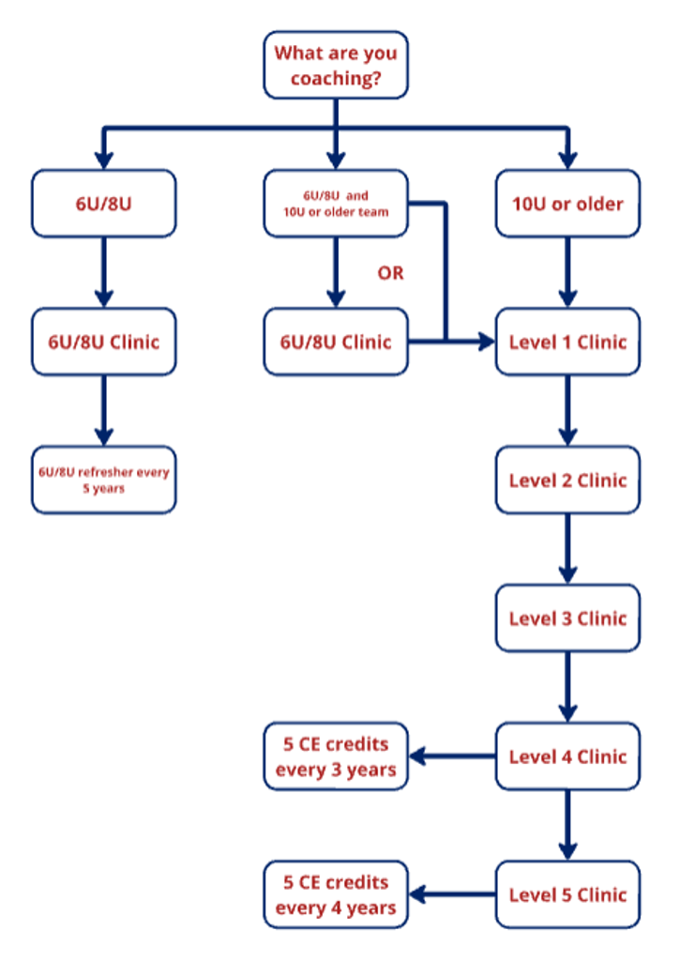
(f) Continuing Education (CE) Accumulation and Expiration
The USA Hockey clinic listings will indicate all continuing education offerings and the credit value of each. The Coaching Education Program retains the responsibility for defining continuing education credit values, including clinic or online course work.
Coaches that are Level 1, 2, 3, 4, or 5 may accumulate continuing education credits and will remain available for a maximum of 8 years since completed, subject to the Level 4 and Level 5 expiration credit hours.
Coaches at the 6U/8U Level will be able to take continuing education but will not be able to bank credit hours.
Once a Level 4 or 5 coach reaches their expiration date, all credits will be applied from their account and if they have their 5 credits of continuing education their certification will renew.
Any credits above the five needed to recertify their Level 4 or 5, the credits will be erased from their account.
(2) Evidence of Level
It is the responsibility of the local association to identify those coaches who do not meet the certification requirements. All coaches have until December 31 of the current season, to attend a USA Hockey coaching clinic. All coaches must complete the online age-specific modules PRIOR to participating with their team.
Beginning January 1 of the current season, prior to the start of each game, all coaches present are required to sign the designated area of the scoresheet in order to verify the accuracy of the playing roster, as it appears on the scoresheet, for that game.
(3) Penalty and Enforcement
Any coach not in possession of these certification requirements will be ineligible to coach for the remainder of the season. Districts and/or affiliates are required to uphold this penalty. It will be the responsibility of the local association registering the team to enforce the national penalty.

