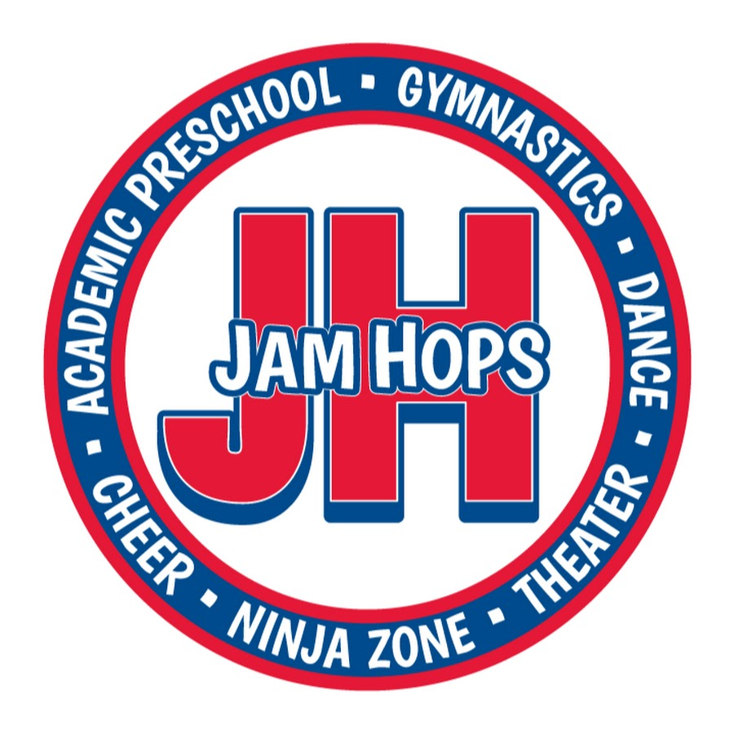

Competition Cheerleading
Handbook

We would like to thank you for your interest in our Jam Hops Cheer program. Since we began our cheer program, we have enjoyed increasing success with each passing year. We are dedicated to offering a professional staff and a well-structured organization. Our goal is to provide the best training environment for our athletes while teaching them ideals such as teamwork, integrity, work ethic, commitment and sportsmanship.

The Jam Hops staff understands that we are using the tool of competition cheer to shape and develop our athletes into leaders of their peer groups and leaders of tomorrow. We believe all our athletes have exceptional talents and it is our responsibility to cultivate that talent with our compassion, dedication and knowledge. As coaches we take true PRIDE in the growth of our athletes both inside and outside the gym. Although the coaching staff and training involved is clearly a factor in the success of each team, the PASSION, love and desire to excel is critical for each athlete to achieve their goals. We pride ourselves in offering the environment to ensure this happens.

We believe in instilling skills in teamwork, leadership, and commitment while increasing the physical skills of our athletes. We work to develop the entire athlete, physically, mentally, and emotionally. To that end, we have high expectations regarding attendance. Practices and competitions are mandatory. Practices cannot be fully productive if all athletes are not there. Please understand the level of commitment before you join our program. We are training athletes not only in skill, but also to understand responsibility to a team and how to work hard to achieve goals.

In order to be successful in the competitive program at Jam Hops, athletes must first and foremost possess a strong DESIRE to be a competitive Cheerleader. There are many fulfilling aspects of competitive cheerleading, but there are certain aspects that are less desirable: the conditioning, the monotony of repetition, the minor aches and pains, etc. Despite these things, if an athlete still has the desire to come back time and time again and passionately “want it”, they more than likely possess the DISCIPLINE to do what it takes to become successful. They must respect the coaches and the process they are taking with them. They must be willing to put forth 110% effort into everything they do, even the things they may not enjoy doing. And on the occasion they may not feel like coming to practice, they must possess the DEDICATION to come regardless, realizing that the time put into this sport is a necessary factor. Combined, these “3 D’s” are the foundation on which we build our program.

When our athletes are “retired” from our team we hope they have established a base of life skills that will assist them through all of their adult life. We measure our success not so much by the number of awards and trophies we receive, but rather with what the child takes with them when they leave and step into adulthood.

This handbook is designed to give each family the information necessary to decide if they are ready for the commitment that is required by cheerleading and Jam Hops Competition Cheer Program. Please take the time to thoroughly read the information, and if you have any questions, please give us a call. Good luck to everyone, and we look forward to a fantastic and successful year!

Thank you,

Nyssa Eitel
Cheer Director

FREQUENTLY ASKED QUESTIONS
What is Competitive Cheer?

Cheer has changed dramatically over the last 20 years. Competition cheer squads do not cheer for other teams. THEY ARE THE TEAM! Cheer is an exciting sport suitable for the earliest beginner all the way through the most accomplished elite level athlete. It combines aspects of tumbling, dance, stunting, cheering, and jumps to create a complex and fast-paced 2 ½ minute routine. This team differs from other sports in that every athlete is a vital and integral part of the routine. THERE ARE NO BENCH-WARMERS! The routines are judged based on difficulty, execution, performance, and creativity. The teams are divided by skill level as well as by age.

When does it Training schedule start?
Teams begin in June and go through March of the following year pending on any bids to larger competitions.
Do you need cheer experience?
No! There is a place for everyone at Jam Hops! We have teams for beginners through advanced skill levels.
Is there travel for competitions?
Our team may travel depending on competition bids. It is unlikely we will travel this year.
Why should I cheer on a competition cheer team?
The character traits instilled through cheer are exactly those needed to promote success! This is a sport that focuses on building individual skills (such as tumbling) while encouraging team development. You will learn focus, determination, perseverance, and discipline. You will also gain confidence by performing in front of large groups of people!

How are tryouts held in April?
Our tryouts are as low-stress as possible. We will give the athletes several opportunities to show us skills they have already mastered. It is up to each athlete though to show us their skills to the best of their ability putting in 100% during tryouts. Once we have evaluated the skill level of each athlete, they will be placed into teams according to appropriate age and skill level. At the coach’s discretion, some athletes will be placed due to the needs of a particular group.

- The “Level” is defined by the difficulty of stunts, pyramids, tumbling, and tosses performed in routines.

- A younger cheerleader may be put onto an older team upon the coaches’ discretion. However, an older cheerleader may not compete on a younger team per UCA rules.

- Teams may adjust depending on numbers.

Important Dates

Team Announcements: April 12th
Parent Meeting: May 24th at 6:45pm
Season Starts: June 3rd
Team Pictures: September

What is the Practice Schedule?

ALL Practice Days and Times are Tentative, Practices may increase frequency during season if needed

- Friday Evenings between 5:30-8:30, time dependent on number and size of teams created.

What Competitions are we attending?

Our competition schedule will run late October through mid-March. We compete at 5-9 competitions depending on team placement. A list of tentative competitions is below for reference. Our final detailed competition schedule will be out August 1st. Once the competition schedule is set please keep the entire weekend free as we will likely have extra practices and we will not know our performance times until the week of the competition. Competitions are mandatory, any conflicts need to be communicated at least 4 weeks in advance.

Competitions
Tentative Competition List

Extreme Cheer Challenge, East Ridge HS ………………………………………. November 12, 2022

Candy Cane Classic, Champlin HS …………………………………………………. December, 2022

University of Minnesota ……………………………………………………………….. December, 2022

Edina Sweetheart Classic, Edina HS ……………………………………………….. January, 2023

Crimson Cheer Challenge, Maple Grove HS …………………………………… January, 2023

MCCA State in St. Paul ……………………………………………………………………. Last week of January 2023

Rochester Cheerfest ……………………………………………………………………….. Mid February, 2023

JAM HOPS COMPETITION CHEER PROGRAM INFORMATION
ATTENDANCE:
Once placed on a Jam Hops team, it is your responsibility to attend ALL practices. Due to the unique team aspect of cheerleading, the absence of just one athlete can hinder the effectiveness of practice for the entire team. Therefore, all practices are mandatory. Athletes will be allotted 3 TOTAL absences from the month of June - August, and then 5 TOTAL absences from the month of September through the end of the season.
*Excessive amounts of absences (excused and/or unexcused) and tardies will not be tolerated and could lead to the potential dismissal from the team without a refund. We understand extenuating circumstances and those will be handled on a case-by-case basis.
COMMUNICATION:
Please let the Director know if you have any questions or concerns.
We will keep you updated regarding competition information, send notices as they become available. Please get in the habit of checking your email and the website, www.jamhops.com/cheer for updates.
Information will be communicated via email and posted on the Jam Hops website. It is extremely important that parents check their email and Jam Hops website regularly. You will be held responsible for all information sent and posted on the website. Practice changes, competition information, updates, travel information, etc. will be posted and communicated via handouts, via email, and/or website. If you have any questions, please ask a coach and not another team member to ensure you are receiving the correct information.

Financial Information
Along with the time involved, there is a substantial financial obligation to be part of the Jam Hops Competition Cheer program. Please carefully consider the financial commitment involved and read this in its entirety. You are responsible for all financial obligations for your athlete.
The decision to join the Jam Hops Competition program is a big one and reflects commitment to the team.
There is an annual Jam Hops Family Member Fee of $45.00 (plus tax) that is due every September. This fee will automatically be charged to the credit card you have set up for auto pay.
PAYMENTS:
Jam Hops Cheer Payment Schedule (payment amount is tentative).
Monthly tuition will be based on the 1.5 hour class rate
This monthly fee does NOT include (fees are estimated):
- Uniform $217.51 (includes Uniform top, Uniform bottom, Bow, Shoes, Team Bag, Practice shirt)
Split into 2 payments of $108.76 Due in June and July
- Additional JH Shirt- $15 (optional)
- Competition Fees - Approximately $210 broken into 3 payments Due in September, November, and January
- Coaching Fees - totaled after each competition - approximately $65 each competition divided amongst all families

All Apparel Fees are non-refundable. Any competitions already paid and registered for are non-refundable. A charge may be assessed depending on if monies are still owed for these competitions pre-registered for. A credit will be applied if fees are less than originally assessed payments following the competition season.

Tuition Discounts: 10% discount for each additional child in the same family.
Athlete’s accounts must be current to participate at competitions. Jam Hops may remove an athlete from the team if the financial commitment is not upheld. Jam Hops reserves the right to discontinue or suspend an athlete until their account is satisfactory.
RECRUITING CREDIT:
For every new member that you recruit to a Jam Hops cheer, you will receive $30 for each new member to join Jam Hops Cheer. For example: You have 3 friends that list you as their referral and they join one of the cheer teams or classes, you will get a $90 credit. New athletes must notify Jam Hops at time of registration.

