Laker Athletic Alliance
Anti-Bullying Statement
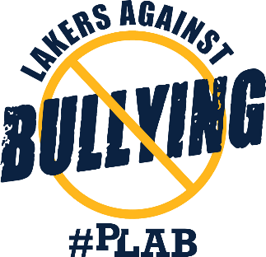
Prior Lake Savage youth athletic organizations united as the Laker Athletic Alliance, with the shared vision of creating a welcoming and safe environment for all youth athletes. It is our belief that decreasing bullying behavior will create an optimal environment for our youth athletes to develop and thrive. We believe this environment can be accomplished by providing awareness and education to athletes, parents, and coaches, as well as decreasing the community’s tolerance for bullying behaviors.
Laker Athletic Alliance Initiatives
Our goal is to engage the Prior Lake Savage community and create opportunities for our youth athletes to develop and thrive, while being led by the anti-bullying voices and visions of our student athletes and youth sports organizations leadership. Our current initiatives include:
- Community Engagement
- High School Student Athlete Leadership involvement and engagement
- Creation of Lakers Against Bullying (LAB) #PLAB
Bullying
Bullying is defined as a repeated and/or severe behavior(s) that is likely to hurt, control, or diminish another person; emotionally, physically, or sexually. Types of bullying may include verbal, social, physical and/or cyber bullying.
Bullying typically, but not only, targets a person’s uncontrollable characteristics (i.e., physical attributes, intelligence, etc.) and/or mistakes a person makes. Bullying is not the same as competitive banter, which does not target a person’s uncontrollable characteristics.
As we continue to develop this initiative, the Prior Lake Savage youth sports organizations have committed to ongoing partnerships and collaboration to address bullying and other sports/community related issues. Additional plans will be made for training opportunities for Prior Lake Savage athletes, coaches, and parents.
For more resources on bullying, please visit stopbullying.gov and eyesonbullying.org

