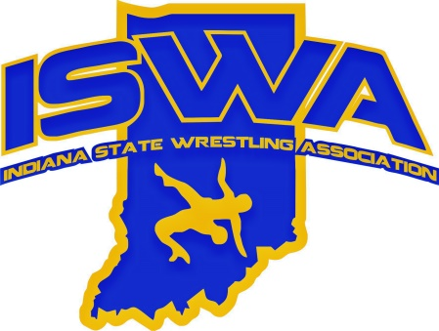
INDIANA STATE WRESTLING ASSOCIATION, INC.

P.O. Box 157, Beech Grove, IN. 46197 Phone 317-780-1885

2024.2025 Section 4 Annual Report Mark Stevenson

52 Section 4 clubs.
State events held in Section 4 include: ISWA Elementary State Duals, IHSWCA Middle School Individual State hosted by IHSWCA/ISWA Center Grove High School.

Thank you all in Section 4 for the help this year!

Mark Stevenson
Section 4 Director

