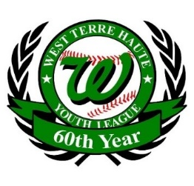
Paid: CK / Cash/ Credit
(Each player is asked to sell 5 orders per player)

West Terre Haute Youth League Memorial Paver Order Form
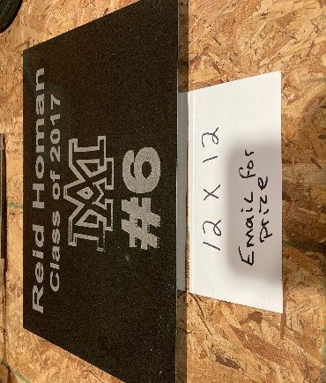
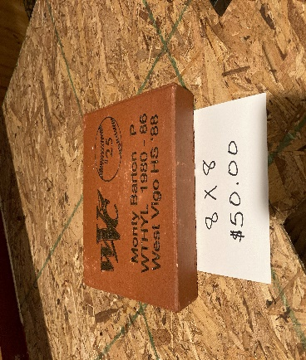
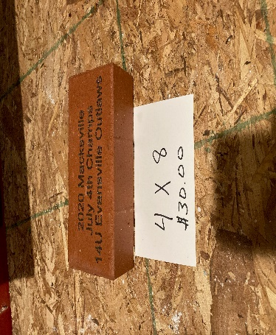
Engraved Brick
4x8 Brick 8x8 Brick 12x12 Granite
Bricks (4x8) two lines and one logo $30.00
Bricks (8x80 two lines and one logo $50.00
Granite (12x12) two lines and one logo $300.00
Also offer granite corner stones up to (16x16) call for spec (812)430-2725
(circle above requested product and fill out lines below on information to be engraved)
Name____________________________________ Phone Number_______________________
Address_______________________________________________ Email__________________
City____________________________________ State_______________Zip Code___________
Amount Enclosed:_____________ (payments payable: West Terre Haute Little-Youth League)
Line #1______________________________________________________________________
Line#2______________________________________________________________________
Line#3______________________________________________________________________
Email all wanted logos to: timturp15@aol.com
Name and age of your player____________________________________________________
(Fill out this form and email back to: westterrehauteyouthleague@gmail.com )

