 | PLEASE JOIN US  South/Roosevelt Nordic Ski Team  Kick-Off and Information Night

Time: Monday, November 7th from 6:30 - 8:00pm

Location: Roosevelt High School Auditorium. Enter at the Main Door on 28th Ave.

Please Join Us: This is an event for all new and returning parents and skiers to learn about the ski team, meet the coaches and captains, learn about the schedule, equipment rental, booster club fees and events, fund raisers, and other ways to support the team. All returning skiers and prospective skiers and families are strongly encouraged to attend.

Head Coach: Jon Furlow – jon.furlow@gmail.com; 608.852.4506

The Nordic Ski Team. Minneapolis South and Roosevelt join together to compete in the Minneapolis Conference in Nordic ski racing. We are an inclusive, quality Nordic ski program that last season had 93 athletes, including 25 middle school athletes. All are welcome regardless of experience, and we strive to provide an environment that allows everyone to become a successful athlete, whether that means just learning to ski or competing to qualify for the Minnesota State Meet at Giant’s Ridge. Our goal is to promote and foster healthy competition for everyone.

Our 2022-23 Season. The Nordic skiing season starts on November 15 and concludes on February 17. Prior to skiable snow, we train together 4 days a week at and around South and Roosevelt, including Powderhorn Park, and sometimes on Saturday mornings. Once there is skiable snow, we meet at the Trailhead at Theodore Wirth Park and train from 4:00 to 5:30 p.m most weekdays, plus we offer a Saturday training session. We also have several overnight training trips, one to Ironwood, MI in early December and the second at the start of winter break. Racing starts in early to mid-December, and we typically race on Tuesdays, although that schedule can change from time to time based on conditions, etc.

GO TIGERS AND TEDDIES!

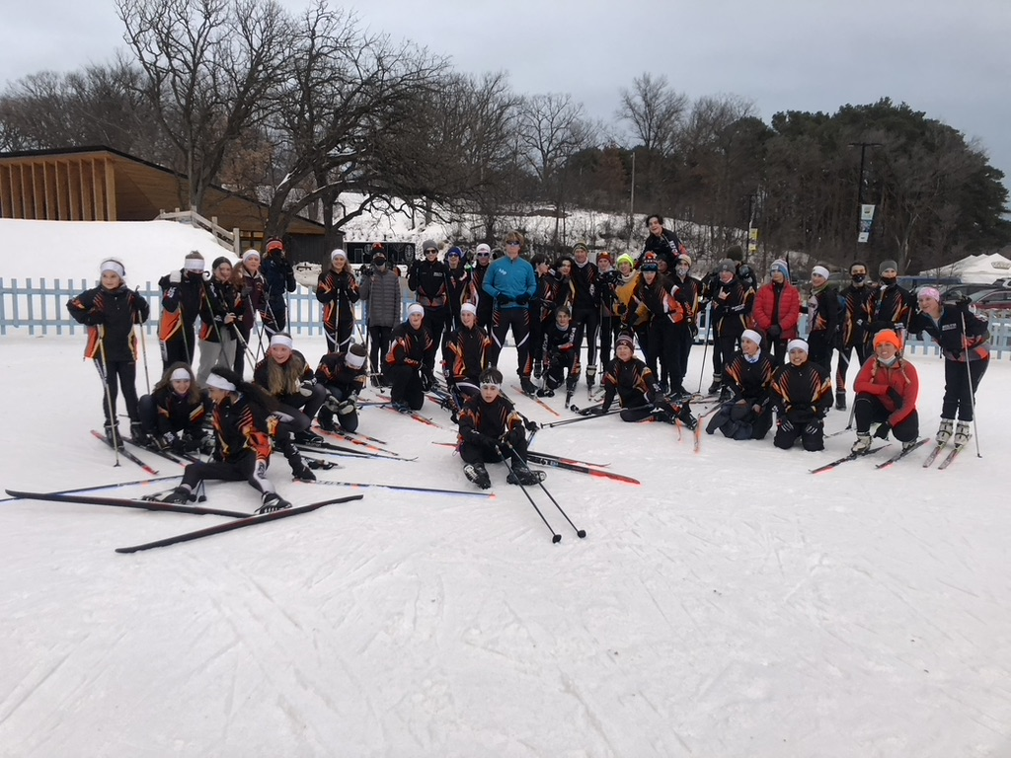 | 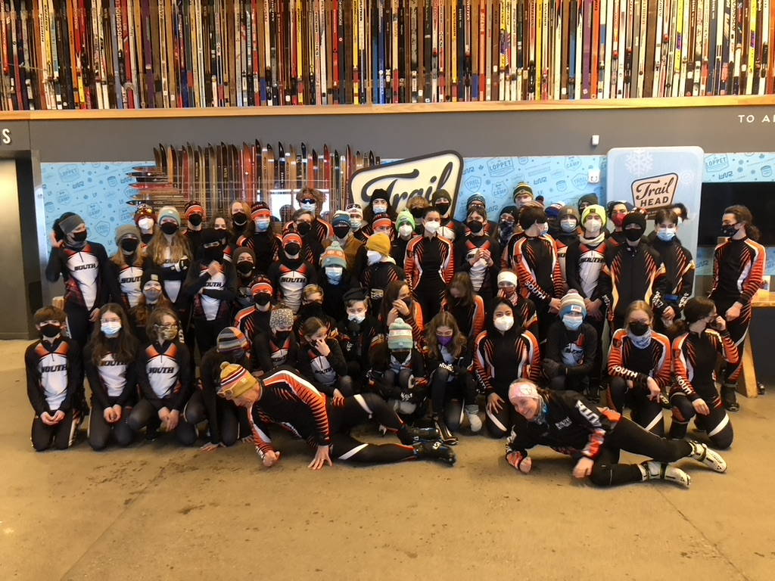 | 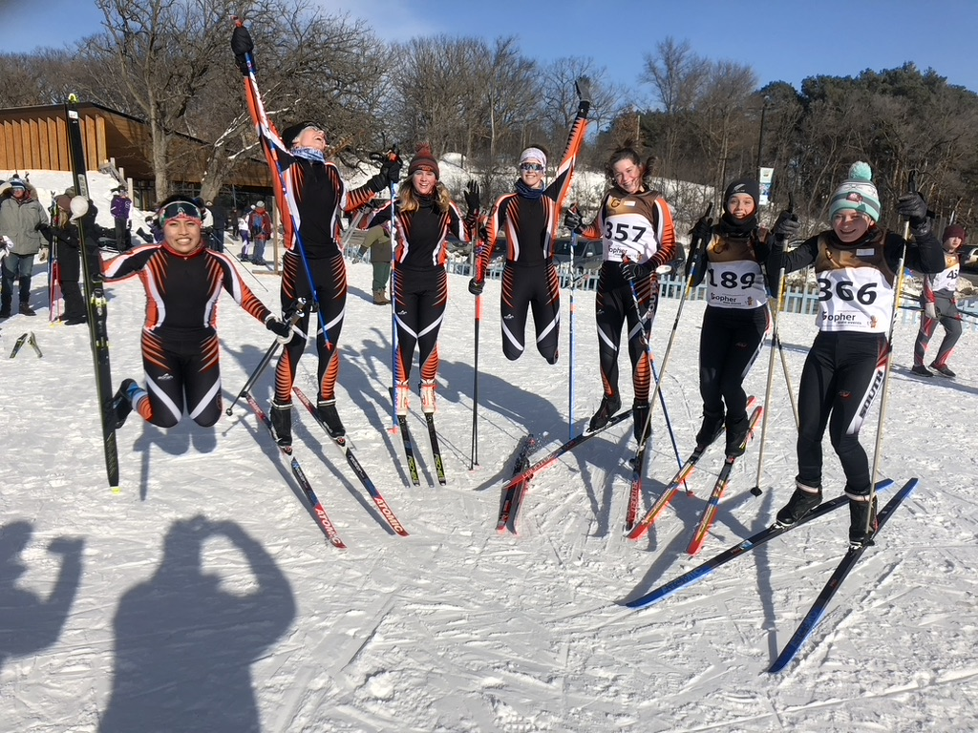

See you November 7th!

