Castle Rock, CO.
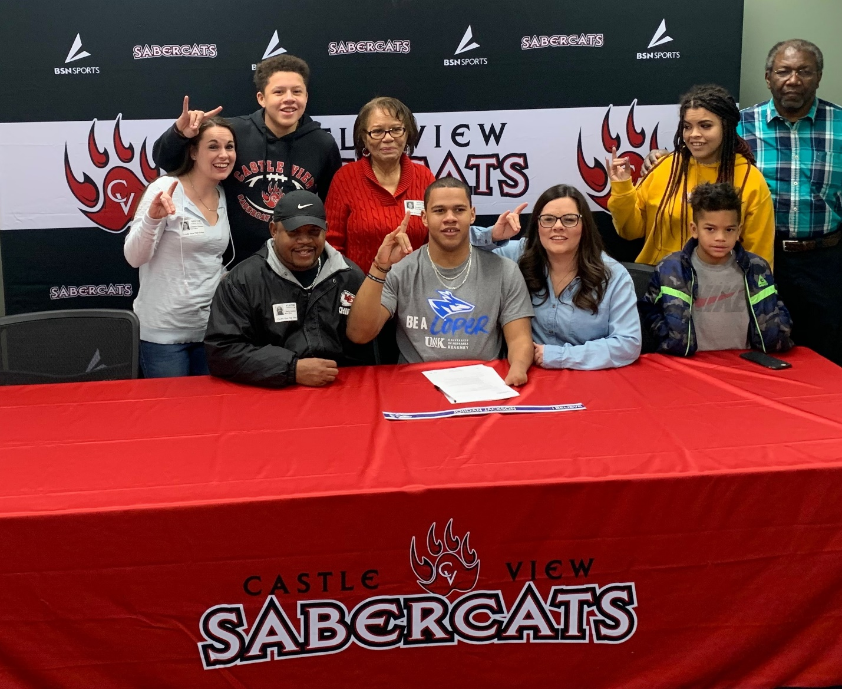
February 5th, 2020 began as a cold, frigid morning in Castle Rock, CO. This day, however, would heat up quickly at Castle View High School as it was National Signing Day for college bound athletes. Castle View’s own Jordan Jackson made it official today, signing his letter of intent to continue his football career at the University of Nebraska at Kearney.
The Lopers play in the MIAA Conference, arguably the most competitive in all of NCAA Division II football. Jordan was recruited to play inside linebacker and joins a recruiting class that may be the best overall class in Head Coach Josh Lynn’s tenure at the school. “The coaches really stood out. The facilities exceeded expectations, they shocked us. There was instant chemistry with the team; loved everything about them”
Jordan plans to study American History at while at Kearney with aspirations of becoming a professor in the future. Any lessons for his younger Sabercat teammates? “Take advantage of the opportunities and your time at CV…it goes by so fast!”. Jordan, the team MVP, will be missed on the Sabercat squad next season. Asked about favorite memories, Jordan cites “Definitely playing (older brother) Jaylen and (younger brother) Cameron was special. Really, the team bus rides, the team meals….even practice; I have great memories of it all”.
Castle View High School is home to many gifted students and athletes. Today the Sabercats honor Jordan Jackson. Nebraska, you are getting a good one!

