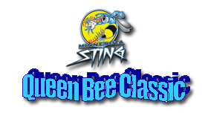
Registration Form

Tournament Dates: May 18-19, 2019
Venue: Lac Lavon Park, Burnsville, MN
Level of Play: B & C

Team Name: _______________________________________________________________

Age Group: 8U-_____ //10U-_____ // 12U-_____

Head Coach:________________________________________________________________

Mailing Address: ____________________________________________________________

Phone Number: ________________________________

Email Address: ________________________________

Tournament Details:
Cost - $310 + 2 Balls for 10U -12U, $200 + 2 Balls for 8U
Pool Play to Brackets with consolation
5 Game Guarantee for 10s and 12s, 4 Game Guarantee for 8s
Location: Lac Lavon Park – 15501 La Lavon Drive in Burnsville, MN
Amenities include concession stands and restrooms with running water

Tournament Highlights:
Medals for top slots
ASA/ NAFA/ USSSA Northern National Berths Awarded for 10s and 12s
USSSA Northern National Berths Awarded for 8s

Please mail completed Registration and check in the proper amount (payable to the MN Sting) to the following:

Steve Hofer
8821 Crestwood Road
Bloomington, MN 55437
Cell phone: (612) 366-4472
Email: sphofer@gmail.com

