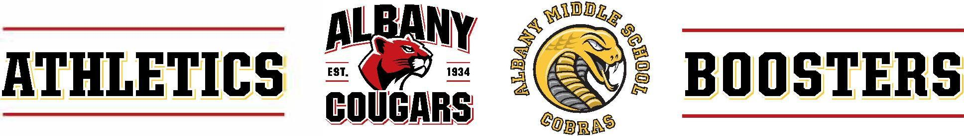
Athletics Boosters Board & General Meeting Notes
603 KEY ROUTE BLVD · ALBANY · CA · 94706
September 16, 2025 - 6:00-8:00 PM (Board 6:30-7:15, General 7:15-8)
*In-Person
- Welcome, Intros, & Agenda Review
In attendance:
  - Garth Schultz, President
  - Bill Tressler-AUSD Athletic Director
  - Sarah Roberts, Treasurer, AMS Liaison
  - Shannon Yee, Fundraising & Triathlon
  - Diandra Sam, Secretary
  - Marie Hopper-Member at Large and Snap! Raise Liason
  - Anna O’Conner, Fundraising & Triathlon
  - Teo Shimura, Co-Commissioner of Spirit and Athletics
  - Maia Liu, Co-Commissioner of Spirit and Athletics
- Fundraising & Triathlon Update
  - Volunteers still needed for the triathlon
  - Additional outreach needed for water polo and girls’ tennis
  - Solano stroll was a swag selling success
- Athletic Department Update
  - Girls’ volleyball team remains undefeated in league
  - Football team will have first home game this week
  - Girls’ basketball and boys’ soccer at AMS will begin soon
  - Cross country team had their first meet in San Francisco
  - There is a new mascot coming at senior nights
- Student/Athletic Commissioner update
  - Good team spirit and general excitement reported for upcoming home football game
  - Students Maia Liu and Imani west introduced and reported on a good season and team cohesion
  - Girls’ volleyball playing St Mary’s 9/17/25.
- Fundraising update
  - Volleyball team coach, Dave, is hopeful to finish as league champions. Team parents are fundraising using concession stands, annual tournament, and Snap! Raise
  - Cross country using is using Schoolfundr, while football is using Snap! Raise
- Finance update/budget
  - Fewer registered athletes at middle school and high school than previous years
  - Girls’ volleyball is on track with fundraising goals
  - Girls’ tennis, golf and polo are not on track with fundraising goals; golf will possibly host a tournament, both are still expected to meet ETC’s.
  - Teams at AMS are on track to meet ETC’s
  - Action Item - Diandra and Garth will provide signatures for bank account
  - Action Item – Sarah will file Statement of Information for State of California, Garth will follow up with non-profit insurance policy

- Communications update
  - No update
- Adjourn

