Advanced Fly Ball Fielding Techniques
Drop Step
The most important skill for being able to track a ball is a good drop step. The first step is always back----never forward!
To drop step, step one foot backwards and angle your body in the direction you stepped. For example, if the balls flight is to your left, drop step with your left foot and angle your body to the left. If the ball is hit directly over your head, drop step with your glove side foot.
The drop step is not a huge leap backwards. Stay balanced and simply step your foot back directly behind you. As you step, turn your upper body and hips in the direction of your step.
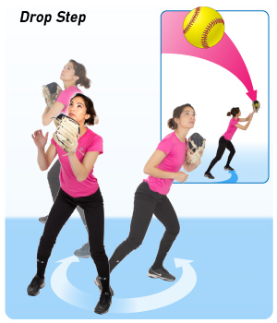

Sprint Back
When you drop step and start going for the ball sprint! 3 things to remember:
Tuck your glove: Tuck your glove into your chest and raise it to make the catch at the last moment.
Run to where the ball is going: Sprint to where the ball is going and try to round behind it so that you settle under it coming forward.
Be behind the ball, coming forward as you catch it: If you are behind the ball coming forward as you catch it, you have added momentum to your throw.

