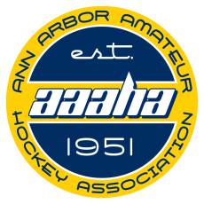
ANN ARBOR AMATEUR HOCKEY ASSOCIATION

AAAHA 2021-2022 SPONSOR FORM
For more detailed sponsorship information, please contact Peggy.costello@aaaha.org

SPONSOR INFORMATION

Sponsor Name:

Contact Person:

Address:

City: State: Zip:

Phone: Email:

TEAM SPONSOR $600. Jersey Sponsor
Is there a player whose team jersey you would like your company name on? (One logo per team) Yes No
If yes, please indicate player name: Player birth year or division (leave blank if unknown):

Cross Ice Board Sponsor $1000.
Your business logo on our cross-ice boards. The logo would be on both the front and back of the cross-ice boards for several seasons.

NAME/LOGO INFORMATION
Please email a file of your name and/or logo in vector or jpeg. These format(s) provide the best- quality for t-shirts, banners, program, etc.
Note: Sponsorships for jersey logos must be received three weeks prior to the start of league play (typically Sept. 15) to be included on jerseys.

PAYMENT INFORMATION
- Mail to: AAAHA Sponsorship P.O. Box 2448, Ann Arbor, MI 48106
- If you have any questions, please contact Peggy Costello Peggy.Costello@aaaha.org

THANK YOU FOR YOUR SUPPORT!

