In Partnership with Complete Game & Molitor Cages Presents its 4th Annual
Baseball & Softball Bat DEMO Day
Sponsored by

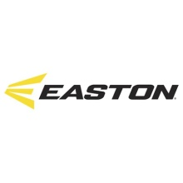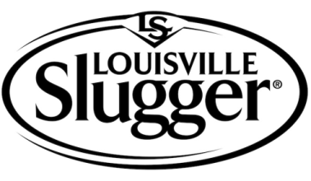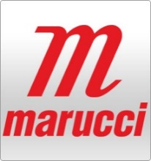

Date: Saturday January 19th, 2019
Time: 9 AM to 1 PM
Location: Molitor Cages 4501 103rd Court NE, Circle Pines, MN
Cost: FREE
Registration: No pre-registration required
Ages: 8 through Adult
Bring your parents, bring the team, bring the kids, bring yourself to try out the newest in 2019 Baseball/Softball equipment!
Specialists from Easton, Louisville, DeMarini, Rawlings and Mariucci will be on site to answer specific questions about the product.
Receive DEMO Day BAT specials (10% to 25% depending on the manufacturer) on same day bat orders. Credit or debit card required to place order.
TradeWins will offer 10% off new baseball and softball inventory on the day of the demo.

