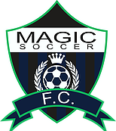

Youth Indoor League Stat Sheet

Team: Orange Crush – U9/10 Match Week: Date:

Team Roster

Name | # | Goals | Assists | YC | RC
Brooke, Leo
Gerving, Alex
Hintz, Keaton
Hoag, Kylan
McKenzie, Brogan
Ramsdell, Ayden
Roerick, Logan
Schmidt, Alex
Voigt, Trevor

Goalkeepers

Name | # | Saves

- Count stats by using tally marks. | 