To find your team, hover on ‘SYB Leagues’ and then hover your cursor over your league name, then click on your team name.
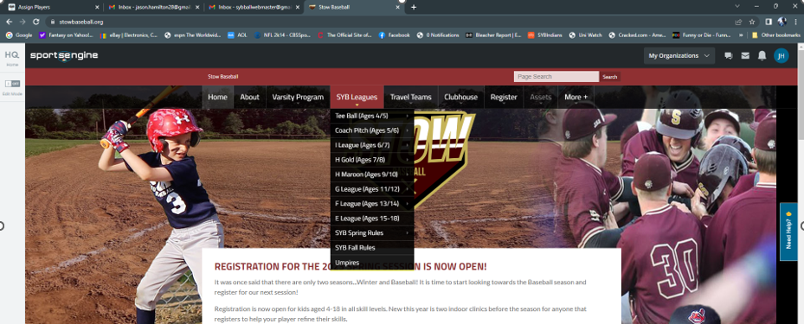

Click on the Edit button on the Left side of the screen:
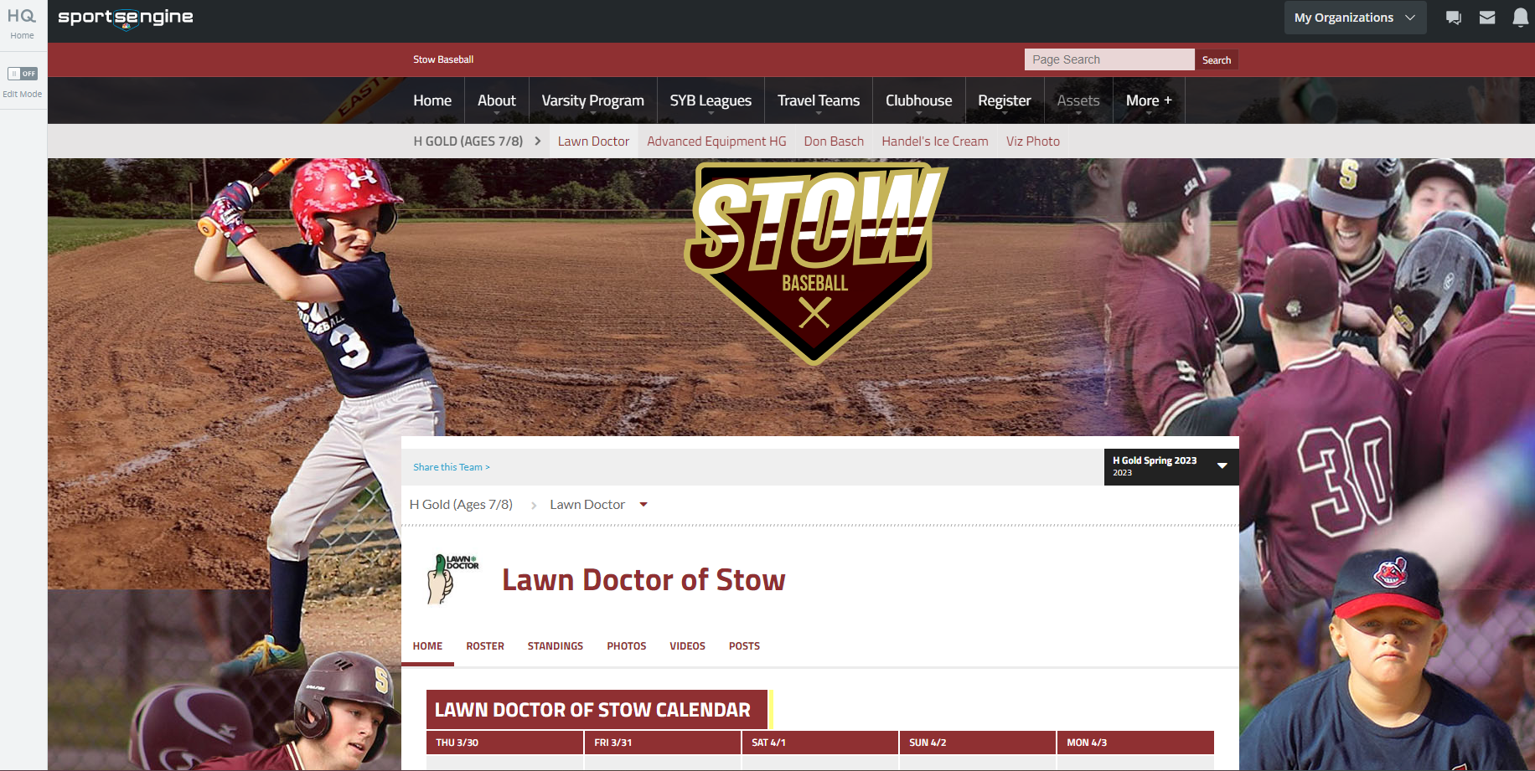

Click on ‘Manage Team’
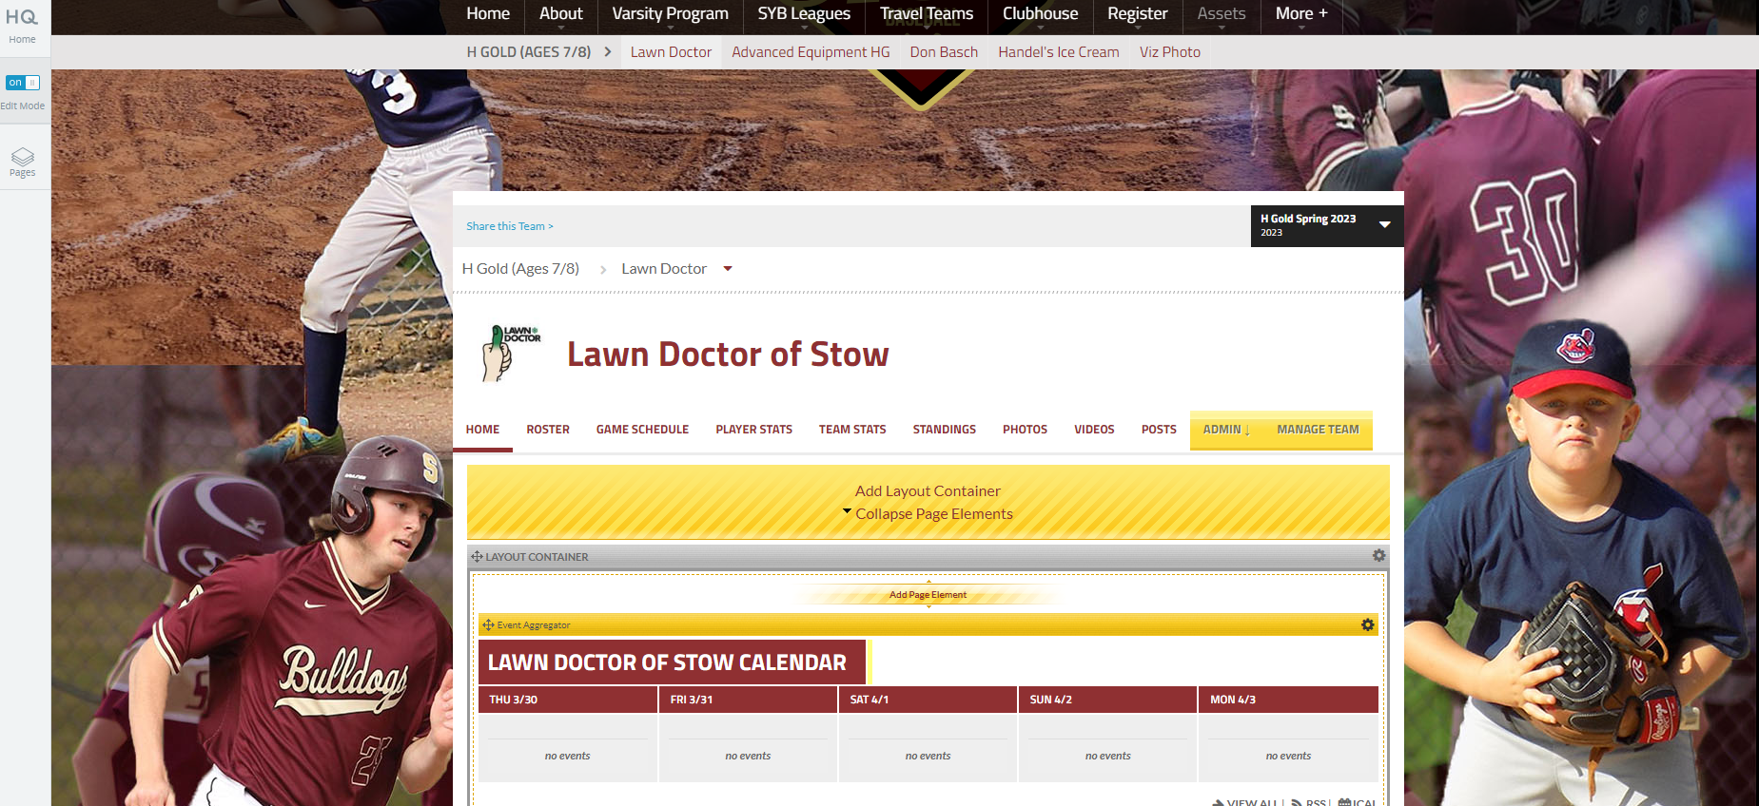

Click on ‘New Event’
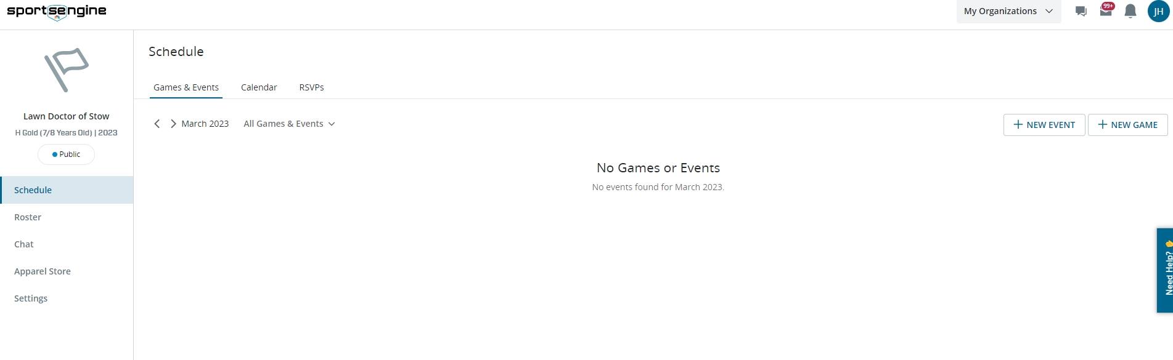

Fill in details, date, time, location:

