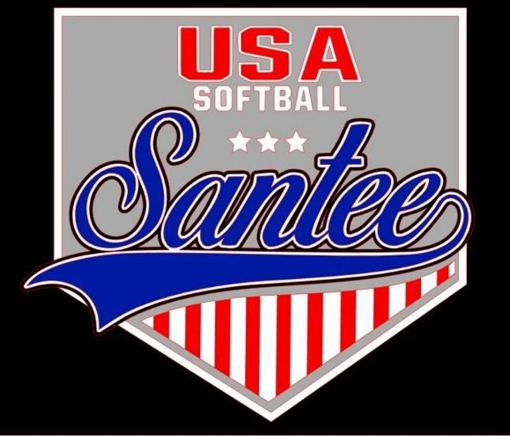
MINUTES TO BE APPROVED AT THE NEXT BOARD MEETING. THESE MINUTES ARE NOT CURRENTLY POSTED AND SHOULD NOT BE DISTRIBUTED UNTIL APPROVED BY USASSCS BOARD.
Board Meeting Minutes August 12, 2024
Location: Santee City Hall
Attendees Shown with Marked Box
Guests: Mia Fergueson, Katja Moskowicz
President | Jay Strandberg |  | Field Prep | Kevin Hopkins
1st VP/ Field Prep/Uniforms | Erik Ruiz | x | Field Prep | Trevor Henton | x
2nd VP | Kelli Timanus | x | Field Prep | James Timanus | x
Treasurer | Tiffany Lynch | x | Field Prep
Secretary/Safety Coordinator/Head Scorekeeper | Bryan Scholar | x | Field Prep | Brad Allen | x
Tax Advisor | Lori Britt |  | Field Prep/Equipment | Shane Frary | x
Player Agent | Lance Craw | x
UIC/Parliamentarian | Felicia Leca | x | Head Team Parent Coordinator | Dana Hisaw | x
Field Scheduler/Fall Ball Coordinator | Chris Klima | x
Webmaster/Social Media/All-Star Coordinator | Alexis Ruiz | x | Picnic Coordinator/Pictures
BOTH Tournament Coordinator | Kayleigh Ponciano-Ahue | x | Snackbar #1
Sponsorships | Kylee Scholar |  | Snackbar #2
Awards | Janis Aiello |  | Social Media Coordinator | Sophia Vigil | x

Meeting called to order: 7:11 PM
Meeting Minutes
Shane Frary motioned to approve minutes from July 2024. Brad Allen seconded the motion.
Meeting rule – One Topic at a Time
Financial Update (Tiffany L)
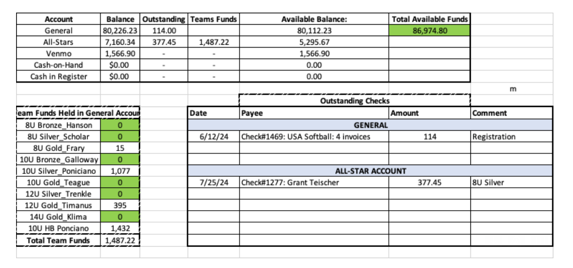
Board Positions Updates
- 2 field positions open
- 2 snack bar positions open
- Picnic & Pictures position open
- UIC position to train new board member

Snack Bar Break – in
- Happened after C State games
- Police report filed
- New padlocks installed on roller doors

Fall Season

Registration open through 8/18
Numbers as of 8/12:
23, 6u players (2 rec teams)
7, 8u players (4 1904 teams, 2 rec teams)
3, 1904 teams, 2 rec teams
12u, 4 1904, 1 rec team
14u, 2 teams playing in 1904, 2 rec teams

Halloween Havoc: October 24 – October 27

Rules Committee
Bringing proposals to the board for spring rec league from July 22 rules meeting

Meeting Adjourned: 8:39 pm
Next Meeting: September 9th

