MIDDLETON BASEBALL
IT’S BIGGER THAN THE GAME

MBA expectations of our coaches are necessarily high. As parents and guardians, we entrust the physical, mental, and emotional well-being of our children to you for at least a few hours each week. But a coach’s actions and example can influence a child’s development and trajectory—as an athlete, but more importantly, as a person—far beyond the field.
As such, we look for specific qualities in our coaches and ask that they embody the virtues of the MBA program.
Coaching Qualities

- Places the safety and well-being of the children first.
- Possesses a passion for and working knowledge of the game and the commitment to remain a student of the game.
- Patience.
- Some things aren’t clear right away. That’s where you need to be patient. If we lose patience, we fail the kids.
- Committed to creating a culture of respect; for each other, opponents, coaches, umpires, families, the game, the fields and environment.
- Understands the proper balance between player/team development and fun.
- Believes that leadership is best administrated by example.

Virtues of MBA – what we teach our players.

- Respect – for selves, others, community and environment
- Teamwork – working towards a collective goal.
- Sportsmanship – how to compete, win and lose with grace.
- Trust and the belief that everyone has a job to do.
- Hard work – an indispensable virtue in life and critical for overcoming adversity.
- Competition – pushes us to grow and excel.
- Loyalty

What we should all ask of our players

- Always pay attention.
- Always try your very best.
- Never give up…on anything.

COACHING RULES
THESE ARE NOT SUGGESTIANS

1. Sportsmanship

How your teams compete is dictated by your overall expectation of sportsmanship. You are expected to teach sportsmanship to all players and exhibit it yourself. Win or lose you will handle it with grace and teach the kids to do so as well. If you fail to do this, you have failed as a coach.

2. Practice.

You will hold a standard practice which involves ALL players. You will focus on areas of MOVEMENT over areas of Mechanics.

Most youth baseball coaches do not have a studied background in sports performance and kinesthetics. In fact, even among the big leagues, most don’t know what actually constitutes proper baseball mechanics. It’s safe to say if you’re a new coach you don’t either. At the most basic level of the game, the key is to teach movement rather than mechanics. Mechanics will come as a player progresses. (Babe Ruth coaches should start to teach basic mechanics)

3. Have a practice plan.

Practice is about more than hitting and pop fly’s. In order to be an effective baseball coach, especially in the youth field, you must prepare a practice plan. Age and skill level aside, you should always have a plan and you should always stick to it.

Most rookie coaches show up to the field with no practice plan whatsoever. This leads to the same old structured practice regiment: stretch, warm up, conditioning, and letting one player practice batting while the others stand around. Developing a plan gives the team an opportunity to grow together and reach goals. (If you need help with running a practice, please feel free to reach out to me. I will attend a practice if available and help.)

4. Preserve the arm and limit throws.

Rarely do baseball coaches caution against overuse of the arm. Preserving the throwing arms of our young ones is crucial. With a recent rise in pitching injuries, like “Little League elbow,” it’s important to limit the total number of throws while at practice. At no time should a player catch and pitch in the same game.

5. Be a coach to ALL the players.

During practice, all players should be treated equally. Try to avoid viewing players as “good” or “bad.”

Many coaches often tend to internally label certain players as “bad” and deem them as counterproductive to the team’s progress without realizing it. In the same way, they view “good” players as the ones they equate to success and winning.

Be sure to build a practice plan that avoids skill biases and actively integrates “bad” players into the training day. This will help everyone improve, not only the player who needs work. In turn, it will create lasting team chemistry and give your kids the opportunity to do what they love most: have fun.

Of course, players can and should be run through drills that are suited to their specific skill level. But it is important to give the rest of the team the same chances.

6. Discipline.

Player discipline will be addressed by the Head Coach only. The assistant is there to help with coaching only. A coach will treat their own child as equal to the other players. "I'm the dad" is not an excuse to be harder in your own child then the other players.

If you face a more serious issue with regards to discipline, you will first reach out to your league director who will council with the player agent. All decisions with regards to player issues will be decided in the favor of what is best for the players experience and safety of the team.

7. Play time.

Play time will be equitable among all players regardless of ability. We are a league that is built around developing talent and skill. As a coach you will move players to various positions over the span of the season. You will consider player safety as you do so, however, opportunity in games is how a player grows.

You will have the discretion to assign players as a pitcher or catcher. We trust you to make good sound decisions. Remember, we want to avoid the stigma of "the coaches kid always gets the best position." You will not be required to play all players at those positions; however you must adhere to strict pitch counts and do your part to develop their talent in a positive manner.

At no time should a player catch and pitch in the same game.

Players will never sit for more than one inning. If you encounter any issues with this rule, you can reach out to the player agent.

You will direct any issues from parents to the player agent and not engage in any on field debates about playtime.

8. Language.

Foul language in unacceptable and will not be allowed. Enough said.

9. Board members.

When and board member has a child playing on your team they are expected to attend the game as a parent and not become involved in the game unless that involvement relates specifically to their board assignment. You should also avoid utilizing them when issues arise.

10. Umpires.

Coaches will respect the difficult job of an umpire. You are free to petition a ruling, however, you will do so in a respectful manner. The umpire has the final say on the field. You are not to engage in arguments with an official regarding judgment calls. You can, however, petition rule conflicts. You will be expected to accept the final ruling and move on with the game. If you have further concerns with regards to officiating you must reach out to the Player Agent or the Umpire Director with your concerns.

HOW TO RUN A PRACTICE
Don't play it until you get it right, play it until you can't play it wrong.

A practice should last no more than 2 hours. You should try to finish within 1 hour and 30 minutes.
Practice should start with the RST model. (Run Stretch Throw)
- Start your practice with a simple run and stretch.
  - Encourage the players to take responsibility for these activities. We want to build the characteristic of leadership and team work.
- Throwing drills should be focused on movement not mechanics.
  - Start the players at a distance of 10 feet or less. A soft toss first and increase the distance until they are 140 feet or more are apart.
- Ground balls and cutoffs.
  - It’s important to keep all players busy during practice. If you have capable assistants, you can split the infield and outfield drills. I prefer to have them work together so you can also work on cutoffs.
  - You will hit fly balls and ground balls.
  - Have the players make appropriate throws ending at first base. See diagram 2 and 3
- Batting / Bullpen
  - Split your players into 3 separate groups. Utilize the batting cage if you have one. If not, you must be creative. Focus on hitting from a tee, Soft toss and in the cage. Repetition is important. Don’t attempt to fix the mechanics of every player. If you have issues with mechanics, try and find one on one time after practice. This is why an hour 30 minutes is best.
  - As a coach you need to find time to give your pitcher and catcher reps in a bullpen. This might be a good time if you have capable assistants.
- Play a game!
  - We aren’t teaching them to be successful at drills. It’s about playing a game and having fun.
  - Split your players into 3 groups.
    - Infield
    - Outfield
    - Batting
  - Place them on the field as shown in diagram 1.
    - Players will line up and rotate positions until they have rotated all the way through.
    - You will hit pop fly’s and ground balls as you see fit.
    - On each hit you will have a runner attempting to advance to home without getting thrown out.
    - Once The runner is home or out all players will rotate one position. Runner to left, left to center and so on.
    - Play continues until everyone has an opportunity at each spot.

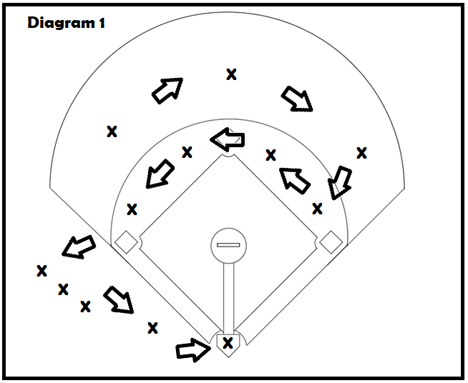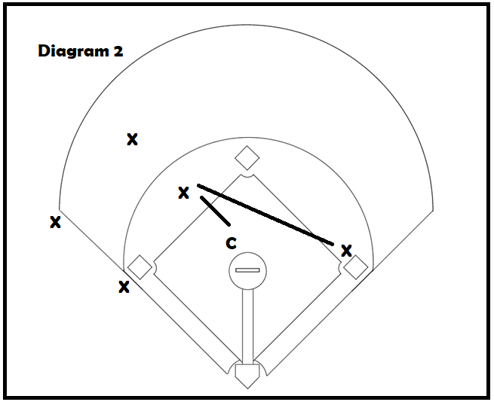
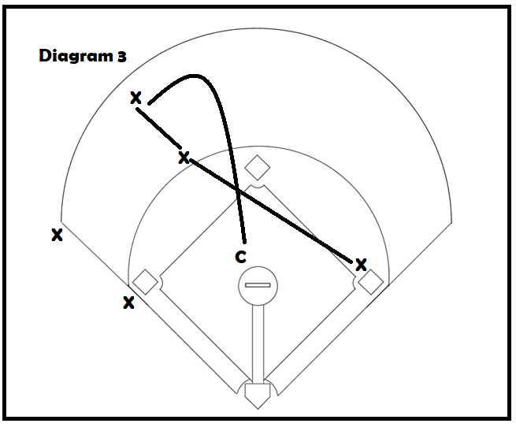
Team Managemnt
Consider recruting a parent to assist with team management. A team manager can keep track of mant tasks that are difficult for a coach to keep track of.
- Score book.
  - Each team is responsiuble for keeping a score book at each game.
    - If you don’t know how to fill out a statics roster you will need to reach out to your league director for help. A player parent will usually know how to fill one out.
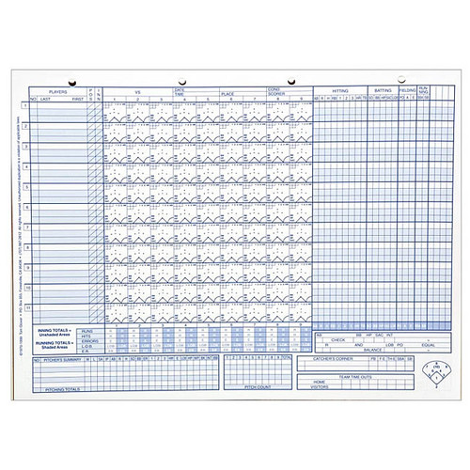
  - Pitch count
    - You are expected to track pitches of ALL pitchers in a game. If you fail to to so and an oposing team chalanges it you will be required to swap pitchers.
    - Pitch count expectations will be covered prior to the season start.
  - Rosters
    - Players rosters will be provided to an umpire and oposing team prior to each game.

