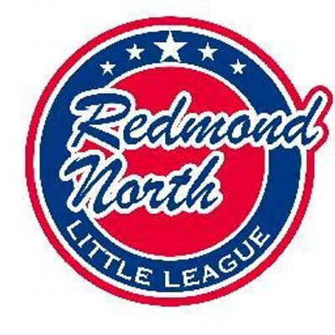

January 21st 201 Meeting Minutes
Attendees:
Bill Bieber
Tiffany Gore
Krystal Klein
Scott Miller
Alec Weintraub
Kathy Duncan
Josh Sattler
Meghan Dosch
Mike Sessions
Ellen Reed

Alec opened the meeting.

Registration Update

Numbers are still down on last year. We are down 35 in the 8-12 year range with 49 new to baseball registrations. The largest losses are in the 7, 8 and 9 year old age groups. This year the league is looking at 4 majors teams, 5 coast teams and 5 AAA teams. AAA managers are needed.
For Softball we have 80 girls registered. RNLL will field teams at the AA level. We will have at least 2 teams, possibly 3. JR field has pitching rubber holes for softball.

Evaluation Day

More volunteers are needed to help the day run smoothly. A number of board members will be there all day and were waiting to see where help was needed.

New AAA Rules

Bill to forward full details of the new AAA rules to the board for their consideration before sending to D9 on Wednesday for their approval, with the main goal to make the game faster and more enjoyable for everyone.

Interleague Play

Sno-valley has reached out to request interleague games as they are predicting to field only 2 majors teams this year. The board is open to playing games with Sno-valley at the Major and Coast level but due to field access issues are reluctant to include AAA in interleague games. Sno-valley will provide umpires for these games, which would be held at Redmond Ridge.

This is planting the seed for consolidation of leagues in the future if numbers continue to drop. The board would need to decide which league to match up with, Eastlake or Redmond West? Perhaps possible to separate by school district boundary?

Scheduling

It was noted that Bear Creek School has their Spring Break on a different week to LWSD.

Training

Free Mariners Training is offered this Saturday. Unfortunately this coincides with evaluation day. Another free training sessions is being offered in Bellevue on February 9th.

Financial

The tax return has been received. Kristal will scan a copy of it for Alec.

Web Master

John Kim’s wife has offered to help out with the RNLL facebook page. Alec will reach out to Jorge for further instructions.

Safety

The safety plan was submitted. Mike will send on to Alec.

Equipment

A query was raised as to what equipment Softball AA teams will require. Kara to be included in discussion. New bags are to be purchased for the IB managers.

Player Agent

Ellen requested a copy of the registration data. VPs to hold draft meetings asap after Evaluation Day.

Scorekeeping

Ellen met with RW scorekeeper. They are switching to Iscore as it is compatible with Sports Engine.

Umpire in Chief

UNW contract is expected next week. Once the contract is received, Alec will discuss details of the new AAA rules with them. Cheat sheet to be supplied for UNW umps.

Sponsorship

A number of sponsors have renewed. Eastside Harley are not interested in renewing their sponsorship.

NEXT MEETING

The next board meeting will be Monday 18th February, 7pm – 9pm at Ixtapa Restaurant.

