PROMOTE YOUR BUSINESS & HELP A GOOD CAUSE

Advertise with Glendora Softball!

Your business has an opportunity to help the Glendora Softball program (G.G.A.L) while promoting your business at the same time. You can get a 3’H X 4’W high quality, full color, custom sign of your business logo to be mounted to our fence, (road-facing) at Glover Field for an entire year!. Our field is located on the well-traveled, high volume intersection of Evesham Rd. & Schubert Ave.

The first year is only $380.00. If you continue to advertise with us, the following year will only be $300! (That means it breaks down to only $32 a month for the first year and $25 a month for every year after that if you renew!). Another sponsorship offer is to sponsor a team for $150.00 and your business’s name will be placed on a 8 ½ by 11 sign and hung on our dugouts fences.

If you choose to be both a sign and team sponsor, the price is reduced to $500!

When you sponsor with us, we will also list your company logo and information (website url) on our Facebook page. Our goal is to highlight your business on our website as well as promote your business to our parents and friends via word of mouth and blast emails.

Our u8, u12 and u15 programs have won multiple tournaments as well as league championships over the last 3 years! With over 200 players, 10 teams with each team playing 12 -15 games per season that is a lot of foot traffic in/out of our facility! Sponsorships are tax deductible as well!

We ask that if you intend to sponsor with us - you send us an email at ggalsoftball@gmail.com so we can get the artwork completed as soon as possible. You may also call Carrie Evans at 609-932-9699.

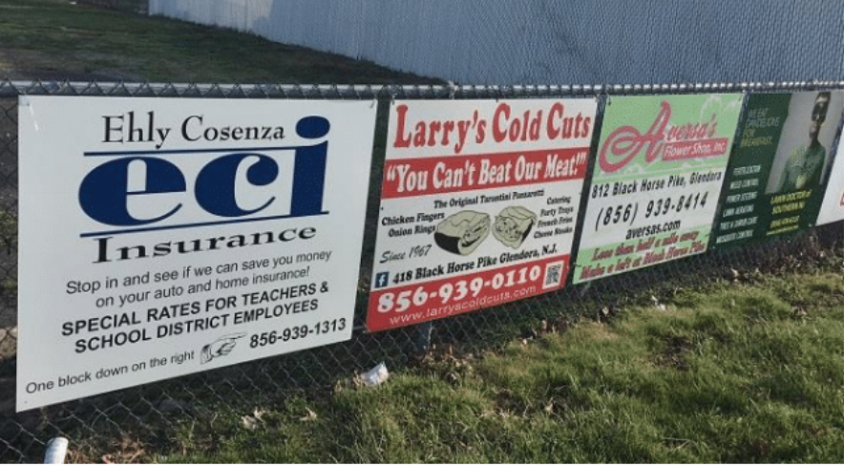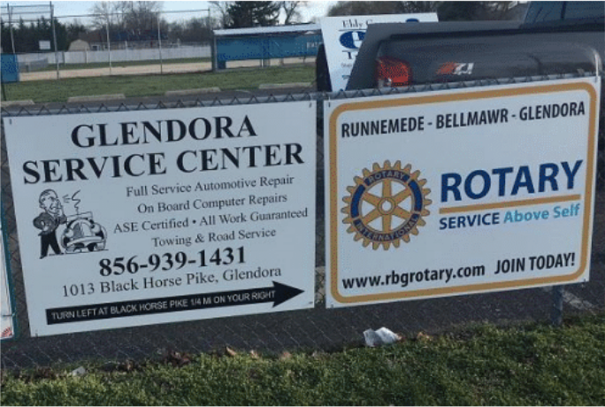
Please fill out the reverse side of this form and return with payment as soon as possible.

Glendora Softball 2022 Sponsorship

I am interested in:

_____ Sign Sponsorship ($380) _____Team Sponsor ($150) _____ Both ($500)

*Please send your electronic picture or artwork to (ggalsoftball@gmail.com) for your sign.

Company Name: ___________________________________________________________________

Contact Person: __________________________

Web Address: ____________________________

Cell Phone #: ____________________________

E-mail: _________________________________

Address: ___________________________________________________________________________

Signature: __________________________________________________________________________

Please mail all checks to:

Glendora Softball
P.O. Box 1
Glendora, NJ 08029

We now accept venmo payments at: @GGALSOFTBALL or Paypal @ggalsoftball@gmail.com

Need assistance? Email us at ggalsoftball@gmail.com
Please include in memo line - new sponsor 2022

Check #______ Venmo/Paypal:_______

