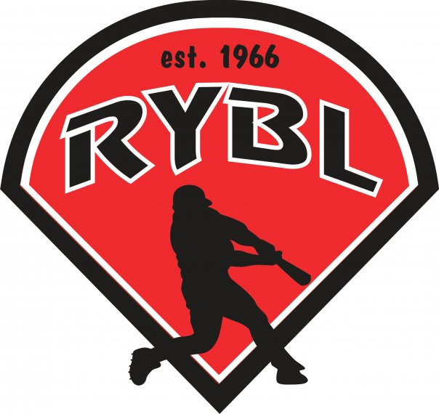
RYBL July 2023
Board Meeting
07/20//2023 7:00PM
- Call to Order 7:16pm
- Opening Prayer- Bryan
- Previous Board Minutes Approval – yes
  - March 2023 Minutes – Approval – April and June meetings canceled due to ball field needs
- Treasurer’s Report – DJ Butcher
  - Current Bank Balance: $44,783.00- approved
    - Outstanding Bills:
    - Accounts Receivable:
- Office and Committee Reports –
- Secretary – Andy Keogh – $400 stolen from concessions – people were replaced and no more money stolen
- President – Bryan Altmaier – 40k in sales from concessions
- online registration for fall numbers – 77 kids last week should be more end of July
- background checks for new managers – for fall ball -
- RYBL Won City Tournament in all Divisions - Good job kids
- Fire pizza
- Possibly win state all-stars – all three divisions in state tourney
- Put an age group of when your kid can play baseball on flyer, website and facebook
- 1st Vice President- Chris Pavey – t-ball director – Justin t-ball director -
- position open -
- 2nd Vice President – Mickey White –
- find managers and make schedule
- new president at Taylor league to play on their fields for games and practice
- position open
- minor could do some live arm games next season mid-season
- Player Agent – Brandon Darling
- Fall ball coaches need assigned – only four responded so far
- Equipment Manager – Dawn Hyman –
- position open
- ordered baseballs for next year
- working on fall ball shirt design
- return day for league equipment
- Umpire in Chief – Matt Adams – fall ball just major umpires only – one to start with
- Media Director- Taylor White –
- Unfinished Business – did we find out about the stolen rings and $400 from concessions.
  - Light pole donation from Stellhorn – how to get to Russiaville – show some progress- on the poles – we have the lights already to go
  - Mower and fields in good shape – find out the cost
  - Missing rings – never found had to pay for new ones

- New Business – next season maybe order a new wheel and pads for pitching machines – have to go through jugs for new wheel and pads –
- tarps all spring season
- To avoid paying taxes we need to fill out the paperwork – Bryan on it
- follow up with softball will pay their portion of the taxes – Bryan on it
- Nominations in October for new board members
- Adjournment – at 8:30pm and Next board meeting August 17th at 7pm

