Pre and Post Pitch Movement

All infielders start about 5 steps deep at their position. As the pitcher begins her windup they start walking forward (3 steps) and break down to the ready position at the pitch (no elbows on knees!). After the pitch they move back to their starting position and repeat. 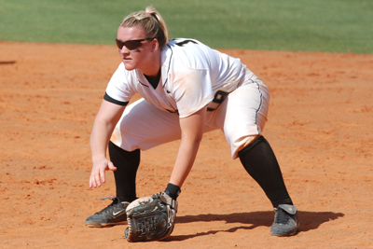

3Rd Base – The hands should be positioned with the fingers pointing up and around the shoulders. They need to be in a position to protect their head in case of a line drive
After the pitch the 2nd baseman and shortstop should hustle to get behind the pitcher around 2nd base to cover any overthrow from the catcher.

All outfielders should breakdown to their ready position at the windup.
