
MINUTES TO BE APPROVED AT THE NEXT BOARD MEETING. THESE MINUTES ARE NOT CURRENTLY POSTED AND SHOULD NOT BE DISTRIBUTED UNTIL APPROVED BY USASSCS BOARD.
Board Meeting Minutes October 14, 2024
Location: Santee City Hall
Attendees Shown with Marked Box
Guests: Emily Tolliver
President | Jay Strandberg | x | Field Prep | Kevin Hopkins
1st VP/ Field Prep | Erik Ruiz |  | Field Prep | Trevor Henton | x
2nd VP | Kelli Timanus | x | Field Prep/Uniforms | James Timanus
Treasurer | Tiffany Lynch | x | Field Prep | Shane Hanson | x
Secretary/Safety Coordinator/Head Scorekeeper | Bryan Scholar | x | Field Prep | Brad Allen | x
Tax Advisor | Lori Britt |  | Field Prep/Equipment | Shane Frary | x
Player Agent | Lance Craw |  | Field Prep
UIC/Parliamentarian | Felicia Leca | x | Head Team Parent Coordinator | Dana Hisaw | x
Field Scheduler/Fall Ball Coordinator | Chris Klima
Webmaster/Social Media/All-Star Coordinator | Alexis Ruiz
BOTH Tournament Coordinator/Picnic Coodinator | Kayleigh Ponciano-Ahue | x | Snackbar #1 | Katja Moskowicz | x
Sponsorships | Kylee Scholar |  | Snackbar #2
Awards | Janis Aiello | x | Social Media Coordinator | Sophia Vigil | x

Meeting called to order: 7:05 PM
Meeting Minutes
Brad Allen motioned to approve minutes from September 2024. Eric Dechant seconded the motion.
Meeting rule – One Topic at a Time
Financial Update (Tiffany L)
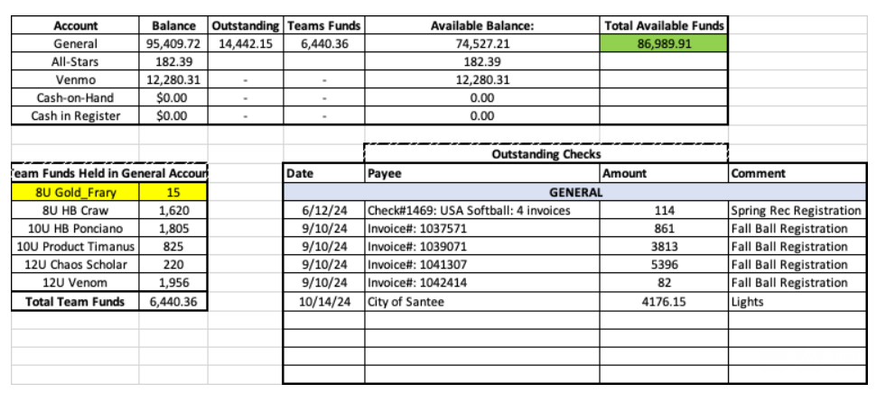
Permits after Fall Ball
- Field 1 and 5 will remain open during the city field closure. Fields 2, 3, & 4 will remain closed from November 24 – January 12
- Santee USA Softball will work on a fair way to distribute field permit use during the closed time period
Halloween Havoc
- Teams sign up for field prep and trash pick up
- Landscape Day – Wednesday, 10/23 from 6 – 9 pm – No field practices or cages
- Shane Frary and Brad Allen to put field prep schedule for each team
- Kelli Timanus to put together for board member registration table
USA Softball Meeting
- November 24 in Irvine – Kelli Timanus, Janis Aiello, Katja Moskowicz attending
Spring Rec Season
- Registration begins November 11 – Post banners & social media on November 4
  - Bryan to send information to Alexis Ruiz
  - Social Media – Posted by Nov. 4
- Warm Up Clinic: January 15 - 17
- Evaluations January 18 – 19
Fields
- Jay will order chalk
- Field prep team will add feathers before Halloween Havoc

Meeting Adjourned: 8:58 pm
Next Meeting: November 11

