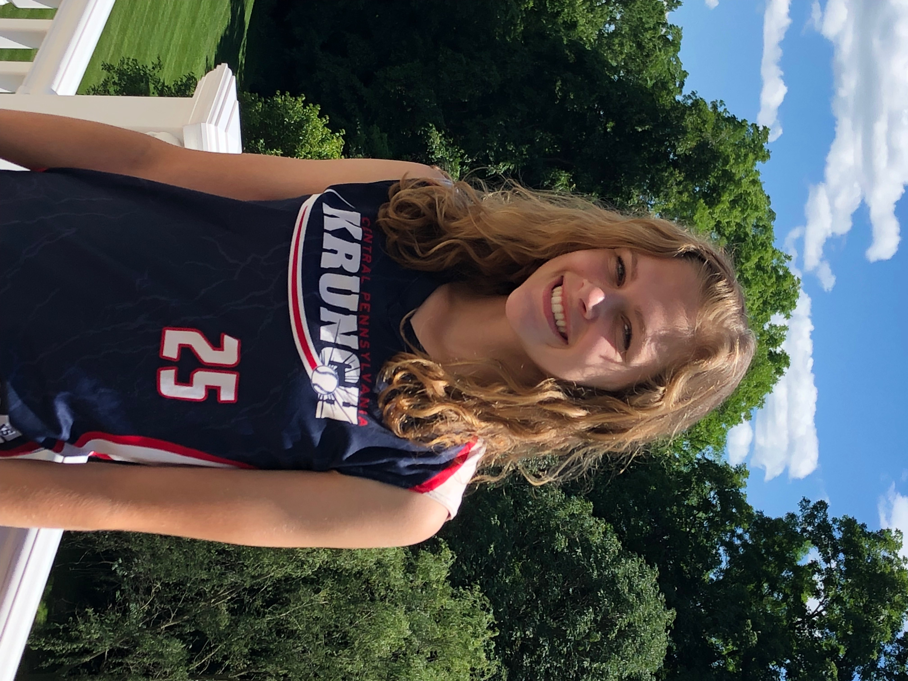
Name: Caitlyn Saccary #25
Grad Year: 2020
Position: OF/ 2B / C
GPA: 4.0

SAT: not yet taken
Intended Major: Nursing

2018 Statistics
BAT AVG | OB% | SLG% | HR’s | SB | Contact to 1st B | Home to Home
.444 | .444 | .444 | 0 | 2 | 3.0 | 12.60

Address: 5625 Charlton Way
City: Mechanicsburg
State: PA
Zip: 17050
Phone: 717-557-4522
Email: caitlynsaccary@gmail.com

High School: Cumberland Valley Highschool
DOB: August 14, 2002
Weight: 110
Height: 5’6
Bats: Right
Throws: Right

Non-Softball Activities
2016-17 2017-18
Key Club Key Club
Eagle Buddies German Club
8u softball coach THON Committee member
Special Olympics volunteer Special Olympics Volunteer
Bethany Village volunteer

Summer Team: Central Pennsylvania Krunch 16U Coaches Name: Naul Walter
Phone: 484-241-9454
Coaches Email: nwalter@weareberg.com

Reference Name: Kim Holl
Phone:717-436-7747
Email: hollgirl1195@gmail.com

