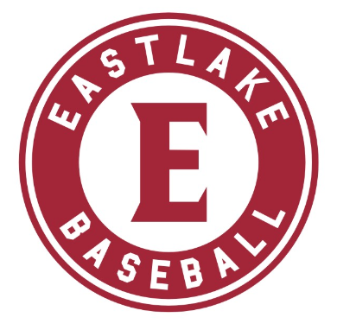
2022 Eastlake Baseball
Banner Sponsorship Form

Sponsor Name: ____________________________________________________________________________________

Website Address:___________________________________________________________________________________

Contact Name (primary):
_________________________________________________
Address:
_________________________________________________
_________________________________________________
_________________________________________________
E-mail:__________________________________________
Business Phone:___________________________________

Sponsorship Opportunities (please check your order/s)

2022 Banner Sponsorships:
□ 4.5’ x 10’ Multi-color Vinyl Banner $800
□ Renewal of current banner $500

Instructions – Two-Three easy steps…

1. Make check payable to Eastlake Baseball Booster Club.
2. Mail completed Banner Sponsorship Form to:
Eastlake Baseball Booster Club
704 228th Ave NE PO Box 934
Sammamish, WA 98074
3. For NEW BANNERS ONLY – email all banner artwork to: donodon@msn.com
Email artwork (logo, business card image, message, etc.) in .jpeg format
Please contact Jen O’Donnell at donodon@msn.com with any questions.

*** You will receive a draft of your banner ad to review and approve prior to printing***

Sponsor Authorization:_______________________________________ Date:_____________________

