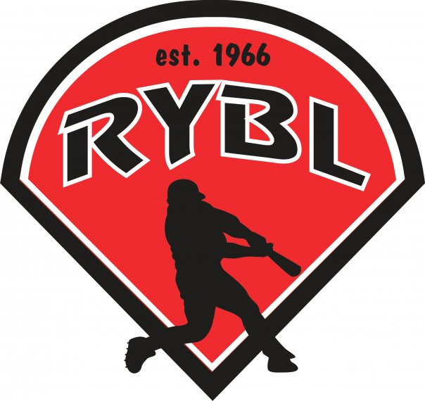
RYBL September 2022
Board Meeting
9/15/2022 7:30 PM
- Call to Order 7:33
- Opening Prayer
- Guest Adrian to discuss concessions - Amy is leaving – who gets free food? – need 4 people to run it – umpires get food and drinks – Amy was overwhelmed – 5 to 9:30ish is work schedule – kids should be 14yrs old to work it and 16yrs old to do the food – boy scouts and girl scouts and loins could members and even church groups – getting a key – ladies auxiliary
- Guest Greg to discuss meeting with Blake Marschand with suggestions for the fields - #1 aerate fields and over seed – he has better quality seed at $160 a bag – Greg ordered two bags – total to work the fields is $4-5k. #2 the mower is leaking oil; Greg is going to take mower and look under it
- Previous Board Minutes Approval – Andy Keogh
  - August 2022 Minutes – Approval
- Treasurer’s Report – Adam Brock working and getting with Dawn on everything
  - Current Bank Balance: $35,421 last balance I have on record
    - Outstanding Bills: $1,000 for field material
    - Accounts Receivable:
- Office and Committee Reports
- Secretary – Andy Keogh – working on getting mins on website
- President – Bryan Altmaier
- 1st Vice President- Chris Pavey
- 2nd Vice President – Mickey White – press box?
- Player Agent – Vacant
- Equipment Manager – Dawn Hyman
- Umpire in Chief – Matt Adams – no reschedule of cancelled games
- Unfinished Business
*Field Material replenishing costs
Leffert Stone $95 to deliver to Russiaville 2 pallets of material
Play ball Conditioner $12.45/bag x 40 bags= $49
Drying Agent $9.95/bag x40 bags = $398
Total $991 for field material
Adding a new board position- Social Media Manager/Sponsorship Manager to be voted on in October
- Job duties would include running online platforms for the league, sending invoices out to sponsors, and actively trying to get more sponsors into the league. Responsible for sponsor shout outs, league information, game highlights, etc.
Filling Adam Brock and Zac Resers spots. Is anyone else not planning to come back next season? We need to know so we can plan to fill these spots in October.
Closing Field Day (October 1st and 8th) Should be really simple, shutting water off, getting hoses all put away. I say we keep the nets up and look at replacing some of them in the spring. We can look at backstop options in spring.
- New Business
Have one inquiry about the concession stand manager, need to come up with ideas to make this easier on them in the future. Two people to tag team the job.
- Adjournment – Next board meeting is second Thursday of the month 10/6 at 730 to vote in new board positions due to fall break
- Press box doorknobs are bad, hard to use -

