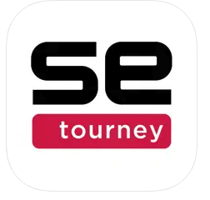
GNLL uses SportsEngine Tourney for all Spring/Summer/State games. This will be the most up-to-date schedule and should be checked weekly by Team Managers for schedule changes. Team managers need to update the SportsEngine team calendar with updates noticed on this Tourney app.

Once the app is downloaded, follow these steps to find your event/team:

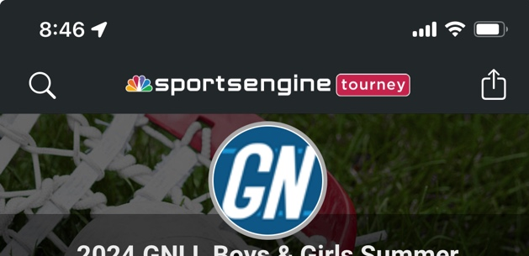

Click the magnify glass to search for an event.

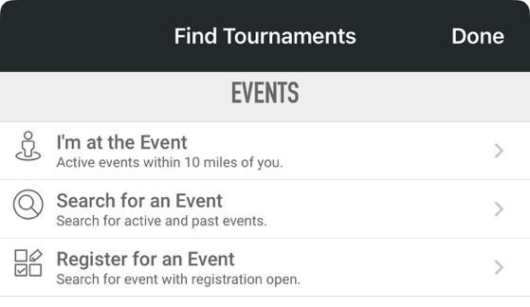

Select Search for an Event

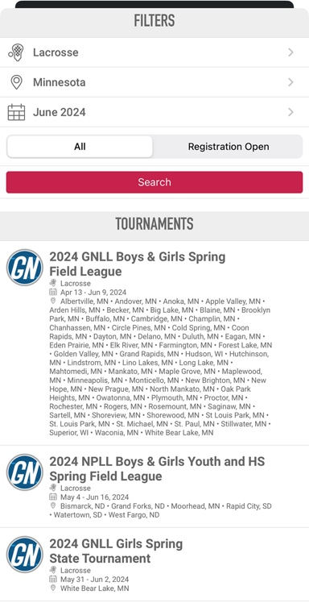

Enter in filters:
*Sports = Lacrosse
*Location = Minnesota
*Date = can leave blank

Hit Search and a list of all events available in SportsEngine
Tourney will show up. Select the event you are looking for.

For SSRLAX, we use:
*(Year) GNLL Boys & Girls Spring Field League
*(Year) GNLL Boys Spring State Tournament
*(Year) GNLL Boys & Girls Summer Field League
*(Year) GNLL Boys Summer State Tournament

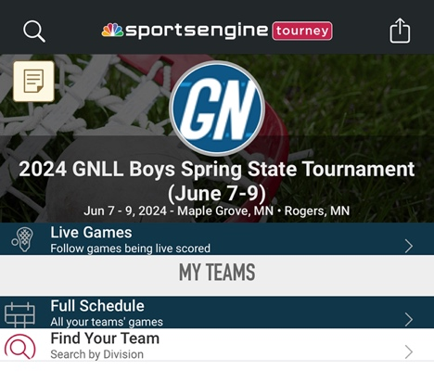

Once you have selected the event; click on Find Your Team.

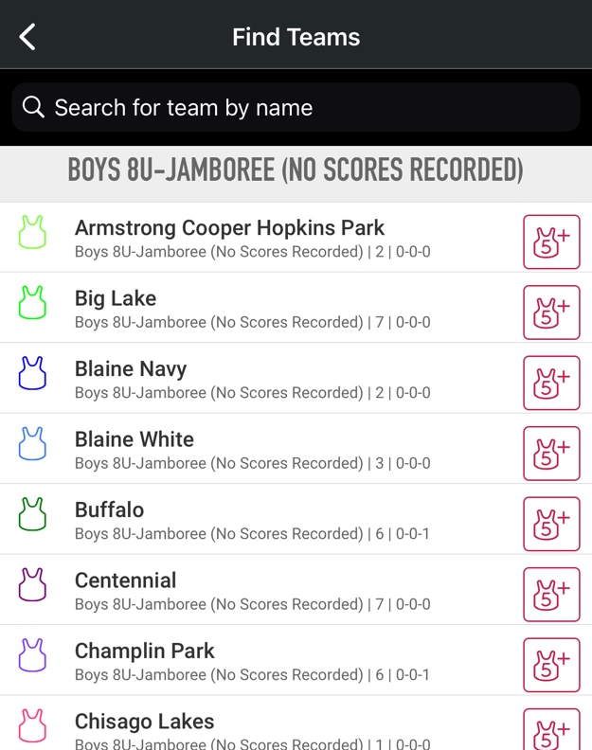

Type in your team name to search or scroll through list until you find your team; NOTE:

*All age levels participating in an event are listed-verify
you have the correct age level and team

*If there is more than one team/age level for SSRLAX-
verify you are selecting the correct team

Select the jersey icon to follow your team

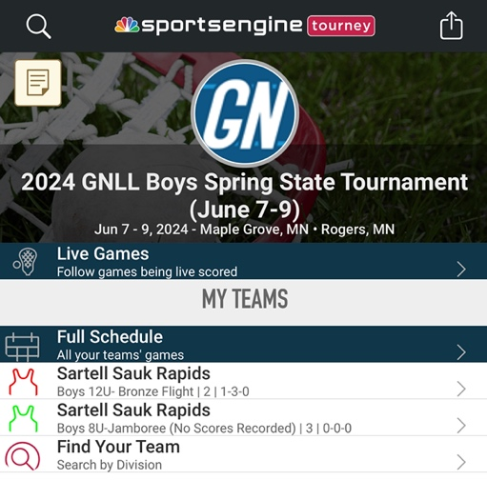

All teams you have followed for an event will show up on your home screen under MY TEAMS.

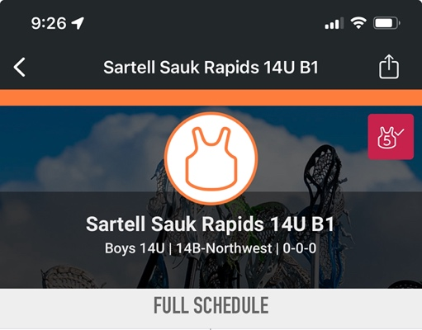

After following your team, you can click on the team to view the full schedule, scores, etc. To share this link with your team, click the share icon at the top of the screen to email it to everyone. Not required, but it is helpful for all families to know this app is available.

