 X 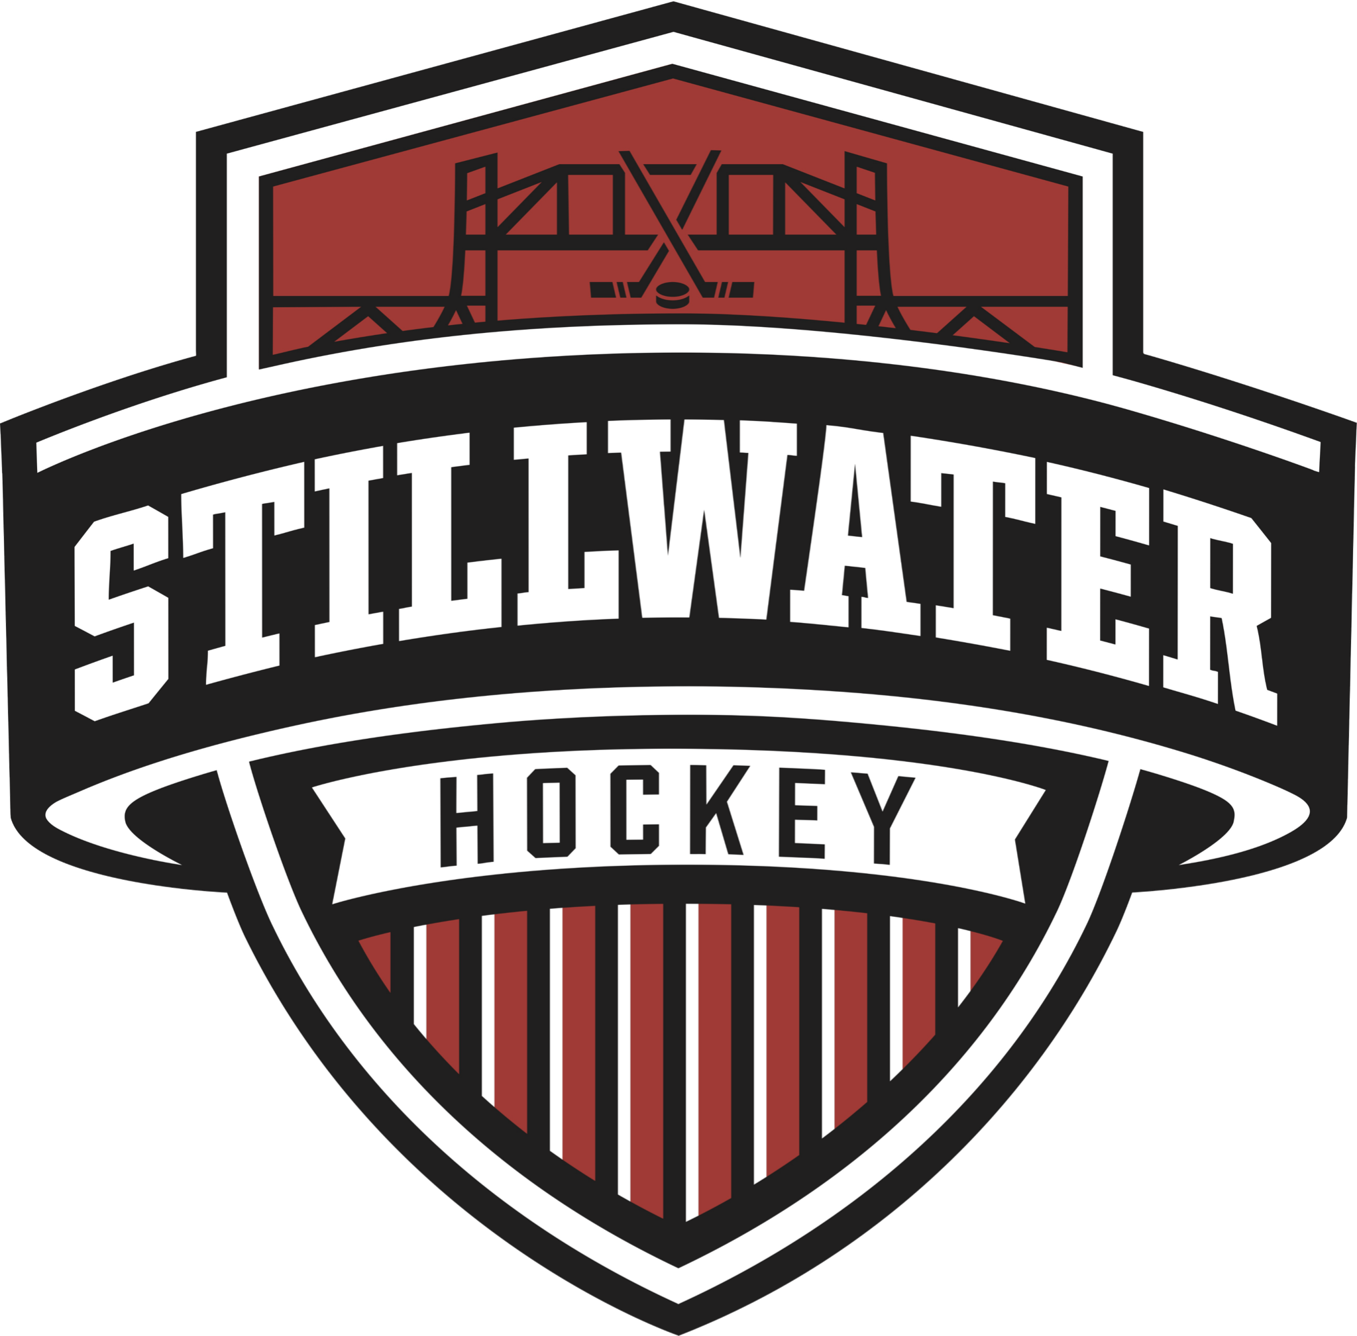
2022 FUNDRAISER

Dear Friends & Family–

This year our friends at Chopper Mill, a children’s mitten & outdoor gear company based in Stillwater, Minnesota, have created a fundraiser that will directly benefit our team! We are able to earn 30% of all sales when you enter our team discount code on www.choppermill.com, for our team’s 2022-2023 hockey season.

The products that Chopper Mill carries include:

- “The Mitten Thief” RETAIL: $15
- The Winter Snow Choppers (included-first lost single replaced for free) RETAIL: $89
- The Winter Natural Choppers (included-first lost single replaced for free) RETAIL: $89
- Mittens for Life Gift Set (Includes 3 pairs of Choppers & FREE book - “The Mitten Thief” by local Stillwater author, Jill Kaufenberg) RETAIL: $250
- GearDryer Solo 120V RETAIL: $199
- GearDryer12 RETAIL: $899

This fundraiser will run from October 15th-December 15th, perfect for Christmas gifting this year. We will then be able to apply these funds to our team tournament travel, and other expenses.

Thank you so much for your consideration in supporting our team within the Stillwater Area Hockey Association! Our specific discount code that helps track our sales is SAHASQUIRTB2BLACK. If you have any questions about their products, please feel free to contact Chopper Mill at hello@choppermill.com.

Bring on the pond hockey!

Child’s/Parent’s Name

