SPORTS INTERNSHIP OPPORTUNITY
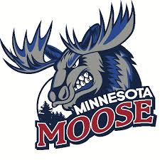
Minnesota Moose, United States Premier Hockey League
Part Time & Full Time
Offseason (May-Sept)
Half-Season (Sept-Dec; Jan-May)
Full Season (Sept-May)

The Minnesota Moose Hockey Club, are moving in to the fourth year of operation and are looking for motivated, passionate interns to assist with operations during the 2020-2021 season. Moose internships are full-time or part-time and allow students the opportunity to gain valuable work experience within a sports organization through hands-on experience. A successful applicant will demonstrate strong organizational skills along with initiative, resourcefulness, and an ability to collaborate with team members for the achievement of team goals. In past years, interns working with Jr. A hockey teams have been successful in securing full time positions across a wide field of industries post-internship. Career mentoring is a central aspect to the Moose internship program.
Marketing & PR Internship
Public Relations, Promotions, Branding, Messaging
- Responsibilities
  - Assist in development of sales collateral
  - Help connect our brand to our fans
  - Assist in advertising design
  - Help create short-term and long-term social media marketing campaigns
  - Assist in maintenance of team website and social media accounts
  - Facilitate cross-promotional messaging for corporate partners
- Qualifications
  - Enrolled in technical or undergraduate program, school credit available in accordance with school and program qualifications
  - Strong knowledge of Microsoft Office and Google Documents
  - Preferred knowledge of Adobe Creative Suite
  - Preferred knowledge of video editing software
  - Creative mind to consistently find opportunities to create content
  - Self-starter and highly motivated

- To apply, please send cover letter and resume to mnmoosecoach@gmail.com

Jon Jonasson
Head Coach/ General Manager
952-457-0525
mnmoosecoach@gmail.com

