

Sponsorship

P.O. Box 318, Sonoma CA 94576 League ID# 4053512

**SATURDAY, JANUARY 27 2019** Hughes Field









**MANDATORY FOR ALL MANAGERS/COACHES**

* **Review fundamentals of teaching the game**
* **Review local league policies and procedures**
* **Review 2019 changes to the Little League Rule Book**
* **Review basic First Aid / Safety Procedures**
* **Review and distribute Safety Plans, Medical Release Information**
* **Distribute First Aid Kits**
* **Distribute team equipment**
* **Assign practice field schedule**

**NO TEAM IS AUTHORIZED TO PRACTICE OR MEET WITHOUT FIRST ATTENDING THIS MEETING!**

**TABLE OF CONTENTS**

Coaching & Safety Clinic – January 27 2018 i

Introduction 2

Mission Statement 2

Policy Statement 2

Safety Action Items 3

Important Phone Numbers 4

Board of Directors (2019) 5

Safety Code 6

Manager’s Required Equipment 7

A Parent’s Guide to the Little League Child Protection Program 8-9

Little League Volunteer Application (2019) 10

Asthma Emergency Signs 11

Catcher’s Equipment (Rule 1.17) 12

Emergency Treatment of Athletic Dental Injuries 13

Guidelines for Staying Hydrated 14

Lightning Safety 15

Hey Coach – Pre-Game, Pre-Practice Reminders 16

Coach, Let Players Play Catch (Rule 3.09) 17

Using Steroids Equals Cheating 18

Accident Reporting Procedure 19

Overuse Injury Report 20

Activities/Reporting (Incident/Injury Tracking Report 21

Little League Accident Notification Form 22-23

Snack Bar Safety Checklist 24

Volunteers Must Wash Hands 25

Sport Parent Code of Conduct 26

Protecting Young Pitching Arms 27-43

Little League Baseball Game Pitch Log 44

Little League Baseball Pitcher Eligibility Tracking Form 45

National Facility Survey 46-52

2019 Qualified Safety Program Registration Form 53-56

**INTRODUCTION**

Sonoma Little League is a fully chartered Little League program open to boys and girls between the ages of 5-12 living within the boundaries of Sonoma Little League, as determined and approved by Little League Baseball. Our league plays in District 53 of the Western Region of Little League Baseball. Our league consists of four (4) divisions of play: Coach Pitch, AA Minors, AAA Minors and Majors.

**MISSION STATEMENT**

Sonoma Little League and its volunteers pledge to provide:

* A positive Little League experience for young people in our community
* An equal opportunity for all children
* Instruction geared toward to learning and improving
* Valuable lessons in sportsmanship and team work
* A safe and friendly environment to develop and nurture a love for the game of baseball.

**POLICY STATEMENT**

In 1995, Little League International introduced ASAP (A Safety Awareness Program). This program was created to emphasize the importance of safety within the Little League organization. More importantly, it helped the local league’s Safety Officer to create awareness, through education and information, of the opportunities to provide a safer environment for kid and all participants of Little League Baseball.

Sonoma Little League has developed this safety plan to provide important information to managers, coaches, players and parents. The goal of this safety plan is to establish guidelines that will be used by all participants in Sonoma Little League, to ensure safety for all players, coaches and volunteers.

This safety plan is distributed to all managers at the start of each season. This manual is also readily available in all snack bars and equipment sheds and can also be viewed online at [www.sonomalittleleague.com.](http://www.sonomalittleleague.com/)

**SAFETY ACTION ITEMS**

|  |  |  |
| --- | --- | --- |
| **ACTIVITY** | **RESPONSIBLE PARTY** | **TIMELINE** |
| Facilities Survey | Safety Officer | *Pre-season* |
| Equipment Inspection | Safety Officer / Equipment Manager | *Pre-season* |
| Field Inspections | Safety Officer / Managers | *Ongoing* |
| Conduct Background Checks | Safety Officer / President | *Ongoing* |
| Distribute First-Aid Kits | Safety Officer | *Coaches Mtg* |
| Submit Safety Manual | Safety Officer / President | *January 24th* |
| Traffic Safety Awareness | Safety Officer | *Coaches Mtg* |
| Review Concession Stand Log | Safety Officer | *Weekly* |
| Safety Report to Board | Safety Officer | *Monthly* |
| First-Aid Inspections | Safety Officer / Managers | *Monthly* |
| Practice/Game Visits | Safety Officer | *Ongoing* |
| Injury Report Follow Up | Safety Officer / President | *As occurs* |
| Review Injury Reports | Safety Officer / President / Managers | *As occurs* |
| Review Playing Condition Reports | Safety Officer / President / Facilities Managers | *As occurs* |
| Review Equipment Reports | Safety Officer / President / Equipment Manager | *As occurs* |
| Enforce Pitch Count Rules | Safety Officer / President / Coaching Coordinator / Managers | *Ongoing* |

**IMPORTANT PHONE NUMBERS**

|  |  |  |
| --- | --- | --- |
| EMERGENCY | *From Land Line* | 9-1-1 |
| *From Cell Phone* | (707) 565-2121 |
|  |  |  |
| SHERIFF | *City of Sonoma* | (707) 996-3602 |
| *Sonoma County* | (707) 565-2511 |
|  |  |  |
| FIRE | *City of Sonoma* | (707) 996-2102 |
|  |  |  |
| CALIFORNIA HIGHWAY PATROL | *State* | (707) 253-4906 |
|  |  |  |
| SONOMA VALLEY HOSPITAL | *Sonoma* | (707) 935-5000 |
|  |  |  |
| POISON CONTROL |  | (800) 876-4766 |
|  |  |  |
| LITTLE LEAGUE INTERNATIONAL INSURANCE CLAIM OFFICE | *Williamsport* | (570) 327-1674 |
|  |  |  |
| DISTRICT 53 SAFETY OFFICER – TOM FERGUSON |  | (707) 426-7441 |







**BOARD OF DIRECTORS**

|  |  |  |
| --- | --- | --- |
| PRESIDENT | *Mike Brown* |  |
| [*sonomaLLpresident@gmail.com*](mailto:sonomaLLpresident@gmail.com) |
| VICE PRESIDENT | *Steve Sangiacomo* |  |
| [*vp@sonomalittleleague.com*](mailto:vp@sonomalittleleague.com) |
| PLAYER AGENT | *Shannon Kiser& Chelsea Pirker* |  |
| *playeragent17@gmail.com* |
| SECRETARY | *Kimberly Subaie* |  |
| *kim@ironbarkarborists.com* |
| TREASURER | *Mike Boehm* |  |
| michaelboehm@yahoo.com |
| COACHING COORDINATOR | *Michael Conway* |  |
| conmway@siwnyc.com |
| INFORMATION OFFICER | *Brian Filippi* | (707) 480-7943 |
| *brianfilippi@gmail.com* |
| **SAFETY OFFICER** | ***Nate Reynes*** | **(707) 953-0014** |
| [nreynes@benziger.com](mailto:nreynes@benziger.com) |

**SAFETY CODE**

The Sonoma Little League Safety Code has been adopted by the Board of Directors and is enforced by the Safety Officer and League President. All league participants, volunteers and officers are required to abide by this code. It is the responsibility of the Safety Officer to make revisions to the Safety Code from year to year, as necessary.

* Managers, coaches and umpires should have basic training in first-aid. First-aid kits are distributed to each team at the beginning of the season and basic first- aid supplies are located at each field.
* Managers and coaches are responsible for inspecting the fields (before games

*and* practices) for holes, damage, stones, glass and other foreign objects prior.

* In games where Umpires are presiding, the Umpire will ensure that the managers and coaches carry out field inspections. Umpires have the discretion to call the game and if it is determined that the field is not suitable for play.
* No games or practices shall be held when weather or field conditions are not good, particularly when lighting is inadequate.
* All team equipment should be stored within the team dugout or behind screens and not within the area defined by the Umpires as “in play.”
* Only players, managers, coaches and Umpires are permitted on the playing field or in the dugout during games and practices.
* Responsibility for keeping bats and loose equipment off the field of play should be that of a player assigned for this purpose or the team’s manager and/or coaches.
* During practice and games, all players should be alert and watching the batter on each pitch.
* During warm-up drills players should be spaced so that no one is endangered by wild throws or missed catches.
* Equipment should be inspected regularly for the condition of the equipment as well as for proper fit. Replacements for damaged equipment can be obtained through the league’s Equipment Manager.
* Batters must wear Little League Baseball approved protective helmets during batting practice and games.
* Catchers must wear catcher’s helmet, mask, throat guard, long model chest protector, shin guards and protective cup with athletic supporter at all times for all practices and games. NO EXCEPTIONS! Manager should encourage all male players to wear protective cups and supporters for practices and games.
* Except when a runner is returning to a base, headfirst slides are not permitted.
* During sliding practice, bases should not be strapped down or anchored.
* At no time should “horseplay” be permitted on the playing field.
* Players must not wear watches, rings, pins or metallic items during games and practices.
* Parents of players who wear glasses should be encouraged to provide safety glasses.
* The catcher must wear catcher’s helmet and mask with the throat guard in warming up pitchers. This applies between innings in the bullpen during a game and also during practices.
* Managers and coaches may not warm-up pitchers or play catch with any player at any time.
* On-deck batters are not permitted.
* All pregame warm-ups should be performed within the confines of the playing field and not within areas that are frequented by, and thus endanger spectators.

**MANAGER’S REQUIRED EQUIPMENT**

A manager and/or coach must bring the following to every practice or game:

1. Cell Phone
2. Proper league-issued playing equipment
3. First-Aid Kit
4. Medical Release Forms for every player
5. Safety Plan





















**A Parent’s Guide to the Little League Child Protection Program**

**Introduction**

The backbone of Little League® is the adult volunteer. One million strong, it is this corps of dedicated people who coach the teams, umpire the games, work in the concession stands, serve on the local board of directors, and serve at the District level. These people, who live in every U.S. state and more than 100 other countries, make Little League the world’s largest and most respected youth sports organization.

We know that the greatest treasure we have is children. As adults, we must ensure that these young people are able to grow up happy, healthy and, above all, safe. Whether they are our children, or the children of others, each of us has a responsibility to protect them.

The Little League Child Protection Program seeks to educate children and volunteers in ways to prevent child abusers from becoming involved in the local league. Part of that education has been to assist local Little League volunteers in ﬁnding effective and inexpensive ways to conduct background checks. Little League regulations now say: “No local league shall permit any person to participate in any manner, whose background check reveals a conviction for any crime involving or against a minor.” (Reg. I [c] 9.)

Background checks were optional until the 2003 season. Effective in 2007, the local league must conduct a nationwide search that contains the applicable government sex offender registry data. Advances in computer

technology – allowing greater access to public records – make it possible for background checks (at a minimum, to see if an individual is a registered sex offender in any given state) to be conducted in every U.S. state. Local Little League programs are now ***required*** to annually conduct a background check of Managers, Coaches,

Board of Directors members and any other persons, volunteers or hired workers, who provide regular service to the league and/or have repetitive access to, or contact with, players or teams. (Reg. I [b], Reg. I [c] 9.)

The purpose of these background checks is, ﬁrst and foremost, to protect children. Second, they maintain Little League as a hostile environment for those who would seek to harm children. Third, they will help to protect individuals and leagues from possible loss of personal or league assets because of litigation.

The United States Department of Justice National Sex Offender Public Registry is free and available at [www.nsopr.gov.](http://www.nsopr.gov/)

**What Can Parents Do?**

Most children have been warned about the dangers of talking to strangers. But for many children, sexual molestation is committed by someone they know. In fact, 80 to 85 percent of all sexual abuse cases in the U.S. are committed by an individual familiar to the victim, according to statistics compiled by Big Brothers & Big Sisters of America.

The truth is, child sex offenders can come from every background, every occupation, every race, and every level of education. They may be married, and they may have children of their own. It is dangerous to believe that the only threat is the stranger in a long raincoat, lurking behind a tree.

In fact, the promotion of this myth may contribute to the problem. Sometimes, a child who is molested by a known and “trusted” person will feel so guilty about not reacting the “right” way that he or she never reports the problem.

Sadly, we have all seen too many reports in which teachers, police ofﬁcers, clergy, youth sports volunteers, etc., trusted by all, have violated that trust and molested children in their care. Of course, this must never be tolerated in Little League or anywhere else.

In many of these situations, the young victims are actually seduced, sometimes over a period of months or even years. The child’s family is lulled into believing the unusual attention being lavished is a bond of friendship between the adult and the child. In fact, the adult abuser often uses gifts, trips,

attention and affection as part of a courtship process. Sometimes, the courtship process extends to the child’s parent(s), but the real target is the child.

Often, but not always, the victim of this type of child sex offender is the child of a single parent. In these cases, the single parent sees the child’s adult friend as a surrogate parent – a Godsend. The very opposite is true.

**Two good rules of thumb**

**for all local Little Leagues and parents**

·∙ Generally, a person involved in a local Little League program should not put himself or herself in a one-­on-­one situation involving a child who is not their own. Of course, some isolated situations may arise where one-­on-­one situations could take place. However, a one-­on-­one situation should not be actively *sought out* by the adult, and should not be an ongoing occurrence.

·∙ Generally, a person involved in a local Little League program should not provide unwarranted gifts, trips, attention and affection to individual children who are not their own. The key word is *unwarranted*.

**Warning Signs of a Seducer**

While it remains important to teach young children about the dangers of accepting items from strangers, or talking to them, we should all beware of the danger posed by the “seducer-­type” child sex offender.

***Each of the individual signs below means very little.*** Taken as a group, however, the signs ***MAY*** point to this type of child sex offender, and should

be applied to anyone who has repetitive access to, or contact with, children.

·∙ Provides unwarranted gifts, trips, affection and at-­ tention to a speciﬁc child or small group of children

·∙ Seeks access to children

·∙ Gets along with children better than adults

·∙ “Hangs around” children more than adults

·∙ Has items at home or in vehicle speciﬁcally appeal-­ ing to children of the ages they intend to molest, such as posters, music, videos, toys, and even alco-­ hol or drugs

·∙ Displays excessive interest in children (may include inviting children on camping trips or sleepovers)

·∙ Single, over 25 years old (but could be married, sometimes as a “cover,” and could be any age)

·∙ Photographs or videotapes children speciﬁcally

·∙ Lives alone, or with parents

·∙ Refers to children as objects (“angel,” “pure,” “in-­ nocent,” etc.)

·∙ Manipulates children easily

Again, each of these items, by themselves, is relatively meaningless. Taken together, however, they may indicate a problem.

**What to Watch For in Your Child**

We’ve seen the signs that could point to a child sex offender, but what about the signs a child might display when he or she has been sexually abused or exploited? Some of these symptoms may be present in a child who has been or is being sexually abused, when such symptoms are not otherwise explainable: sudden mood swings, excessive crying, withdrawal, nightmares, bed-­wetting, rebellious behavior, fear

of particular people or places, infantile behavior, aggressive behavior, and physical signs such as pain, itch, bleeding, ﬂuid or rawness in private areas.

**Getting More Information**

***These items are meant solely as a general guide, and should not be used as the only means for rooting out child sex offenders.*** Parents can access more information on child abuse through the National Center for Missing and Exploited Children (a non-­proﬁt organization founded by John W[alsh, http://www.missingkids.com/)](http://www.missingkids.com/)) and the

National Clearinghouse on Child Abuse and Neglect

Information (part of a service of the Children’s Bureau, within the Administration on Children, Youth and Families, Administration for Children and Families, U.S. Department of Health and Human [Services, http://www.calib.com/nccanch/).](http://www.calib.com/nccanch/))

**How to Report Suspected Child Maltreatment**

The National Clearinghouse on Child Abuse

and Neglect Information advises this: If you suspect a child is being maltreated, or if you are a child who is being maltreated, call the Childhelp USA National Child Abuse Hotline at 1-­800-­4-­A-­CHILD (1-­800-­

422-­4453;; TDD [text telephone] 1-­800-­2-­A-­CHILD).

This hotline is available 24 hours a day, seven days a week. The Hotline can tell you where to ﬁle your report and can help you make the report.

Or, for a list of states’ toll-­free telephone numbers for reporting suspected child abuse, visit the [“Resource Listings” section at this site: http://www.](http://www/) calib.com/nccanch/pubs/prevenres/organizations/ tollfree.cfm, or call the Clearinghouse at 1-­800-­FYI-­ 3366.

**Talk to Your Kids;; Listen to Your Kids**

It is important that you as a parent talk frankly to

your children. If a child reports sexual abuse, statistics show he or she is probably telling the truth.

Unfortunately, the sexually molested child often sees himself or herself as the one “at fault” for

allowing abuse to happen. Your children MUST know that they can come to you with this information, and that you will support them, love them, and *believe* them.

If there is an allegation of sexual abuse of a minor, the crime should be reported immediately. These criminals who steal childhood MUST BE STOPPED.

*This brochure was produced by Little League Baseball, Incorporated;; P.O. Box 3485;; Williamsport, PA 17701*

*Little League Baseball and Softball does not limit participation in its activities on the basis of disability, race, creed, color, national origin, gender, sexual preference or religious preference.*

##### Little League® Volunteer Application -2018Do not use forms from past years. Use extra paper to complete if additional space is required.

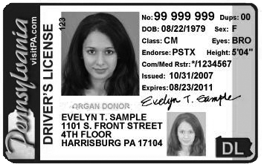

**A COPY OF VALID GOVERNMENT ISSUED PHOTO IDENTIFICATION MUST BE ATTACHED TO COMPLETE THIS APPLICATION.**

Name Date Address City State Zip **Social Security # (mandatory with LexisNexis or upon request)** Cell Phone Business Phone E-mail Address: Date of Birth Occupation Employer Address Special professional training, skills, hobbies:

Community affiliations (Clubs, Service Organizations, etc.):

Previous volunteer experience (including baseball/softball and year):

Do you have children in the program? Yes No If yes, list full name and what level? Special Certification (CPR, Medical, etc.): Do you have a valid driver's license: Yes No

Driver's License#: State Have you ever been convicted of or plead guilty to any crime(s): Yes No

If yes, describe each in full:

Are there any criminal charges pending against you regarding any crime(s) involving

or against a minor? Yes No If yes, describe each in full:

Have you ever been refused participation in any other youth programs? Yes No If yes, explain:

In which of the following would you like to participate? (Check one or more.) League Official Coach Umpire Field Maintenance Manager Scorekeeper Concession Stand Other

10

Please list three references, at least one of which has knowledge of your participation as

a volunteer in a youth program:

**Name/Phone**

AS A CONDITION OF VOLUNTEERING, I give permission for the Little League organization to conduct background check(s) on me now and as long as I continue to be active with the organization, which may include a review of sex offender registries, child abuse and criminal history records. I understand that, if appointed, my position is

conditional upon the league receiving no inappropriate information on my background. I hereby release and agree to hold harmless from liability the local Little League, Little League Baseball, Incorporated, the officers, employees and volunteers thereof, or any other person or organization that may provide such information. I also understand that, regardless of previous appointments, Little League is not obligated to appoint me to a volunteer position. If appointed, I understand that, prior to the expiration of my term,

I am subject to suspension by the President and removal by the Board of Directors for violation of Little League policies or principles.

Applicant Signature Date If Minor/Parent Signature Date

Applicant Name(please print or type)

*NOTE: The local Little League and Little League Baseball, Incorporated will not discriminate*

*against any person on the basis of race, creed, color, national origin, marital status, gender, sexual orientation or disability.*

**LOCAL LEAGUE USE ONLY:**

Background check completed by league officer on

System)s) used for background check (minimum of one must be checked):

Sex Offender Registry Criminal History Records *LexisNexis

*\*Please be advised that if you use LexisNexis and there is a name match in the few states where only name match searches can be performed you should notify volunteers that they will receive a letter directly from LexisNexis in compliance with the Fair Credit Reporting Act containing informa- tion regarding all the criminal records associated with the name, which may not necessarily be the league volunteer.*

***Only attach to this application copies of background check reports that reveal convictions of this application.***

1-02-11-VOLUNTEER APPLICATION 3/28/11

**Asthma Emergency Signs**

##### Seek Emergency Care If A Child Experiences Any Of The Following:

**+ Child’s wheezing or coughing does not improve after taking medicine (15-20 minutes for most asthma medications)**

**+ Child’s chest or neck is pulling in while struggling to breathe**

**+ Child has trouble walking or talking**

**+ Child stops playing and cannot start again**

**+ Child’s fingernails and/or lips turn blue or gray**

**+ Skin between child’s ribs sucks in when breathing**

**Asthma is different for every person.**

The “Asthma Emergency Signs” above represent general emergency situations as per the National Asthma Education and Prevention Program 1997 Expert Panel Report.

If you are at all uncertain of what to do in case of a breathing emergency...

**Call 9-1-1 and the child’s parent/guardian!**

**Michigan Asthma Steering Committee of the Michigan Department of Community Health**

**(From the Grandville, Mich., Little League 2001 Safety Plan)**

Make



























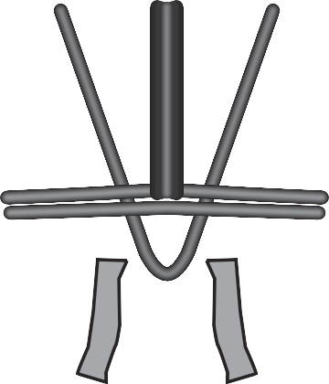





Sure They Are Safe!

**“Dangling”**

REMEMBER:

Catchers must wear helmets during warm-ups and infield/outfield practice.

**RULE 1.17**

“...All catchers must wear a mask, ‘dangling’ type throat protector and catcher's helmet during infield/outfield practice, pitcher warm-up and games.”

**Emergency Treatment of Athletic Dental Injuries**

|  |
| --- |
| **LUXATION (Tooth in Socket, But Wrong Position)** |
| THREE POSITIONS  **EXTRUDED TOOTH** - Upper tooth hangs down and/or lower tooth raised up.   1. Reposition tooth in socket using firm finger pressure. 2. Stabilize tooth by gently biting on towel or hand- kerchief.   **3. TRANSPORT IMMEDIATELY TO DENTIST.**  **LATERAL DISPLACEMENT** - Tooth pushed back or pulled forward.   1. Try to reposition tooth using finger pressure. 2. Athlete may require local anesthetic to reposi- tion tooth; if so, stabilize tooth by gently biting on towel or handkerchief.   **3. TRANSPORT IMMEDIATELY TO DENTIST.**  **INTRUDED TOOTH** - Tooth pushed into gum - looks short.  1. Do nothing - avoid any repositioning of tooth.  **2. TRANSPORT IMMEDIATELY TO DENTIST.** |
| **FRACTURE (Broken Tooth)** |
| 1. If tooth is totally broken in half, save the broken portion and bring to the dental office as described under Avulsion, Item 4. Stabilize portion of tooth left in mouth by gently biting on towel or handker- chief to control bleeding. 2. Should extreme pain occur, limit contact with other teeth, air or tongue. Pulp nerve may be exposed, which is extremely painful to athlete. 3. Save all fragments of fractured tooth as described under Avulsion, Item 4. 4. **IMMEDIATELY TRANSPORT PATIENT AND TOOTH FRAGMENTS TO DENTIST.** |

***Pulp Canal (root canal)***

***Pulp (nerves, blood vessels)***

***Dentin Enamel***

**Root**

**Crown**

***Professionally-made, properly fitted Custom Mouthguards greatly reduce the risk and severity of mouth injuries. Mouthguards are recommended injury prevention equipment for all at-risk sports.***

**AVULSION (Entire Tooth Knocked Out)**

1. Avoid additional trauma to tooth while handling.  **Do Not** handle tooth by the root. **Do Not** brush or scrub tooth. **Do Not** sterilize tooth.
2. If debris is on tooth, *gently* rinse with water.
3. If possible, reimplant and stabilize by biting down gently on a towel or handkerchief. Do only if athlete is alert and conscious.
4. If unable to reimplant:

Best - Place tooth in Hank’s Balanced Saline Solution, i.e. “Save-a-tooth.”

2nd best - Place tooth in milk. Cold whole milk is best, followed by cold 2% milk.

3rd best - Wrap tooth in saline-soaked gauze. 4th best - Place tooth under athlete’s tongue. Do this ONLY if athlete is conscious and alert.

5th best - Place tooth in cup of water.

1. Time is very important. Reimplantation within 30

**Academy for Sports Dentistry**

**875 North Michigan Ave.**

**Suite 4040**

**Chicago, IL 60611-1901**

**1800-273-1788**

**1800-ASD-1788**

The Academy for Sports Dentistry, a professional organization dedicated to the dental needs of ath- letes at risk to sports injuries, recommends that every sports medicine team include a dentist knowledgeable in sports dentistry.

minutes has the highest degree of success rate.

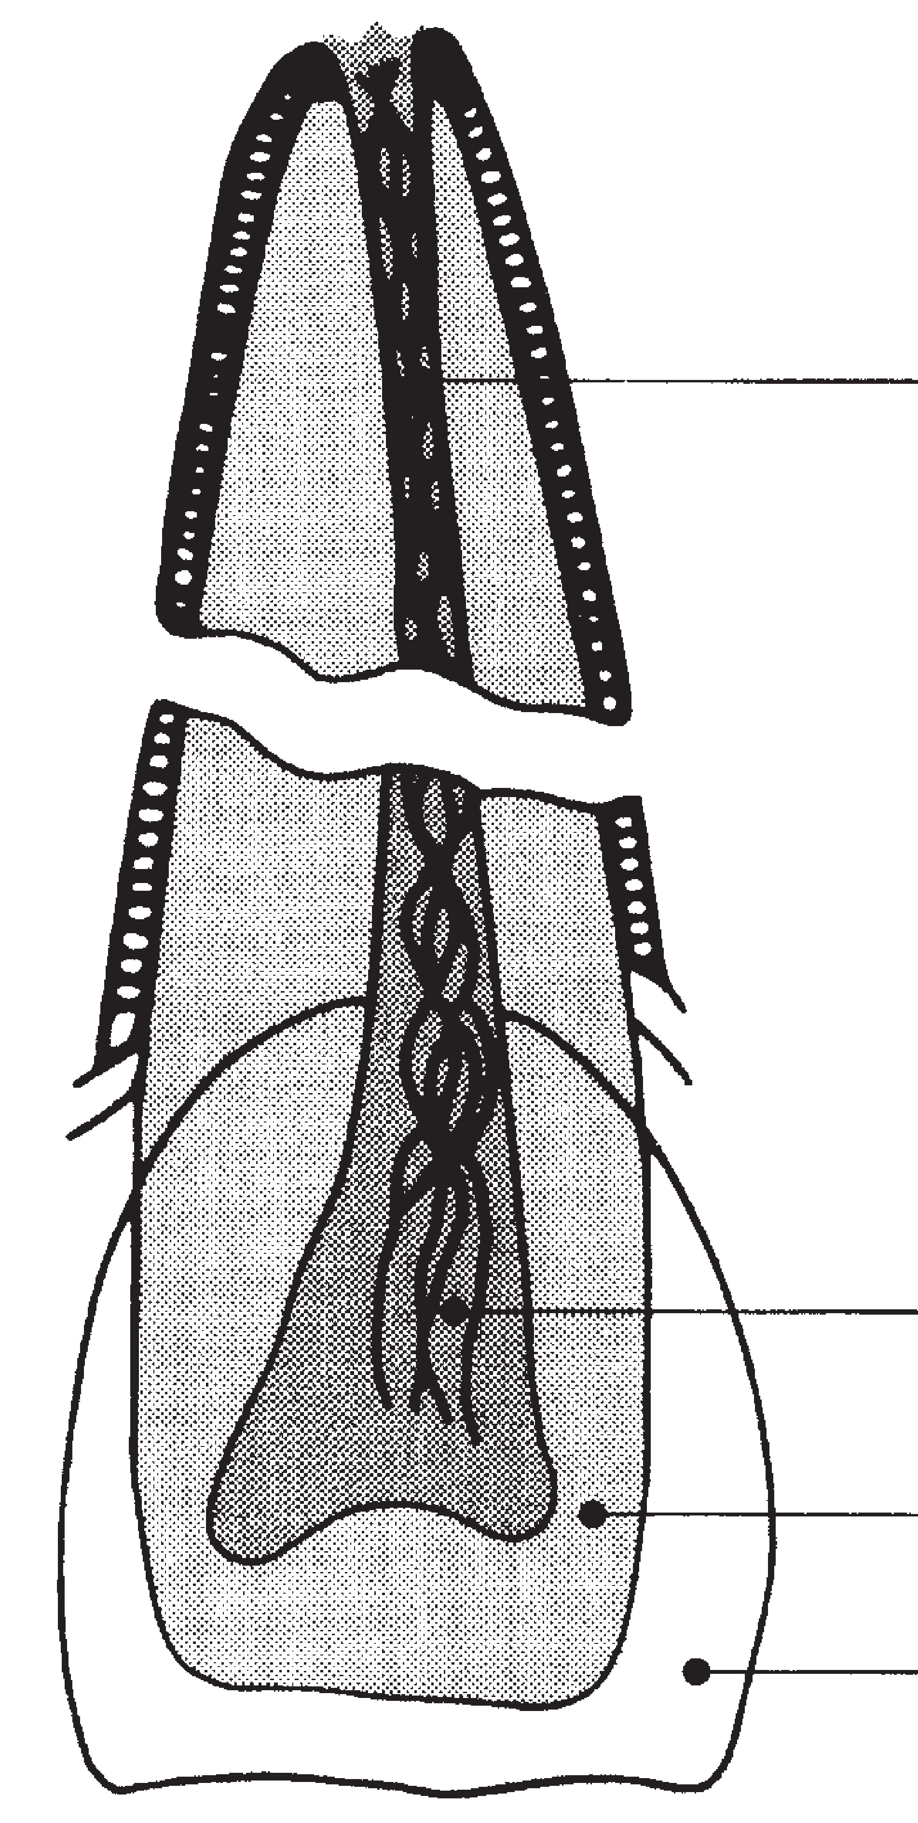

**TRANSPORT IMMEDIATELY TO DENTIST.**

***MOUTHGUARDS SHOULD NOT BE***

***OPTIONAL EQUIPMENT***

© 1996 Little League Baseball® and Musco Lighting, Inc.

Drinking Guidelines For Hot Day Activities

**Before:** Drink 8 oz. immediately before exercise **During:** Drink at least 4 oz. every 20 minutes **After:** Drink 16 oz. for every pound of weight lost



**Dehydration signs:** Fatigue, flushed skin, light-headed **What to do:** Stop exercising, get out of sun, drink **Severe signs:** Muscle spasms, clumsiness, delirium

### If You See It, Flee It;

If You Hear It, Clear It

REMEMBER:

* Track approaching storms the best way possible: Internet radar websites, dedicated storm warning system at field, or other storm warnings
* Evacuate fields when storms are about 10 miles away: Have players and spectators go to enclosed building or to cars with windows rolled up
* Clear fields immediately after thunder has been heard or lightning seen!

PLEASE WAIT!

* Wait 30 minutes before returning to play after last sign of lightning activity in your area
* Cars shouldn’t leave until the game is called, so all players can be accounted for

*Guidelines from the National Oceanic and Atmospheric Administration’s (NOAA) National Weather Service*

Copy and post at dugouts. 15

HAVE YOU:

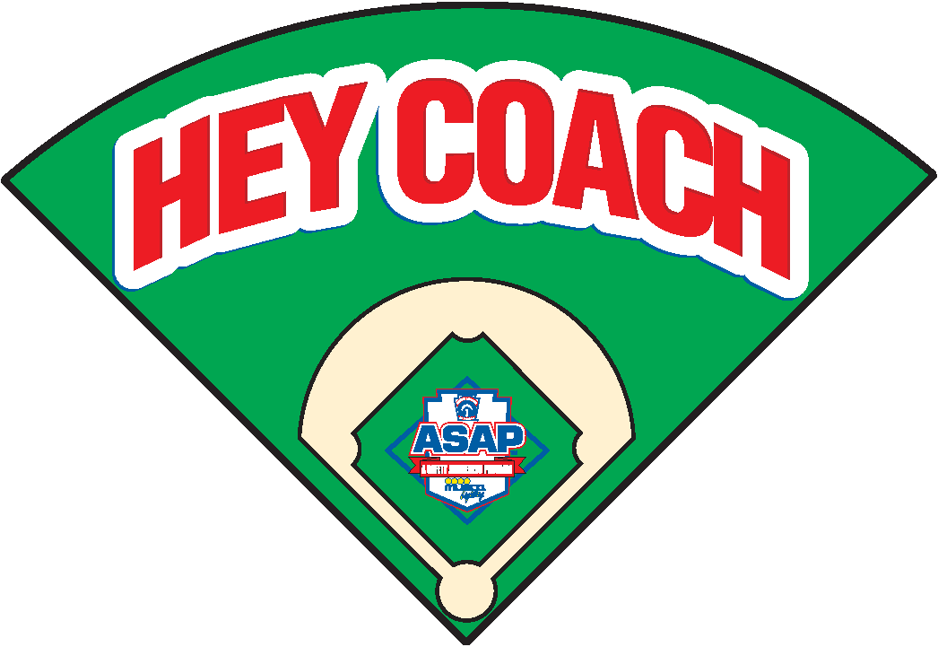

 Walked field for debris/foreign objects  Inspected helmets,bats,catchers' gear  Made sure a First Aid kit is available

 Checked conditions of fences,backstops, bases and warning track

 Made sure a working telephone is available  Held a warm-up drill

-16

## Coach, Please



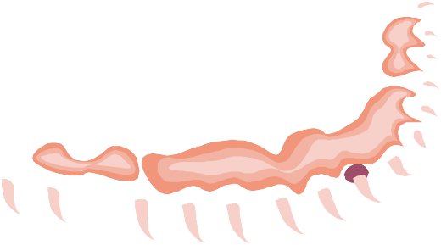

Copy and post at dugouts.

Let Players Catch!

REMEMBER:

###### Coaches and managers must not warm up pitchers. Let Players Catch.

**RULE 3.09**

“...Managers or coaches must not warm up a pitcher at home plate or in the bull pen or elsewhere at any time. They may, however, stand to observe a pitcher during warm-up in the bull pen.”

**6 March 2003** 17

**Little League Baseball and Softball Online**



> Little League Online > Parents > Using Steroids = Cheating

**Using Steroids = Cheating**

**Parents:** Little League International offers the information below regarding the use of performance-enhancing drugs by athletes. Please have your Little Leaguers read this, and then talk with them about it. For more information, please read Little League’s position statement on the use of steroids and steroid precursors.

**Children’s doctors agree:** there are no shortcuts to success.

If you like to watch or read about sports, you might know that certain drugs called anabolic steroids have been in the news a lot lately. Anabolic steroids are pills or injected drugs that are sometimes used by athletes who want to gain an unfair advantage over their competition. While steroids may help some people grow quickly, they are known to cause very serious health problems for those who use them.

Little League is against its players using these drugs and other supplements in an attempt to improve ability. Now a major health organization, the American Academy of Pediatrics (AAP), a group of more than 60,000 children’s doctors, is making sure parents and volunteers know how to help young athletes stay away from steroids.

The AAP reminds kids that “many factors help determine athletic ability … including diet and how hard an athlete trains.” Th AAP says that the medical dangers of steroid use far outweigh the advantage of gains in strength or muscle mass.

“Success in sports takes talent, skill and most of all, practice and hard work,” says the AAP. “Using steroids is a form of cheating and interferes with fair competition.”

There are many healthy ways to increase your strength or improve your appearance. Even if you don’t expect to play high school, college or pro sport someday, keep the following tips in mind:

Train safely, without using drugs.

Eat a healthy diet.

Get plenty of rest.

Set realistic goals and be proud of yourself when you reach them.

Seek out training supervision, coaching and advice from a reliable professional or volunteer.

Avoid injuries by playing safely and using protective gear.

Talk to your pediatrician about nutrition, your health, preventing injury and safe ways to gain strength.

Share this information with friends and teammates.

To be a truly great athlete and maintain your health, use your natural ability to work hard in practice and concentrate on developing your skills. There are no shortcuts to success on the field or off it.

Copyright © 2003-2013 Little League. All Rights Reserved. | Trademark | Privacy Policy | Text and Images| Site Map

2018 Sonoma Little League Safety Plan

**ACCIDENT REPORTING PROCEDURE**

1. *WHAT to report.*

An incident that causes any player, manager, coach, umpire or volunteer to receive medical treatment and/or first aid must be reported to the Safety Officer, Player Agent or League President. This includes even passive treatments such as the evaluation and diagnosis of the extent of the injury or periods of rest.

1. *WHEN to report.*

All such incidents described above must be reported to the Safety Officer, Player Agent or League President within 24 hours of the incident.

1. HOW to make the report.

Reporting incidents can come in a variety of forms. Typically, they are telephone conversations. At a minimum, the following information must be provided:

* + Name and phone number of the individual involved.
  + Date, time and location of the incident.
  + Detailed description of the incident.
  + Preliminary estimation of the extent of any injuries.
  + Name and phone number of the person reporting the injury.

**OVERUSE INJURY REPORT**

|  |
| --- |
| ***Directions:*** Managers must fill out this form if a player reports pain that prevents participation in athletic activities. This report must be submitted to the Safety Officer, Player Agent or League President immediately. |
| **INJURED PLAYER’S BACKGROUND INFORMATION** |
| Name: |
| Date of Birth: |
| Phone Numbers: |
| Manager: |
| Team Name: |
| **INJURY INFORMATION** |
| Description: |
| Date Injury Reported: |
| Actions Taken: |
| Manager’s Signature: Date Submitted to SLL: |
| **FOLLOW-UP (to be completed by Safety Officer)** |
| Update on Condition: |
| Safety Officer Signature: Date: |

**A Safety Awareness Program’s Incident/Injury Tracking Report**

**Activities/Reporting**

League Name:

League ID: - -

Incident Date:

Field Name/Location:

❒

❒

Incident Time:

Injured Person’s Name: Address: City: State ZIP: Parent’s Name (If Player):

Date of Birth:

Age: Sex: Male Female Home Phone: ( ) Work Phone ( )

Parents’ Address (If Different):

**Incident occurred while participating in:**

❒

❒

❒

❒

❒

❒

❒

❒

❒

City

|  |  |  |  |  |  |
| --- | --- | --- | --- | --- | --- |
| **A.)** | Baseball | Softball | Challenger | TAD |  |
| **B.)**  **C.)** | Challenger Senior (14-16) Tryout | T-Ball (5-8)  Big League (16-18) Practice | Minor (7-12)  Game | Major (9-12)  Tournament | Junior (13-14)  Special Event |

Travel to Travel from Other (Describe):

❒

❒

❒

❒

❒

❒

❒

❒

❒

❒

**Position/Role of person(s) involved in incident:**

❒

❒

❒

❒

❒

❒

|  |  |  |  |  |  |  |
| --- | --- | --- | --- | --- | --- | --- |
| **D.)** | Batter | Baserunner | Pitcher | Catcher | First Base | Second |
|  | Third | Short Stop | Left Field | Center Field | Right Field | Dugout |

Umpire Coach/Manager Spectator Volunteer Other:

❒

❒

❒

❒

❒

❒

❒

❒

❒

❒

❒

**Type of injury:**

**Was first aid required?** Yes No If yes, what:

❒

❒

**Was professional medical treatment required?** Yes No If yes, what: (If yes, the player must present a non-restrictive medical release prior to being allowed in a game or practice.)

❒

❒

|  |  |  |  |  |
| --- | --- | --- | --- | --- |
| **Type of incident and location:** |  | | | |
| **A.)** On Primary Playing Field  Base Path: Running *or* | Sliding |  | **B.)** Adjacent to Playing Field Seating Area | **D.)** Off Ball Field Travel: |
| Hit by Ball: Pitched *or* | Thrown *or* | Batted | Parking Area | Car *or* Bike *or* |
| Collision with: Player *or* | Structure |  | **C.)** Concession Area | Walking |

Grounds Defect Volunteer Worker League Activity

❒

❒

❒

❒

❒

❒

❒

❒

❒

❒

❒

❒

❒

❒

❒

❒

❒

❒

❒

❒

❒

Other:

❒

Customer/Bystander Other:

**Please give a short description of incident: _____________________________________________________**

**Could this accident have been avoided? How:**

This form is for Little League purposes only, to report safety hazards, unsafe practices and/or to contribute posi- tive ideas in order to improve league safety. When an accident occurs, obtain as much information as possible. For all claims or injuries which could become claims, please fill out and turn in the official Little League Baseball Accident Notification Form available from your league president and send to Little League Headquarters in Williamsport (Attention: Dan Kirby, Risk Management Department). Also, provide your District Safety Officer with a copy for District files. All personal injuries should be reported to Williamsport as soon as possible.

Prepared By/Position: Signature:

Phone Number: ( ) Date:

**LITTLE LEAGUE**

**BASEBALL AND SOFTBALL**

**Send Completed Form To:**

**®** Little League

®

International

**ACCIDENT NOTIFICATION FORM**



**INSTRUCTIONS**

539 US Route 15 Hwy, PO Box 3485

Williamsport PA 17701-0485

**Accident Claim Contact Numbers:**

Phone: 570-327-1674 Fax: 570-326-9280

1. This form must be completed by parents (if claimant is under 19 years of age) and a league official and forwarded to Little League Headquarters within 20 days after the accident. A photocopy of this form should be made and kept by the claimant/parent. Initial medical/ dental treatment must be rendered within 30 days of the Little League accident.
2. Itemized bills including description of service, date of service, procedure and diagnosis codes for medical services/supplies and/or other documentation related to claim for benefits are to be provided within 90 days after the accident date. In no event shall such proof be furnished later than 12 months from the date the medical expense was incurred.
3. When other insurance is present, parents or claimant must forward copies of the Explanation of Benefits or Notice/Letter of Denial for each charge directly to Little League Headquarters, even if the charges do not exceed the deductible of the primary insurance program.
4. Policy provides benefits for eligible medical expenses incurred within 52 weeks of the accident, subject to Excess Coverage and Exclusion provisions of the plan.
5. ***Limited*** deferred medical/dental benefits may be available for necessary treatment incurred after 52 weeks. Refer to insurance brochure provided to the league president, or contact Little League Headquarters within the year of injury.
6. Accident Claim Form must be fully completed - including Social Security Number (SSN) - for processing.

League Name League I.D.

Name of Injured Person/Claimant SSN

PART 1

Date of Birth (MM/DD/YY)

Age

Sex

D Female D Male

Name of Parent/Guardian, if Claimant is a Minor Home Phone (Inc. Area Code) Bus. Phone (Inc. Area Code)

( ) ( )

Address of Claimant Address of Parent/Guardian, if different

The Little League Master Accident Policy provides benefits in **excess** of benefits from other insurance programs subject to a $50 deductible per injury. "Other insurance programs" include family's personal insurance, student insurance through a school or insurance through an employer for employees and family members. Please CHECK the appropriate boxes below. If YES, follow instruction 3 above.

Does the insured Person/Parent/Guardian have any insurance through: Employer Plan Yes No School Plan Yes No

D

D

D

D

Individual Plan Yes No Dental Plan Yes No

D

D

D

D

Date of Accident Time of Accident Type of Injury

DAM DPM

Describe exactly how accident happened, including playing position at the time of accident:

Check all applicable responses in **each** column:

D BASEBALL

D SOFTBALL

D CHALLENGER

D T-BALL

(4-18)

(4-7)

(5-18)

(5-8)

(7-12)

D PLAYER

D MANAGER, COACH

D TRYOUTS

D PRACTICE

D SPECIAL EVENT (NOT GAMES)

D CHALLENGER

D MINOR

(6-12)

D VOLUNTEER UMPIRE

D SCHEDULED GAME D SPECIAL GAME(S)

D TAD (2ND SEASON) D LITTLE LEAGUE(9-12)

D INTERMEDIATE (50/70) (11-13)

JUNIOR (13-14)

SENIOR (14-16)

BIG LEAGUE (16-18)

D JUNIOR (12-14)

D SENIOR (13-16)

BIG (14-18)

D PLAYER AGENT

D OFFICIAL SCOREKEEPER

D SAFETY OFFICER

D VOLUNTEER WORKER

D TRAVEL TO

D TRAVEL FROM

D TOURNAMENT

D OTHER (Describe)

(Submit a copy of your approval from Little League Incorporated)

I hereby certify that I have read the answers to all parts of this form and to the best of my knowledge and belief the information contained is complete and correct as herein given.

I understand that it is a crime for any person to intentionally attempt to defraud or knowingly facilitate a fraud against an insurer by submitting an application or filing a claim containing a false or deceptive statement(s). See Remarks section on reverse side of form.

I hereby authorize any physician, hospital or other medically related facility, insurance company or other organization, institution or person that has any records or knowledge of me, and/or the above named claimant, or our health, to disclose, whenever requested to do so by Little League and/or National Union Fire Insurance Company of Pittsburgh, Pa. A photostatic copy of this authorization shall be considered as effective and valid as the original.

Date

Date

Claimant/Parent/Guardian Signature (In a two parent household, both parents must sign this form.Claimant/Parent/Guardian Signature

**For Residents of California:**

Any person who knowingly presents a false or fraudulent claim for the payment of a loss is guilty of a crime and may be subject to fines and confinement in state prison.

**For Residents of New York:**

Any person who knowingly and with the intent to defraud any insurance company or other person files an application for insurance or statement of claim containing any materially false information, or conceals for the purpose of misleading, information concerning any fact material thereto, commits a fraudulent insurance act, which is a crime, and shall also be subject to a civil penalty not to exceed five thousand dollars and the stated value of the claim for each such violation.

**For Residents of Pennsylvania:**

Any person who knowingly and with intent to defraud any insurance company or other person files an application for insurance or statement of claim containing any materially false information or conceals for the purpose of misleading, information concerning any fact material thereto commits a fraudulent insurance act, which is a crime and subjects such person to criminal and civil penalties.

**For Residents of All Other States:**

Any person who knowingly presents a false or fraudulent claim for payment of a loss or benefit or knowingly presents false information in an application for insurance is guilty of a crime and may be subject to fines and confinement in prison.

**PART 2 - LEAGUE STATEMENT (Other than Parent or Claimant)**

|  |  |  |
| --- | --- | --- |
| Name of League | Name of Injured Person/Claimant | League I.D. Number |
| Name of League Official | | Position in League |
| Address of League Official | | Telephone Numbers (Inc. Area Codes)  Residence: ( )  Business: ( )  Fax: ( ) |

Were you a witness to the accident? DYes DNo

Provide names and addresses of any known witnesses to the reported accident.

Check the boxes for all appropriate items below. At least one item in each column must be selected.

**POSITION WHEN INJURED**

**INJURY**

**PART OF BODY**

**CAUSE OF INJURY**

|  |  |  |  |  |  |  |  |  |  |  |  |
| --- | --- | --- | --- | --- | --- | --- | --- | --- | --- | --- | --- |
| D | 01 | 1ST | D | 01 | ABRASION | D | 01 | ABDOMEN | D | 01 | BATTED BALL |
| D | 02 | 2ND | D | 02 | BITES | D | 02 | ANKLE | D | 02 | BATTING |
| D | 03 | 3RD | D | 03 | CONCUSSION | D | 03 | ARM | D | 03 | CATCHING |
| D | 04 | BATTER | D | 04 | CONTUSION | D | 04 | BACK | D | 04 | COLLIDING |
| D | 05 | BENCH | D | 05 | DENTAL | D | 05 | CHEST | D | 05 | COLLIDING WITH FENCE |
| D | 06 | BULLPEN | D | 06 | DISLOCATION | D | 06 | EAR | D | 06 | FALLING |
| D | 07 | CATCHER | D | 07 | DISMEMBERMENT | D | 07 | ELBOW | D | 07 | HIT BY BAT |
| D | 08 | COACH | D | 08 | EPIPHYSES | D | 08 | EYE | D | 08 | HORSEPLAY |
| D | 09 | COACHING BOX | D | 09 | FATALITY | D | 09 | FACE | D | 09 | PITCHED BALL |
| D | 10 | DUGOUT | D | 10 | FRACTURE | D | 10 | FATALITY | D | 10 | RUNNING |
| D | 11 | MANAGER | D | 11 | HEMATOMA | D | 11 | FOOT | D | 11 | SHARP OBJECT |
| D | 12 | ON DECK | D | 12 | HEMORRHAGE | D | 12 | HAND | D | 12 | SLIDING |
| D | 13 | OUTFIELD | D | 13 | LACERATION | D | 13 | HEAD | D | 13 | TAGGING |
| D | 14 | PITCHER | D | 14 | PUNCTURE | D | 14 | HIP | D | 14 | THROWING |
| D | 15 | RUNNER | D | 15 | RUPTURE | D | 15 | KNEE | D | 15 | THROWN BALL |
| D | 16 | SCOREKEEPER | D | 16 | SPRAIN | D | 16 | LEG | D | 16 | OTHER |
| D | 17 | SHORTSTOP | D | 17 | SUNSTROKE | D | 17 | LIPS | D | 17 | UNKNOWN |
| D | 18 | TO/FROM GAME | D | 18 | OTHER | D | 18 | MOUTH |  |  |  |
| D | 19 | UMPIRE | D | 19 | UNKNOWN | D | 19 | NECK |  |  |  |
| D | 20 | OTHER | D | 20 | PARALYSIS/ | D | 20 | NOSE |  |  |  |
| D | 21 | UNKNOWN |  |  | PARAPLEGIC | D | 21 | SHOULDER |  |  |  |
| D | 22 | WARMING UP |  |  |  | D | 22 | SIDE |  |  |  |
|  |  |  |  |  |  | D | 23 | TEETH |  |  |  |
|  |  |  |  |  |  | D | 24 | TESTICLE |  |  |  |
|  |  |  |  |  |  | D | 25 | WRIST |  |  |  |
|  |  |  |  |  |  | D | 26 | UNKNOWN |  |  |  |
|  |  |  |  |  |  | D | 27 | FINGER |  |  |  |

Does your league use batting helmets with attached face guards? DYES DNO

Does your league use breakaway bases on: DALL DSOME DNONE of your fields?

If YES, are they DMandatory or DOptional At what levels are they used?

I hereby certify that the above named claimant was injured while covered by the Little League Baseball Accident Insurance Policy at the time of the reported accident. I also certify that the information contained in the Claimant's Notification is true and correct as stated, to the best of my knowledge.

Date League Official Signature 23

2019 Sonoma Little League Safety Plan

**SNACK BAR SAFETY CHECKLIST**

1. Ensure all workers wash their hands before handling food.
2. Instruct workers that the “money handlers” should not handle unwrapped food items.
3. All workers should know where the fire extinguisher is and know how to use it.
4. All workers should know where the first aid kit and extra ice packs are located.
5. All tripping hazards should be cleared.
6. Items stored on shelves should be secured.
7. Regularly inspect for frayed or damaged cords. Multi-prong adapters should not be used. Power strips are acceptable.
8. Food items should be kept at their proper temperature. No cooked items or opened food items shall be restored. These items should be thrown away at the end of daily operations.

24

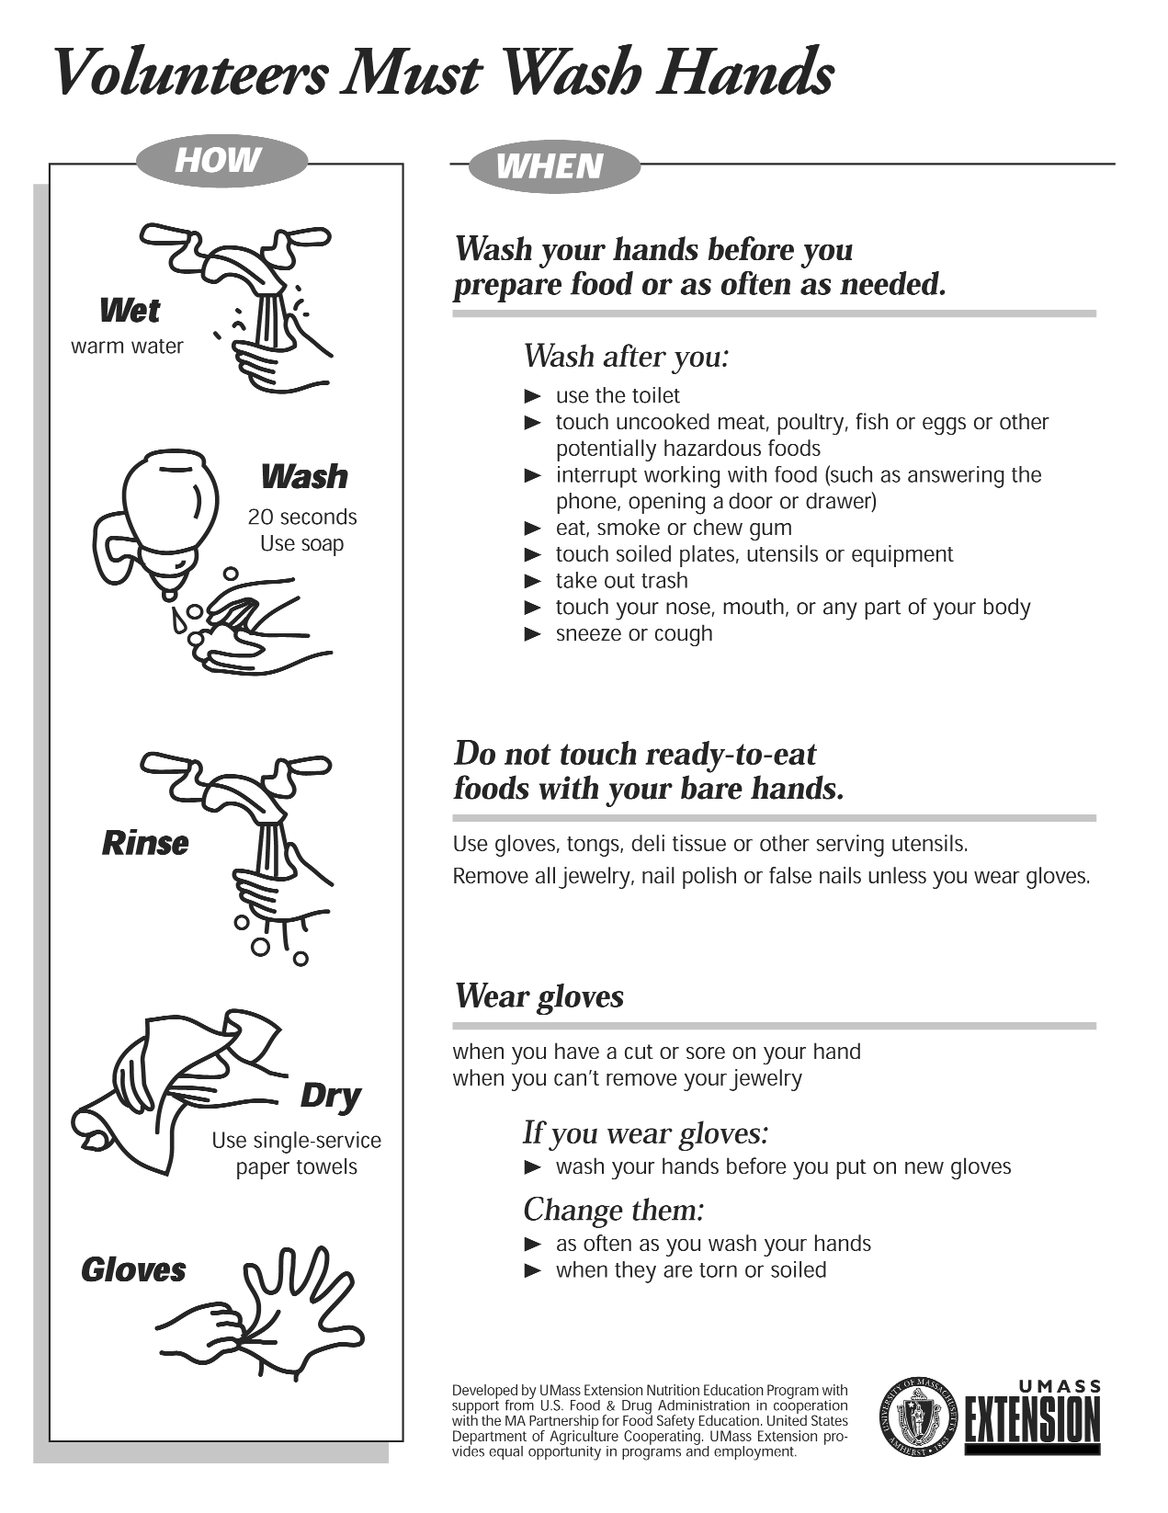

.

*25*

***Sport Parent Code of Conduct***

We, the Little League, have implemented the following Sport Parent Code of Conduct for the important message it holds about the proper role of parents in supporting their child in sports. Parents should read, understand and sign this form prior to their children participating in our league.

Any parent guilty of improper conduct at any game or practice will be asked to leave the sports facility and be suspended from the following game. Repeat violations may cause a multiple game suspension, or the season forfeiture of the privilege of attending all games.

***Preamble***

The essential elements of character-building and ethics in sports are embodied in the concept of sportsmanship and six core principles:

* Trustworthiness,
* Respect,
* Responsibility,
* Fairness,
* Caring, and
* Good Citizenship.

The highest potential of sports is achieved when competition reflects these “six pillars of character.”

***I therefore agree:***

1. I will not force my child to participate in sports.
2. I will remember that children participate to have fun and that the game is for youth, not adults.
3. I will inform the coach of any physical disability or ailment that may affect the safety of my child or the safety of others.
4. I will learn the rules of the game and the policies of the league.
5. I (and my guests) will be a positive role model for my child and encourage sportsmanship by showing respect and courtesy, and by demonstrating positive support for all players, coaches, officials and specta- tors at every game, practice or other sporting event.
6. I (and my guests) will not engage in any kind of unsportsmanlike conduct with any official, coach, player, or parent such as booing and taunting; refus- ing to shake hands; or using profane language

or gestures.

1. I will not encourage any behaviors or practices that would endanger the health and well being of the athletes.
2. I will teach my child to play by the rules and to resolve conflicts without resorting to hostility or violence.
3. I will demand that my child treat other players, coaches, officials and spectators with respect regardless of race, creed, color, sex or ability.
4. I will teach my child that doing one’s best is more important than winning, so that my child will never feel defeated by the outcome of a game or

his/her performance.

1. I will praise my child for competing fairly and trying hard, and make my child feel like a winner every time.
2. I will never ridicule or yell at my child or other participants for making a mistake or losing a competition.
3. I will emphasize skill development and practices and how they benefit my child over winning. I will also de-emphasize games and competition in the lower age groups.
4. I will promote the emotional and physical well- being of the athletes ahead of any personal desire I may have for my child to win.
5. I will respect the officials and their authority during games and will never question, discuss, or confront coaches at the game field, and will take time to speak with coaches at an agreed upon time

and place.

1. I will demand a sports environment for my child that is free from drugs, tobacco, and alcohol and I will refrain from their use at all sports events.
2. I will refrain from coaching my child or other players during games and practices, unless I am one of the official coaches of the team.

Parent/Guardian Signature

26

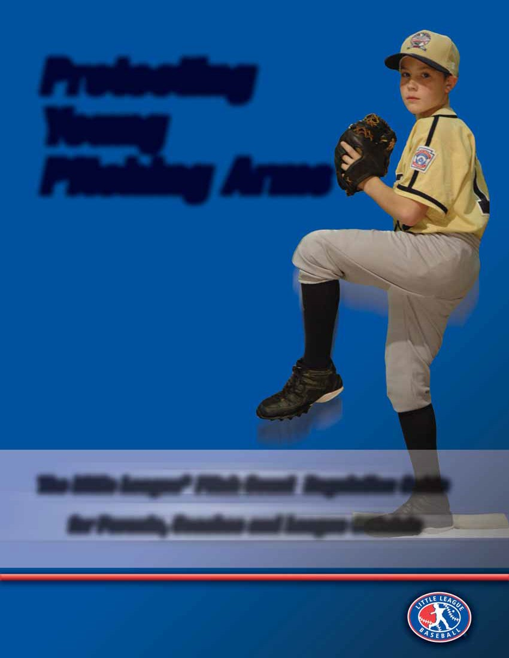























































































































































































































































































































































































27





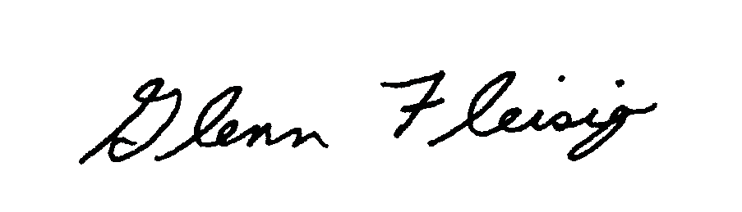

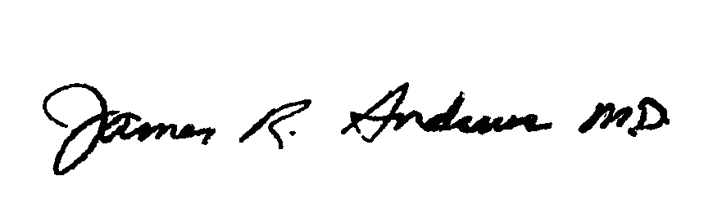



www.asmi.org

Baseball is a great sport, and Little League continues to be one of the premier youth

However in the mid-1990’s (when today’s Little Leaguers were born), we

organizations.

For

started to notice an alarming increase in serious injuries in adolescent pitchers.

example during the last five years of the 1990’s, 21 of the 190 “Tommy John” surgeries

at our center were high school age pitchers or younger; however during the first five

years of this decade, 124 of our 627 “Tommy John” surgeries were high school age

This alarming trend was also happening for other types of pitching

pitchers or younger.

injuries.

Anecdotally it’s believed that the rise in injuries is due to increased amounts of pitching

To determine if this was true, our American Sports Medicine Institute

at a younger age.

conducted a series of scientific studies with support and cooperation from USA Baseball,

We followed hundreds of youth

Little League Baseball, and Major League Baseball.

baseball pitchers, and monitored arm problems and potential contributing factors

including pitch counts, types of pitches, quality of mechanics, and other factors.

The

scientific results confirmed that the number of pitches thrown was the most significant

Another study compared our young, surgery patients with

contributor to arm problems.

healthy adolescent pitchers and found that young pitchers who often pitched past the

Another risk

point of fatigue were 36 times more likely to end up on the surgery table.

factor was year-round baseball without sufficient rest (the data suggested at least four

Other risk factors included participating in

months a year away from throwing).

Of course ball velocity is valuable for

showcases, and throwing with high ball velocity.

all pitchers, but we believe that there is too much emphasis on ball speed instead of on

quality of mechanics, speed variation, and control, in today’s “radar gun” generation.

Details about these scientific studies can be found at asmi.org.

Little League Baseball has been the leader in recognizing the rise in injuries and has

Some issues – such as

taken dramatic steps to make baseball safe for young players.

showcases and participation in independent traveling teams – may be beyond Little

League’s control, but Little League has embraced the pitch count research and boldly

28

We applaud Little League for their continued effort to insure that their

altered their rules.

game is as safe and enjoyable as possible for you and your children.

Glenn S. Fleisig, Ph.D.

ASMI Research Director

James R. Andrews, M.D.

ASMI Medical Director



Contents

Introduction: Goal of New Little League Regulation: Protecting Pitchers’ Arms 2

The New Pitch Count Regulation 3

Regular Season – Baseball Only 3

Regulation VI – Pitchers 3

Tournament Rule – Baseball Only 4

Twenty Questions on the Pitch Count 5

Best Practices of the Pitch Count Pilot Program 7

Conclusions 8

Pitching Fundamentals By Nicholas Caringi 9

The Starting Position 9

The Delivery 10

Drills 12

Eight Essentials of Post-Pitching Recovery By Jim Ronai MS, PT, ATC, CSCS 13

Pitching Eligibility Form 15

Pitching Log 16

Little League Field Centers........................................................................................Inside Back Cover

***Copyright 2007, Little League Baseball, Incorporated. All rights reserved.*** 29

INTRODUCTION

GOAL OF NEW LITTLE LEAGUE REGULATION: PROTECTING PITCHERS’ ARMS

Little League Baseball has changed its decades-old pitching rules, making the actual number of pitches delivered the deciding factor in determining eligibility in the baseball division.

Twenty copies of this publication, “Protecting Young Pitching Arms: The Little League Pitch Count Regulation Guide for Parents, Coaches and League Officials,” are being provided at no charge to more than 7,000 local Little League programs worldwide. The goal of this publication is to reach as many parents and volunteers as possible, so that everyone will know the benefits and their responsibilities in making this regulation work.

Inside, you’ll find helpful questions and answers about the new regulation, as well as the regular season regulation and the rule to be used in the International Tournament. It also includes great advice from respected medical professionals on the care and conditioning of the pitching arm, and the best ideas from the thousands of Little League volunteers who have successfully used “pitch counts” in their local Little Leagues during the past year or two.

Starting with the 2007 season, pitchers in all divisions of Little League, from age 7 to 18, will have specific limits for each game, based on their age. The number of pitches delivered in a game will determine the amount of rest the player must have before pitching again.

“Little League has a rich history of pioneering baseball safety innovations,” said Stephen D. Keener, president and chief executive officer of Little League Baseball and Softball. “As the world’s largest organized youth sports program, Little League is proud to take a leadership position in youth sports safety.”

There are about 2.3 million players in the baseball divisions of Little League worldwide. There are nearly 400,000 female softball players, but the new regulations will not apply to softball.

For all of Little League Baseball’s history, and for the history of amateur youth baseball in general, pitching regulations have used innings pitched to determine pitcher eligibility. Recently, researchers and medical professionals in the field of sports medicine have been working to determine if the actual number of pitches thrown (i.e., pitch count) is a better way to regulate pitching in youth baseball.

Most notable among those calling for pitch counts has been Dr. James R. Andrews, M.D., medical director at the American Sports Medicine Institute (ASMI) in Birmingham, Ala. Dr. Andrews is the world’s foremost authority on pitching injuries and ulnar collateral ligament reconstruction, or, as it is better known, “Tommy John surgery.” The ASMI and the USA Baseball Medical and Safety Advisory Committee have worked closely with Little League to create the guidelines for the new regulation.

“This is one of the most important injury prevention steps ever initiated in youth baseball by the leader in youth baseball,” Dr. Andrews said. “It is certain to serve as the youth sports injury prevention cornerstone and the inspiration for other youth organizations to take the initiative to get serious about injury prevention in youth sports. I am proud that out American Sports Medicine Institute and USA Baseball can play a small role in this important initiative.”

Little League is the first national youth baseball organization to institute a pitch count. The Little League International Board of Directors approved the measure unanimously at a meeting on Aug. 25, two days before the conclusion of the Little League Baseball World Series.

“This is the right time to make this change,” Mr. Keener said. “We call upon all youth baseball organizations, including travel leagues, to implement their own pitch count programs in the interest of protecting young pitching arms. Our goal continues to be to educate everyone, particularly parents and coaches, on the potential injuries that can occur from throwing too many pitches.”

For the past two years, Little League has conducted a Pitch Count Pilot Program to determine the feasibility of implementing a regulation limiting the number of pitches a Little Leaguer can throw in a day, and the rest required before pitching again. Fifty leagues were studied in 2005, and nearly 500 signed up for the program in 2006.

“Surveys of those leagues showed the overwhelming majority were able to implement a pitch count without any problems,” Mr. Keener said. “They also found that they were able to develop other pitchers who might not have otherwise ever taken the mound. And they found that their pitchers were stronger at the end of the season.”

Regulations for tournament play (all-stars) are similar, but with some modifications. Little League also continues to explore other pitching-related issues, such as the use of breaking pitches.

“While there is no medical evidence to support a ban on breaking pitches, it is widely speculated by medical professionals that it is ill-advised for players under 14 years old to throw breaking pitches,” Mr. Keener said. “Breaking pitches for these ages continues to be strongly discouraged by Little League, and that is an issue we are looking at as well. As with our stance on pitch counts, we will act if and when there is enough medical evidence to support a change.”

Little League International has begun a five-year study on breaking pitches by Little League pitchers. The study is being conducted by the University of North Carolina and is supported by the Yawkey Foundation.

30

***2***

THE NEW PITCH COUNT REGULATION

The following is the text of the new regular season Pitch Count Regulation for all levels of Little League Baseball. (The rule for use in the International Tournament is similar, and also is printed below.)

REGULAR SEASON – BASEBALL ONLY

REGULATION VI – PITCHERS:

1. Any player on a regular season team may pitch. (NOTE: There is no limit to the number of pitchers a team may use in a game.)
2. Junior, Senior, and Big League Divisions only: A pitcher remaining in the game, but moving to a different position, can return as a pitcher anytime in the remainder of the game, but only once per game.
3. The manager must remove the pitcher when said pitcher reaches the limit for his/her age group as noted below, but the pitcher may remain in the game at another position:

|  |  |  |
| --- | --- | --- |
| **League Age** | 17-18 | 105 pitches per day |
|  | 13-16 | 95 pitches per day |
|  | 11-12 | 85 pitches per day |
|  | 10 and under | 75 pitches per day |

Exception: If a pitcher reaches the limit imposed in Regulation VI (c) for his/her league age while facing a batter, the pitcher may continue to pitch until that batter reaches base or is put out. Note 1. Intentional Walk: Before a pitch is delivered to the batter, the catcher must inform the umpire-in-chief that the defensive team wishes to give the batter an intentional base-on-balls. The umpire-in-chief waves the batter to first base. The ball is dead.

1. Pitchers league age 16 and under must adhere to the following rest requirements:
   * If a player pitches 61 or more pitches in a day, three (3) calendar days of rest must be observed.
   * If a player pitches 41 - 60 pitches in a day, two (2) calendar days of rest must be observed.
   * If a player pitches 21 - 40 pitches in a day, one (1) calendar days of rest must be observed.
   * If a player pitches 1-20 pitches in a day, no (0) calendar day of rest must be observed.

Pitchers league age 17-18 must adhere to the following rest requirements:

* + If a player pitches 76 or more pitches in a day, three (3) calendar days of rest must be observed.
  + If a player pitches 51 - 75 pitches in a day, two (2) calendar days of rest must be observed.
  + If a player pitches 26 - 50 pitches in a day, one (1) calendar days of rest must be observed.
  + If a player pitches 1-25 pitches in a day, no (0) calendar day of rest must be observed.

1. Each league must designate the scorekeeper or another game official as the official pitch count recorder.
2. The pitch count recorder must provide the current pitch count for any pitcher when requested by either manager or any umpire. However, the manager is responsible for knowing when his/her pitcher must be removed.
3. The official pitch count recorder should inform the umpire-in-chief when a pitcher has delivered his/her maximum limit of pitches for the game, as noted in Regulation VI (c). The umpire-in-chief will inform the pitcher’s manager that the pitcher must be removed in accordance with Regulation VI (c). However, the failure by the pitch count recorder to notify the umpire-in-chief, and/or the failure of the umpire-in-chief to notify the manager, does not relieve the manager of his/her responsibility to remove a pitcher when that pitcher is no longer eligible.
4. Violation of any section of this regulation can result in protest of the game in which it occurs. Protest shall be made in accordance with Playing Rule 4.19.
5. A player who has attained the league age of twelve (12) is not eligible to pitch in the Minor League.
6. A player may not pitch in more than one game in a day. (Exception: In the Big League Division, a player may be used as a pitcher in up to two games in a day.)

**NOTES:**

1. The withdrawal of an ineligible pitcher after that pitcher is announced, or after a warm-up pitch is delivered, but before that player has pitched a ball to a batter, shall not be considered a violation. Little League officials are urged to take precautions to prevent protests. When a protest situation is imminent, the potential offender should be notified immediately.
2. Pitches delivered in games declared “Regulation Tie Games” or “Suspended Games” shall be charged against pitcher’s eligibility.
3. In suspended games resumed on another day, the pitchers of record at the time the game was halted may continue to pitch to the extent of their eligibility for that day, provided said pitcher has observed the required days of rest.

Example 1: A league age 12 pitcher delivers 70 pitches in a game on Monday when the game is suspended. The game resumes on the following Thursday. The pitcher is not eligible to pitch in the

31 ***3***

resumption of the game because he/she has not observed the required three days of rest.

Example 2: A league age 12 pitcher delivers 70 pitches in a game on Monday when the game is suspended. The game resumes on Saturday. The pitcher is eligible to pitch up to 85 more pitches in the resumption of the game because he/she has observed the required three days of rest.

Example 3: A league age 12 pitcher delivers 70 pitches in a game on Monday when the game is suspended. The game resumes two weeks later. The pitcher is eligible to pitch up to 85 more pitches in the resumption of the game, provided he/she is eligible based on his/her pitching record during the previous three days.

Note: The use of this regulation negates the concept of the “calendar week” with regard to pitching eligibility.

TOURNAMENT RULE – BASEBALL ONLY

1. **PITCHING RULES – LITTLE LEAGUE BASEBALL, 9-10 YEAR OLD, 10-11 YEAR OLD DIVISION, JUNIOR LEAGUE AND SENIOR LEAGUE**

These rules replace the regular season pitching regulations. Violation of these pitching rules is subject to protest and forfeiture by decree of the Tournament Committee in Williamsport if protested before the umpire(s) leave the playing field.

* 1. Any player on a tournament team may pitch. (NOTE: There is no limit to the number of pitchers a tournament team may use in a game.)
  2. A tournament pitcher may not pitch in regular season or Special Games while the team is still participating in the tournament.
  3. Pitchers once removed from the mound may not return as pitchers. Junior/Senior League: A pitcher remaining in the game, but moving to a different position, can return as a pitcher anytime in the remainder of the game, but only once per game.
  4. The manager must remove the pitcher when said pitcher reaches the limit for his/her age group as noted below, but the pitcher may remain in the game at another position:

|  |  |  |
| --- | --- | --- |
| League Age: | 13-16 | 95 pitches per day |
|  | 11-12 | 85 pitches per day |
|  | 10 and under | 75 pitches per day |

Exception: If a pitcher reaches the limit imposed above for his/her league age while facing a batter, the pitcher may continue to pitch until that batter reaches base or is put out. Note 1: Intentional Walk – Before a pitch is delivered to the batter, the catcher must inform the umpire-in-chief that the defensive team wishes to give the batter an intentional base on balls. The umpire-in-chief waves the batter to first base. The ball is dead.

* 1. Pitchers league age 16 and under must adhere to the following requirements:
     + If a player pitches 46 or more pitches in a day, two (2) calendar days of rest must be observed.
     + If a player pitches 21 to 45 pitches in a day, one calendar day of rest must be observed.
     + If a player pitches 1 to 20 pitches in a day, no rest is required.
  2. A player may not pitch in consecutive games. Exceptions – A player may pitch in consecutive games if:

1. less than 21 pitches were pitched in the previous game, or,
2. the previous game was at another level, and the pitcher has received the required number of days of rest as noted in (e.) above. (Levels are District, Section, State, Division, Region, and World Series.)
   1. A player may not pitch in more than one game in a day.
3. **PITCHING RULES – BIG LEAGUE BASEBALL**

These rules replace the regular season pitching regulations. Violation of these pitching rules is subject to protest and forfeiture by decree of the Tournament Committee in Williamsport if protested before the umpire(s) leave the playing field.

* 1. Any player on a tournament team may pitch. (NOTE: There is no limit to the number of pitchers a tournament team may use in a game.)
  2. A tournament pitcher may not pitch in regular season or Special Games while the team is still participating in the tournament.
  3. A pitcher remaining in the game, but moving to a different position, can return as a pitcher anytime in the remainder of the game, but only once per game.

Exception: If a pitcher reaches the limit imposed above for his/her league age while facing a batter, the pitcher may continue to pitch until that batter reaches base or is put out. Note 1: Intentional Walk – Before a pitch is delivered to the batter, the catcher must inform the umpire-in-chief that the defensive team wishes to give the batter an intentional base on balls. The umpire-in-chief waves the batter to first base. The ball is dead.

* 1. The manager must remove the pitcher when said pitcher reaches the limit for his/her age group as noted below, but the pitcher may remain in the game at another position:

League Age: 16 – 18 105 pitches per day

32

***4***

1. Pitchers league age 16 and above must adhere to the following requirements:
   * If a player pitches 51 or more pitches in a day, two (2) calendar days of rest must be observed.
   * If a player pitches 26 to 50 pitches in a day, one calendar day of rest must be observed.
   * If a player pitches 1 to 25 pitches in a day, no rest is required.
2. A player may not pitch in consecutive games. Exceptions – A player may pitch in consecutive games if:
3. less than 26 pitches were pitched in the previous game, or,
4. the previous game was at another level, and the pitcher has received the required number of days of rest as noted in (e.) above. (Levels are District, Section, State, Division, Region, and World Series.)
5. A player may not pitch in more than two games in a day.

TWENTY QUESTIONS ON THE PITCH COUNT

Here are 20 commonly asked questions regarding the regular season baseball pitching regulation (pitch count)

that takes effect in 2007.

1. **Why has Little League changed the pitching regulation for all baseball divisions?**

Recently, researchers and medical professionals in the field of sports medicine have determined that the actual number of pitches thrown (i.e., pitch count) is a safer way to regulate pitching in youth baseball. Little League has a rich history of pioneering baseball safety innovations. As the world’s largest organized youth sports program, Little League is again taking a leadership position in youth sports safety.

1. **How will a league determine who is responsible for counting the pitches?**

Selecting the person responsible for counting pitches will be a decision of each local league. That person’s pitch count will be the officially recognized pitch count for the game.

In most leagues, this responsibility will rest with the game’s official scorekeeper. In that case, since a scorekeeper already keeps track of the balls and strikes on each batter, so he or she will additionally need to keep track of the number of foul batted balls that are hit with two strikes. Each pitcher’s pitch count is computed by adding the number of balls and strikes, the number of foul balls hit with two strikes, and the number of fair batted balls.

Other leagues might assign a separate person who simply keeps track of every pitch on a piece of paper. Little League International will provide local leagues with a suggested form for this in the coming months. Leagues also can use any of the various digital or mechanical pitch counting tools that are available commercially. Still other leagues might assign the task to one or both of the managers, or to one of the base umpires.

1. **What is the penalty for violating the pitch count regulation?**

Violating the regular season pitch count regulation can be protested in accordance with Rule 4.19. And, as with all regular season games, the local league (by action of the local league Board of Directors through the Protest Committee) resolves all protests. The local league Protest Committee could decree a forfeit, or not, as it sees fit. The Board of Directors also could suspend or remove managers who willfully and persistently violate any rule or regulation.

1. **What is the procedure for Interleague Play games?**

As with any procedure of this nature, the Interleague Play Committee (formed from among personnel in the leagues involved before the start of the season) should decide this. The procedure for counting pitches should be agreed upon between all leagues involved in an interleague arrangement before the first game is played.

1. **What is meant by “calendar days” in the regulation?**

The principle of “calendar days” remains the same. A calendar day is one full day as it is seen on a calendar. A calendar day begins at midnight and ends at midnight the following evening.

Example: If a pitcher in the Little League Major Division throws 70 pitches in a game on Saturday morning, that pitcher cannot pitch again until Wednesday, when he/she has had three calendar days of rest (Sunday, Monday, and Tuesday). It makes no difference what time of day the pitcher pitched on Saturday, as the rest period does not begin until midnight that night.

1. **Can the same pitcher throw in consecutive games?**

Yes, depending on the number of pitches thrown and the days of rest, the same pitcher could pitch in consecutive games (regular season).

1. **Can the same pitcher pitch in both games of a doubleheader played on the same day? What about a partial game (such as a continuation of a suspended game) and a full game later in the day?**

No, in both cases. The regulation specifically forbids a player from pitching in two games in one day. It does not matter if one of the two games is only part of a game. (Exception: In Big League Baseball, a player may pitch in up to two games in a day.)

33 ***5***

1. **Why do 7 and 8 year olds have the same pitch limits as 9-10 year olds?**

The medical and expert advice Little League received shows that these age groups are essentially the same.

1. **Could our local Little League place further restrictions on pitching in the Minor Divisions?**

Yes, a local league could further limit the number of pitches that can be thrown by a player in the Minor League.

1. **If a pitcher is pitching a perfect game or no hitter and reaches his or her maximum pitch count, does he or she have to be removed as a pitcher, or can he/she continue until the perfect game or no hitter is lost?**

Any pitcher, without regard to his/her effectiveness, must be removed when he or she reaches the limit prescribed in the regulation. Remember, no game is more important than protecting pitchers’ arms.

1. **Is the pitch count regulation mandatory in all divisions of baseball? What about softball?**

The regulation applies to all baseball divisions of Little League. It does not apply to and cannot be used in softball.

1. **Is there a limit to the number of 12 year olds that can pitch in a week?**

No. A manager may use as many 12-year-old pitchers in a week as he/she chooses.

1. **Can 12 year olds pitch in the minors?**

No. The regulation prohibits 12 year olds from pitching in the Minor Division. The Minor Division must be considered an instructional division for players who, because of age or ability, are not placed in the Major Division. It should be the goal of every league to place all 12 year olds in the Major Division who are capable of playing at that level.

**Note**: A local Little League is limited to only one Major Division, but may have multiple levels of Minor Division play (player pitch, coach pitch, machine pitch, etc.).

1. **Are warm up pitches calculated in the pitch count for a pitcher?**

No. As always, however, umpires should be mindful that the rules permit a returning pitcher to have eight preparatory pitches, or one minute, whichever comes first. (See Rule 8.04.)

1. **If a Major Division pitcher has completed six innings in a game, and the game is tied, will that pitcher be permitted to pitch in the seventh inning if he/she has not reached the limit?**

Yes. There is no limit to the number of innings a pitcher can pitch in a day. A limit is placed on the number of pitches only.

1. **Is the Tournament Pitching Rule the same as the regular season regulation?**

The Tournament Pitching Rule is similar to the regular season rule, but there are some modifications.

1. **Last year, the Pitch Count Pilot Program was optional. Is it optional in 2007?**

No. All leagues in Little League must use the new Pitch Count Regulation in all divisions of baseball.

1. **Will local leagues have the ability to continue to provide feedback to Little League International regarding the new pitch count regulation?**

Absolutely. As with any rule or regulation of Little League, local leagues and districts are encouraged to provide feedback through the regional office. This feedback is valuable in determining what, if any, changes need to be made.

1. **Does this mean a pitcher could pitch in two games in a “calendar week.”**

Yes, but the concept of the calendar week is no longer in use. Here’s why: A pitcher under the previous regulation could have pitched six innings (potentially 150 or more pitches) on a Saturday, and after three days of rest, could have pitched on Wednesday for six more innings (and potentially more than 150 pitches). That’s a potential total of 300 or more pitches in a five-day period.

Under the new regulation, the same pitcher could pitch on Tuesday (but no more than 85 pitches), and, after three days of rest, could pitch on Saturday (again, no more than 85 pitches). That’s a potential of no more than 170 pitches in a five-day period.

1. **What about breaking pitches (curve balls, sliders, etc.)?**

As of now, there is no solid medical evidence that these pitches are detrimental. However, Little League and many experts recommend they not be thrown until age 14. Little League International is currently conducting an epidemiological study on this issue to see if these pitches are harmful.

34

***6***

BEST PRACTICES OF THE PITCH COUNT PILOT PROGRAM:

LITTLE LEAGUE VOLUNTEERS TELL US HOW IT WORKED

Here is a sampling of the comments we received from volunteers in those leagues that used the Pitch Count Pilot

Program in the 2006 season. Little League International asked for the “best practices,” so the information could be shared with all Little Leagues worldwide for the 2007 season. In this book, we’ve also included some sample forms that local leagues can use, also based on the best ideas from Little League volunteers.

* **Greg, from a local Little League in New Jersey** – “We had each team’s scorekeeper keep track of pitches. We made up our own form, which was modeled after the pitching affidavit for tournament play. Before each game, the managers checked both forms to determine eligibility, and after each game, the opposing manager had to sign the sheet (in ink). We bought counters for all teams to use.”
* **Pat, from a local Little League in California** – “We created a sheet that was placed in the scorekeeper’s notebook that kept track of the number of pitches for each pitcher. The scorekeeper was the official pitch count recorder. We used two counters for each game and kept track of the pitches on one counter for each pitcher that was in the game.”
* **Rick, from a local Little League in Illinois** – “We required all managers to purchase a pitch count device with the home team keeping the ‘official book.’ After a few initial complaints from a few managers who, in the past, relied on only a few pitchers to carry the load, our program ran quite well.”
* **David, a president of a local Little League in New York** – “As we do not have enough volunteers to provide official scorers, each team was responsible for keeping track of its own pitch count. Most teams tried to keep track of both pitchers.”
* **Florian, from a local Little League in Alberta, Canada** – “It was fairly easy. The scorekeeper ticks off each ball and strike, and counts one for the pitch that puts the ball into play. If he/she also ticks off two-strike foul balls at the top or below the column, you simply total the column at the end of each inning. The teams were

also required to have with them an updated pitching control roster. They simply stapled it to the back of their scorebook.”

* **Gary, from a local Little League in New Jersey** – “We used a volunteer parent to keep track of pitches for each team. They used a hand-held counter and compared numbers with each other after each half-inning to make sure they were both on the same page. This system worked out very well. Coaches e-mailed pitch counts to our Information Officer along with the scores of the game. The Information Officer kept track of the pitch count for each player.”
* **Rene, from a local Little League in California** – “Our league was very successful with the Pitch Count Pilot Program last season. Everyone was a little hesitant at first, but within a couple of weeks, it was running smoothly. We purchased small hand-held tally counters for each manager and they made one available to the official scorekeeper for each game. Between innings, each manager would come to the official scorekeeper and the three of they would compare pitch counts from the prior inning. Once it was determined how many pitches were thrown, the official scorekeeper would mark it in the official book by the particular pitcher’s name and/or number. We never had any problems with this system.”
* **Steve, from a local Little League in Wisconsin** – “We issued each manager a ‘lap counter’ so each bench could keep track of pitches during each half-inning. At the end of each half-inning, the pitch counters would meet at home plate and record the number of pitches on the umpire’s game sheet. Then we recorded the game totals on our website, for all other coaches and interested parties to view.”
* **Kevin, from a local Little League in California** – “We found that the teams that developed the younger pitching advanced further at the end of the season in the Tournament of Champions. With a year of experience, I don’t think we’ll get any objections from the coaches this year. After a little training of the scorekeepers, coaches and umpires, this seemed to work.”
* **Gary, from a local Little League in Rhode Island** – “We used hand-held counters, and confirmed pitch counts for pitchers after each half-inning. At the conclusion of each game, we had a pitch count sheet that was filled in by each manager and signed by the opposing manager. This sheet was available to all managers at every game, so they could quickly find out the eligibility on any player. It worked extremely well.”
* **Ray, from a local Little League in California** – “We don’t have official scorekeepers for the regular season, so each team had to count pitches for both pitchers. The coaches met between innings to validate the numbers. All coaches must fill in the game results in a book that is kept in our field house.”
* **Kevin, from a local Little League in Iowa** – “We bought a hand-held pitch counter for every field that had a baseball team on it. That allowed one person to track both pitchers in the game on the same device. We just used the home team as the official scorekeeper, since we don’t have a separate scorekeeper. We provided

everyone with a form that they were required to fill out and keep with them for the pitches thrown by game. If a

35 ***7***

manager fails to sign it, we allow the umpire to sign for that person.”

* **Joe, from a local Little League in Pennsylvania** – “We found the best and easiest way to track the number of pitches thrown, was to have the coach keep the scorebook in the dugout, and record each pitch in the scorebook. Since the scorebooks we use had a box for balls and strikes, it was simply a matter of checking off each pitch in the book. For fouls, we just made extra marks next to the strikes. We would then compare the numbers between innings with the opposing coaches, and I would estimate there were not issues 99 percent of the time.”
* **Curtis, from a local Little League in California** – “The Pitching Record form was kept with the ‘Official Game Scorebook’ and the information listed was recorded as the total summary of the pitcher’s usage for that game. To try to maintain a level of honesty, the Pitch Count Record was kept by the visiting team’s scorekeeper, and the Pitching Record was recorded into the book by the home team’s scorekeeper, who was responsible for the ‘Official Game Scorebook.’ ”
* **Bill, from a local Little League in Pennsylvania** – “The feedback I received from my managers was that the process was pretty easy and straightforward. Feedback from the parents was very positive, and we know they can be our worst critics.”
* **Jim, from a local Little League in New Hampshire** – “Each team typically has a coach keeping a book, and we provide a pitch counter to them before the start of each game. In between each half-inning (or when a pitching change occurs), the coaches sync up with the official scorer.”
* **Mike, from a local Little League in Rhode Island** – “Each team received a small hand-held counter. After each inning, the two scorekeepers checked the counts. Counts were e-mailed to me, and a spread sheet was updated each night and e-mailed back to all managers so they would know pitcher eligibility.”
* **Bob, from a local Little League in Michigan** – “We kept the pitch count a couple of different ways. One way was using a small, hand-held counter device (such as one purchased in an office supply store). The other way was to simply add a tally mark next to the area where we keep balls and strikes in the scorebook. The total pitches thrown by each pitcher were written next to each pitcher’s name on the scorebook, and then circled. In

our league, the home team is responsible for keeping and tuning in our scorebooks in after each game. This gave the league the ability to periodically audit the program as well as settle any disputes about when pitchers were eligible to pitch again. In addition to protecting young pitchers’ arms, the pitch count program also places a priority on developing and teaching many more players how to pitch.”

* **Kent, from a local Little League in California** – “I am proud to report that we had absolutely NO arm injuries in 2006, as opposed to at least two a year in previous years. I believe the Pitch Count Pilot Program was a key factor. In our league, each team designated a “pitch count person” (not a coach, but a parent in the stands, as the coaches have too much else going on). The parent was given a hand-held counter and kept track of each pitch. After the end of each half-inning, the parents from each side compared their counts, which were exactly the same 99 percent of the time, then reported them to the official scorekeeper. The scorekeeper had a simple log for each game, which were kept with the official scorebooks in our board room.”
* **Chris, from a local Little League in Arizona** – “As an umpire, we always asked about the pitch count at the end of every half-inning to make sure everyone is communicating.”

CONCLUSIONS

A common thread in many of the responses was the importance of clear communication. Leagues reported that

the official scorekeeper, the pitch counter(s), the umpire-in-chief, and the managers should all be made aware of the pitch counts.

It is also very important for leagues involved in interleague play to ensure all officials concerned are “on the same page.”

Most leagues also kept the Pitch Count Log someplace accessible, so that both teams would know which pitchers were eligible for a particular game, and which ones were not. The location for the log varied, however. Some kept it in the concession stand or other common building, while others maintained the log on the league’s web site, or sent it to managers via e-mail.

The person who actually counts the pitches can vary from league to league. Here are a few of the ideas for the official pitch counters:

* + The official scorekeeper. (Sometimes, this was a coach or parent from the home or visiting team).
  + An assistant to the official scorekeeper whose duty it is to track only the pitch count for each pitcher.
  + One coach or parent for each team in the game, with the two tallies being compared every half- inning.
  + A base umpire.

The mechanics involved in counting the pitches also can vary:

* + The official scorekeeper counts up the balls, strikes, foul balls with two strikes, and fair batted

balls in a scorebook designed for this purpose, or on a separate sheet of paper. 36

***8***

* The official scorekeeper uses a commercially-available computerized scoring program, rather than the traditional paper scorebook, which allows the user to easily track the number of pitches throughout the game.
* The assistant to the scorekeeper counts up the balls, strikes, foul balls with two strikes, and fair batted balls using a form designed for this purpose.
* The person doing the counting uses a hand-held counter specifically designed for counting pitches or counting laps. These are generally available at sporting goods outlets.
* The person doing the counting uses a standard “inventory counter” that is available in most office supply stores.

The bottom line is, whichever system works best in your league for counting pitches, is the system you should use. It might take some leagues a week or two to become accustomed to the new regulation, and some refinements in putting it into effect in your league may be necessary – just as they were in the leagues that used “pitch counts” over the past two years.

INTRODUCTION

PITCHING FUNDAMENTALS

BY NICHOLAS CARINGI

The purpose of this part of “Protecting Young Pitching Arms: The Little League Pitch Count Regulation Guide for Parents, Coaches and League Officials,” is to provide some insight to players and coaches learning about pitching in a mechanically correct way.

From Little League to the professional ranks, pitching styles have always varied. Regardless of the style, there are definite fundamentals all pitchers must follow. By doing this, the chances of injury are lessened.

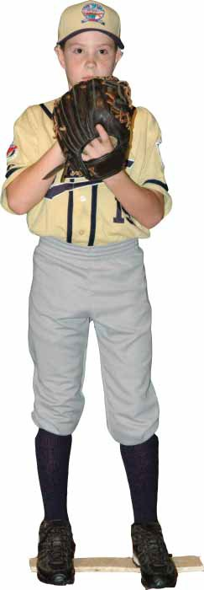

Most effective pitchers have three things in common; working fast, throwing strikes and changing speeds. To be effective a pitcher must learn to keep hitters off balance. After all, hitting requires good timing on the part of the batter. The pitcher’s main task should be to disrupt the hitter’s timing. As a result, this portion of “Protecting Young Pitching Arms: The Little League Pitch Count Regulation Guide for

Parents, Coaches and League Officials,” will teach the change-up, which gives the pitcher an added edge on the hitter.

Learning a skill like pitching is not easy for most players. In order to assist teaching this skill several drills are included that are specifically designed to improve and maintain proper pitching mechanics. Pitchers need to work on these drills every day. The drills do not require expensive equipment; just a baseball, glove, and a hard-working player.

With a positive frame of mind, the willingness to succeed, and the latest knowledge provided in “Protecting Young Pitching Arms: The Little League Pitch Count Regulation Guide for Parents, Coaches and League Officials,” pitchers can succeed

– safely – at any level of ball.

THE STARTING POSITION

When a pitcher stands on the rubber to begin the delivery to the hitter, it is suggested that a right-handed pitcher stand on the right corner of the pitching rubber. Left-handed pitchers should stand on the left side of the rubber. Deception is an important part of pitching. By standing on the throwing-hand side of the rubber, the pitcher gains a deception advantage. The hitter is prevented from picking up the baseball during the delivery until it gets to the “window” – the spot over the pitcher’s shoulder where the batter sees the release of the ball.

The pitcher should start in a relaxed stance with the shoulders square to the plate. Standing with both feet on the rubber, the pitcher’s toes should be slightly in front of the pitching plate. Be sure that there is space between the pitcher’s feet (a little closer than shoulder-width apart). The pitcher’s weight should be on his/her pivot foot with the glove-side leg relaxed and slightly bent. This helps emphasize the weight transfer back when beginning the delivery.

The starting position of the hands can be held in any way that feels comfortable, such as:

***Ready Position***

1. In the throwing hand behind the back; 2. In the glove to the side, and; 3. In the glove resting against the waist or chest.

However, at the point of the delivery, the hands will be brought together in front of the chest and the hands will be together. If the pitcher holds the ball in the glove it is important that the pitcher holds the ball in the palm of

37 ***9***

the glove for securing a grip. Be sure that the pitcher keeps the ball hidden from the batter and the opposing team’s coaches’ view to prevent them from picking up what pitch is going to be thrown.

THE DELIVERY

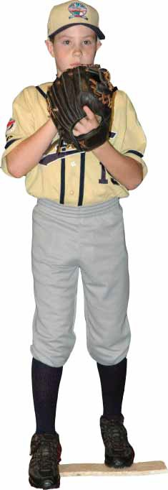

**Weight Transfer**: Regardless of the pitcher’s position on the rubber, the next progression is to start the delivery. The pitcher will take a small step straight back with the left foot (right- handed pitcher), about five or six inches. The pitcher may want to step to the side instead of

straight back. Either way is fine.

One important checkpoint is to make sure that the bill of the cap of the pitcher never leaves the plane of the rubber. This ensures that the pitcher will not pull the body back too far, causing a rushed delivery. The aim is to produce a smooth, tension-free delivery.

The best approach is to keep an unobstructed view of the target. Many pitchers like to take their hands back over their head when beginning the delivery, but some young pitchers may have trouble maintaining balance. Be keeping the pitcher’s hands near the chest during the delivery, balance is more easily

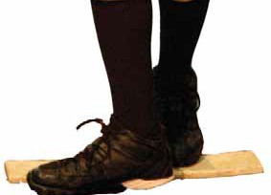

maintained. It is important for the pitcher to move

the hands at the same time the small step back is taken. Otherwise the pitcher gets out of rhythm and the delivery will not be as smooth.

**The Pivot Foot:** Establishing the pivot foot is one of the most important elements in getting the pitcher’s body in a correct position to throw accurately. After transferring the weight back, the next step in the progression is for the pitcher to square off the pivot foot and place it

in front of the rubber. The outside portion of the pivot foot must remain in contact with the rubber, and the instep should be directly at the target. Placing the foot on top of the rubber does

***Weight Transfer***

not allow for an effective push or drive to the plate.

**The Leg Lift:** The leg lift enables the pitcher to obtain a maximum weight transfer towards the plate. As the pitcher’s weight transfers to the pivot foot, his/her shoulders will automatically square toward

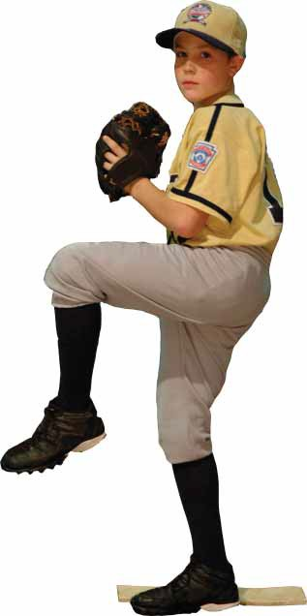

third base (right-handed pitcher). Now the pitcher has established a pointer or a directional side with the glove side pointed

towards the catcher.

The pitcher then begins the knee lift, with three important

***Pivot Foot***

checkpoints. First, make sure the pitcher’s thigh is at least parallel to the ground at the height of the lift, at a comfortable level. A good way to find a comfortable knee lift position is to have the pitcher freeze at the top of the lift. If the pitcher loses balance, the knee lift is too high. The pitcher must keep good posture. Arching the back may cause the pitcher to lose balance during the delivery.

Another checkpoint on the leg lift is to keep the lift foot somewhat underneath the knee. Kicking the foot out will cause the pitcher to lose balance. If the foot is relaxed, it will allow the pitcher to have a higher, more comfortable leg lift. Remember, the pitcher needs to achieve a tension-free delivery.

Finally, at the height of the leg lift, the knee should be turned back slightly towards the plane of the rubber. By bringing the knee back, this ensures that the hips stay closed and the pitcher’s weight is completely on the back leg. By not keeping the

hips closed, the pitcher cannot get maximum hip thrust when throwing the ball. It is important that the pitcher’s head is over the back knee. If the pitcher tips his head toward the plate, it will cause a rushed delivery.

The hands, regardless of where the pitcher has them during the beginning of the delivery, must be at the chest or waist area at the height of the leg lift.

**The Stride:** From the leg lift position, the pitcher should drive off the back leg into the stride. The extent of the drive is the pitchers preference. Some pitchers like to drop their hips low and drive the ball to the plate using their legs as a part of the throwing action. Others like to keep tall and

in a sense “fall” towards the plate. This is a decision for the pitcher to make. The length of the stride may range anywhere from approximately 85 percent of the body height to the actual length of the entire body.

***Leg Lift*** 38

***10***

***Launch Position***

Good advice is to use the pitcher’s physical attributes when making this decision. If the pitcher is tall, then the “tall and fall” method might be desired. If the pitcher is not tall then the “drop and drive” method might be desired. The only problem with the drop and drive method is that some

pitchers have a tendency to drop and drag the elbow during the throwing motion. A low elbow at delivery of the pitch can lead to arm and shoulder injuries. The “tall and fall” method will not

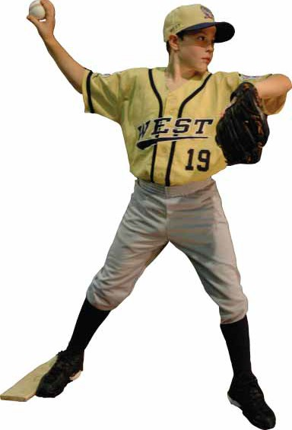

necessarily keep the elbow from dragging, but it makes it easier for the pitcher to stay on top of the ball.

What is important is that the pitcher gets a maximum stride that is comfortable. A maximum stride will allow the pitcher to release the ball closer to the plate, increasing velocity. Over-striding may result in the

pitcher having trouble keeping pitches down in the strike zone.

As the lift knee moves forward into the stride, the pitcher should keep the knee flexible. This prevents the pitcher from kicking out the foot when pushing toward the plate. If the pitcher does kick the lift foot out when

striding, the pitcher will normally arch the back in order to attempt to gain balance. Arching the back cuts down on the stride.

As the pitcher lands on the stride foot, make sure that the landing is on the ball of the foot with the toes pointing just slightly closed to the plate. Landing on the heel of the foot will cause a “jerk” or momentary stop in the delivery. This can create arm problems.

The foot must be in a direct line with the target when landing. If the foot lands away from this line, then the pitcher is forced to either throw across the body, or the follow-through will be affected by the loss of

balance.

**Getting to the Launch Position:** As the pitcher lifts the leg and

takes a comfortable stride, the hands must separate and reach what is called the launch position. The pitcher must concentrate on turning the thumbs in toward the body (down) and turning the palms away from the body when separating the ball from the glove. This action helps to get both the glove-side elbow and the throwing-arm elbow to shoulder height. When the hands break, be sure the pitcher separates the ball and glove inside of the lift knee. If the pitcher throws the hands outside the lift knee, the back may arch.

There are three checkpoints in the launch position. One is to be sure the glove-side elbow is at shoulder height when the pitcher is ready to deliver the ball. This will give the pitcher a better balance and will aid in keeping the throwing elbow from dragging.

The second checkpoint involves the throwing elbow at or slightly above shoulder height. If the elbow drops or drags when throwing the ball, elbow and shoulder problems are soon to follow.

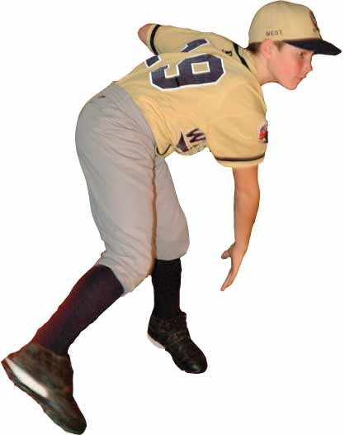

Finally and most important, make sure the ball is facing away from the catcher toward second base. Keep the elbow slightly bent in

an “L” shape. If the ball is not facing away, the elbow will have a tendency to drag below shoulder height as the ball is thrown. With

the ball facing away in the correct position, as the hips are rotated to the plate the ball also will automatically be rotated toward the plate.

Acceleration of the Arm: From the launch position, the pitcher begins to accelerate the arm. At this point, the glove side is just as important as the throwing side. With the elbows at shoulder height in the launch, the pitcher must drive the glove side elbow down vertically past the hip. By “driving the front side down” the pitcher ensures that the throwing shoulder is up and the throwing elbow is at shoulder height. If the pitcher drives the glove hand or elbow horizontally, the throwing elbow may drag.

**Follow Through:** Pitchers must adhere to two absolutes for an effective follow through after delivering the pitch. First, be sure that the pitcher bends

at the waist and is getting the head out over the stride knee. Also, the front knee should be slightly bent to cushion the weight transfer, and to aid in a smooth follow

through.

Second, it is important that the pitcher is in a good fielding position after following through. Make sure that the pitcher does not stop the throwing arm during the follow through. The slowing action causes control problems and completely stopping the arm

can lead to injuries.

***Follow Through***

39

***11***

PITCH VARIETY

A Little League pitcher should concentrate on mastering two pitches, the fast ball and the change up. As players get older, they may elect to learn the breaking ball.

**Fast Ball – Four-Seam Grip:** The most commonly used grip for accuracy is the four-seam fast ball. The four-seam fast ball is held with the index and middle fingers positioned across the large seams. A finger’s width should

be the distance between the index and middle fingers with the thumb positioned underneath the ball on a seam. The pitcher should be sure there is a small space between the web of the hand and the ball. The third and fourth fingers are curled back.

**Fast Ball – Two-Seam Grip:** The two-seam fast ball is held with the index and middle fingers across the seams where the horseshoe-like seams almost meet. The thumb is placed on a seam at the bottom of the ball, while the third and fourth fingers are curled back. Using this grip provides a little extra movement on the fast ball. Again, the pitcher should be sure there is a small space between the web of the hand and the ball.

**Fast Ball – With-the-Seam Grip:** On this grip, the index and middle fingers should be placed on the seams where both horseshoe seams almost meet. The thumb is placed on a seam underneath the ball. The pitcher should be sure there is a small space between the web of the hand and the ball. The third and fourth fingers are curled back. When thrown, this pitch has a tendency to move a little which will make it more difficult to hit.

**Three-Finger Change Up:** The purpose of a change up is to give the appearance of a fastball, but because the speed of the ball is much slower, the hitter’s timing is disrupted.

The three-finger change up can be gripped in any way the pitcher feels comfortable. Most pitchers grip the first and third fingers running the length of the seams with the middle finger in between the seams. The thumb

is positioned underneath on a seam. Some pitchers grip the three-finger change up similar to a four seam fastball with slight modifications.

The most important aspect of the change up is that the ball, unlike all the fast ball grips, is tucked back against the pad of the hand. When throwing any change up, the key is to keep the same pitching mechanics and arm speed. The grip of the ball will slow the speed of the pitch.

DRILLS

The following drills are designed to break down the pitching motion into progressions that can be isolated. They can be done from shorter throwing distances.

**Slow Motion Drill:** Standing on the rubber, or a simulated rubber, or simply line in the dirt or grass and without a ball, the pitcher begins the pitching progression as slow as he or she possibly can. This concentration drill allows the coach and the pitcher to look very closely at each progression of the motion and make corrections. The pitcher fakes a pitch and completes the progression with the follow through.

**Pivot Foot Drill:** The pivot foot drill begins with the pitcher’s pivot foot or power foot placed against the rubber with the instep facing the target or the plate. The weight is on the stride foot. At this point the body should be in control and above the plane of the rubber. The pitcher transfers the weight to the pivot foot which then creates the directional side (meaning glove side pointing to the plate) and goes right through to the knee lift and

finishes the progression. This drill reinforces the control over the rubber as well as the creation of the directional side.

**Knee Lift Drill:** Starting in the knee lift position, the pitcher simply holds

***Four-seam Fastball***

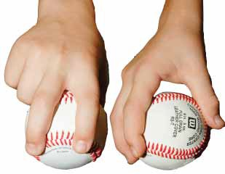

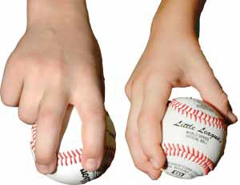

***Two-seam Fastball***

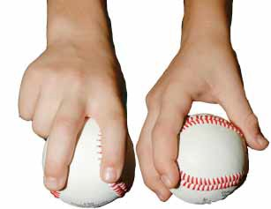

***With-the-Seam Fastball***

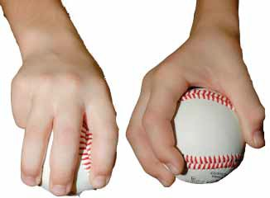

***Three-finger Change Up***

a proper, comfortable knee lift for three to five seconds, and then completes the progression moving to the stride and launch positions. This drill reinforces the balance needed and controlled direction towards the plate.

**Launch Drill:** With the feet separated more than shoulder-width apart, and in a good launch position (both elbows at shoulder height, ball facing away and throwing arm in an “L shape), the pitcher should simply lift the40 ***12***

stride foot slightly, transfer weight from the pivot foot back to the stride foot, continue with the progression by driving the glove side elbow down and back past the hip, and throw the ball with a good follow through.

If needed, the coach can reinforce any position of the launch by simply holding or reinforcing the position. For instance, a pitcher may drag his elbow through the delivery, and the coach may correct it by holding the elbow at the correct height at the start of the launch.

***Nick Caringi of Williamsport, Pa., is the Little League International Director of Operations. He attended St. Bonaventure University (Olean, N.Y.) where he was a pitcher on the baseball team. He graduated in 1990 with a bachelor’s degree in elementary education. He also served as the St. Bonaventure pitching instructor during graduate school.***

EIGHT ESSENTIALS OF POST-PITCHING RECOVERY

BY JIM RONAI MS, PT, ATC, CSCS

The institution of the pitch count in Little League Baseball represents a positive step towards ensuring that the game of baseball is safer both in the present and future careers of young pitchers.

As an adjunct to this new pitch count regulation and in an attempt to protect the health and safety of youth baseball pitchers, the following post-performance suggestions are offered. Since most youth baseball pitchers are typically removed from the mound, but not necessarily from the game, these suggestions are intended for post-game or for a time when the pitcher is considered done for the day.

* 1. Children learn most effectively with a consistent routine. All athletes need to have a routine that they perform both pre- and post-game. The routine needs to be monitored and consistent. Athletes need to know that the routine needs to be completed correctly before they will be permitted to participate in subsequent game or practice play.
  2. Perform a “cool down activity.” Have pitchers jog for four to six minutes, to the point when they start to sweat. This increases general blood flow throughout the body and prepares the body for a post-performance flexibility routine. Increasing blood flow allows the body to circulate oxygenated blood to fatigued muscles. Oxygenated blood helps soft tissues recover and heal following activity.
  3. Spend five minutes on a post-game, movement-based, “dynamic flexibility program.” Incorporate movements for the forearms, shoulders as well as the torso and lower body. As an example,

have athletes perform progressive arm circles forward and backward for their arm and shoulder muscles, and walking heel grabs for their thigh and hip flexor muscles. These drills represent only a portion of a post-outing routine that help the athlete stretch their entire body. Along with increasing the flow of oxygenated blood to muscles and tendons, stretching dynamically following an athletic performance helps to mediate the by-products of exercise that make the body stiff and sore.

* 1. Designate one staff member to review the pitcher’s performance. Keep things simple and to the point. Review the negative aspects of the pitcher’s performance, but be sure to finish the conversation by emphasizing the positive. Leave the athlete feeling good about his/her outing.
  2. Since most young athletes answer questions about how they feel with a shrug or a one-word answer, develop a visual analog scale for the pitchers to use to quantify how they feel before, during, and after the game. The scale can be something as simple as a one-to-10 scale with a picture of a frown at No. 1, a neutral face at No. 5, and a happy face at No. 10. Ask the pitcher how he/she feels before the game, at the end of each inning, and at the end of the performance. The visual scale allows younger players to easily point to the number or picture that most describes how the arm is feeling. Coaches can use the scale to inquire about the condition of a pitcher’s arm before the game as well as any symptoms that he/she develops during or at the conclusion of the game. Monitoring a young pitcher’s perception of his/her physical wellness helps coaches make note of trends related to performance or potential injury related to volume, lack of endurance, or other variables.
  3. Having a cooler of ice available in the dugout is an important part of optimizing a pitcher’s recovery. Keep a few bags of ice available for pitchers to apply to their shoulders and elbows following a pitching outing. Never apply ice directly to the skin or for more than 12-15 minutes. Also be aware of the ulnar nerve found in the area of the “funny bone,” and be sure not to apply ice directly over it.
  4. Do not allow pitchers to go home and re-create their game by throwing with “coach mom or dad.” Once they are done on the field, they are done for the day. Encourage families to follow this approach for the sake of the child’s health.
  5. In an attempt to establish consistent pitching performance, athletes need to gain and maintain strength as well as control of their bodies. An age-appropriate strength, balance and coordination routine for your pitchers should be taught at the beginning of the season and should be

1

4 ***13***

performed by pitchers the day after each outing. These activities help to ensure that the athlete is taking care of his/her “pitching muscles” on a consistent basis in preparation for the next outing. Simple programs should address balance, as well as strengthening for the rotator cuff, back, core and leg muscles. Remember that the season is long, and that without training, muscles fatigue and lose strength over time. Keep them strong for the long haul.

***Jim Ronai MS, PT, ATC, CSCS is a Physical Therapist, Certified Athletic Trainer through the National Athletic Trainers Association (NATA) and a Certified Strength and Conditioning Specialist through the National Strength and Conditioning Association (NSCA). He is the Director of Physical Therapy and Sports Medicine at Rehabilitation Associates, Inc. in Connecticut and Director of Jim Ronai’s Competitive Edge, an athletic performance-training program. Jim has served on the medical staff for two U.S. Olympic teams and is a member of the USA Baseball Medical and Safety Advisory Committee.***

42

***14***

**Little League -- Baseball Game Pitch Log**

**Team**









































































































































































**Opponent**

**Date**

































































































































































































































































































































































































































































































































































































































































































44

|  |  |  |  |  |  |  |  |  |  |  |
| --- | --- | --- | --- | --- | --- | --- | --- | --- | --- | --- |
| **Pitcher's Name** | **Uniform Number** | **League Age** |  | **X** | **Cross out the number as that pitch is thrown.**  **Circle the number for the last pitch thrown in each half-inning.** | | | | | |
| **O** |
|  |  |  | 1 2 3 4 5  36 37 38 39 40  71 72 73 74 75 | | 6 7 8 9 10  41 42 43 44 45  76 77 78 79 80 | 11 12 13 14 15  46 47 48 49 50  81 82 83 84 85 | 16 17 18 19 20  51 52 53 54 55  86 87 88 89 90 | 21 22 23 24 25  56 57 58 59 60  91 92 93 94 95 | 26 27 28 29 30  61 62 63 64 65  96 97 98 99 100 | 31 32 33 34 35  66 67 68 69 70  101 102 103 104 105 |
|  |  |  |  | | | | | | | |
|  |  |  | 1 2 3 4 5  36 37 38 39 40  71 72 73 74 75 | | 6 7 8 9 10  41 42 43 44 45  76 77 78 79 80 | 11 12 13 14 15  46 47 48 49 50  81 82 83 84 85 | 16 17 18 19 20  51 52 53 54 55  86 87 88 89 90 | 21 22 23 24 25  56 57 58 59 60  91 92 93 94 95 | 26 27 28 29 30  61 62 63 64 65  96 97 98 99 100 | 31 32 33 34 35  66 67 68 69 70  101 102 103 104 105 |
|  |  |  |  | | | | | | | |
|  |  |  | 1 2 3 4 5  36 37 38 39 40  71 72 73 74 75 | | 6 7 8 9 10  41 42 43 44 45  76 77 78 79 80 | 11 12 13 14 15  46 47 48 49 50  81 82 83 84 85 | 16 17 18 19 20  51 52 53 54 55  86 87 88 89 90 | 21 22 23 24 25  56 57 58 59 60  91 92 93 94 95 | 26 27 28 29 30  61 62 63 64 65  96 97 98 99 100 | 31 32 33 34 35  66 67 68 69 70  101 102 103 104 105 |
|  |  |  |  | | | | | | | |
|  |  |  | 1 2 3 4 5  36 37 38 39 40  71 72 73 74 75 | | 6 7 8 9 10  41 42 43 44 45  76 77 78 79 80 | 11 12 13 14 15  46 47 48 49 50  81 82 83 84 85 | 16 17 18 19 20  51 52 53 54 55  86 87 88 89 90 | 21 22 23 24 25  56 57 58 59 60  91 92 93 94 95 | 26 27 28 29 30  61 62 63 64 65  96 97 98 99 100 | 31 32 33 34 35  66 67 68 69 70  101 102 103 104 105 |
|  |  |  |  | | | | | | | |
|  |  |  | 1 2 3 4 5  36 37 38 39 40  71 72 73 74 75 | | 6 7 8 9 10  41 42 43 44 45  76 77 78 79 80 | 11 12 13 14 15  46 47 48 49 50  81 82 83 84 85 | 16 17 18 19 20  51 52 53 54 55  86 87 88 89 90 | 21 22 23 24 25  56 57 58 59 60  91 92 93 94 95 | 26 27 28 29 30  61 62 63 64 65  96 97 98 99 100 | 31 32 33 34 35  66 67 68 69 70  101 102 103 104 105 |
|  |  |  |  | | | | | | | |
|  |  |  | 1 2 3 4 5  36 37 38 39 40  71 72 73 74 75 | | 6 7 8 9 10  41 42 43 44 45  76 77 78 79 80 | 11 12 13 14 15  46 47 48 49 50  81 82 83 84 85 | 16 17 18 19 20  51 52 53 54 55  86 87 88 89 90 | 21 22 23 24 25  56 57 58 59 60  91 92 93 94 95 | 26 27 28 29 30  61 62 63 64 65  96 97 98 99 100 | 31 32 33 34 35  66 67 68 69 70  101 102 103 104 105 |
|  |  |  |  | | | | | | | |
|  |  |  | 1 2 3 4 5  36 37 38 39 40  71 72 73 74 75 | | 6 7 8 9 10  41 42 43 44 45  76 77 78 79 80 | 11 12 13 14 15  46 47 48 49 50  81 82 83 84 85 | 16 17 18 19 20  51 52 53 54 55  86 87 88 89 90 | 21 22 23 24 25  56 57 58 59 60  91 92 93 94 95 | 26 27 28 29 30  61 62 63 64 65  96 97 98 99 100 | 31 32 33 34 35  66 67 68 69 70  101 102 103 104 105 |
|  |  |  |  | | | | | | | |
|  |  |  | 1 2 3 4 5  36 37 38 39 40  71 72 73 74 75 | | 6 7 8 9 10  41 42 43 44 45  76 77 78 79 80 | 11 12 13 14 15  46 47 48 49 50  81 82 83 84 85 | 16 17 18 19 20  51 52 53 54 55  86 87 88 89 90 | 21 22 23 24 25  56 57 58 59 60  91 92 93 94 95 | 26 27 28 29 30  61 62 63 64 65  96 97 98 99 100 | 31 32 33 34 35  66 67 68 69 70  101 102 103 104 105 |
|  |  |  |  | | | | | | | |
|  |  |  | 1 2 3 4 5  36 37 38 39 40  71 72 73 74 75 | | 6 7 8 9 10  41 42 43 44 45  76 77 78 79 80 | 11 12 13 14 15  46 47 48 49 50  81 82 83 84 85 | 16 17 18 19 20  51 52 53 54 55  86 87 88 89 90 | 21 22 23 24 25  56 57 58 59 60  91 92 93 94 95 | 26 27 28 29 30  61 62 63 64 65  96 97 98 99 100 | 31 32 33 34 35  66 67 68 69 70  101 102 103 104 105 |
|  |  |  |  | | | | | | | |
|  |  |  | 1 2 3 4 5  36 37 38 39 40  71 72 73 74 75 | | 6 7 8 9 10  41 42 43 44 45  76 77 78 79 80 | 11 12 13 14 15  46 47 48 49 50  81 82 83 84 85 | 16 17 18 19 20  51 52 53 54 55  86 87 88 89 90 | 21 22 23 24 25  56 57 58 59 60  91 92 93 94 95 | 26 27 28 29 30  61 62 63 64 65  96 97 98 99 100 | 31 32 33 34 35  66 67 68 69 70  101 102 103 104 105 |
| Pitching eligibility varies by the league age of the pitcher, which is the pitcher's age as of May 1 of the current year. The pitching eligibility regulation is [Regulation VI (see current rule book for details). A blank electronic version of this form is available for free download at www.littleleague.org.](http://www.littleleague.org/) | | | | | | | | | | |

**Little League -- Baseball Pitcher Eligibility Tracking Form**

**Division**

**Team**

45

|  |  |  |  |  |  |  |  |  |
| --- | --- | --- | --- | --- | --- | --- | --- | --- |
| **Date**  **of Game** | **Pitches**  **Thrown** | **Pitcher's**  **Name** | **Unif.**  **No.** | **League**  **Age** | **Tm. Manager's**  **Signature \*** | **Opp. Manager's**  **Signature \*** | **Scorekeeper/Ump**  **Signature \*** | **Eligible to pitch**  **again on (date)** |
|  |  |  |  |  |  |  |  |  |
|  |  |  |  |  |  |  |  |  |
|  |  |  |  |  |  |  |  |  |
|  |  |  |  |  |  |  |  |  |
|  |  |  |  |  |  |  |  |  |
|  |  |  |  |  |  |  |  |  |
|  |  |  |  |  |  |  |  |  |
|  |  |  |  |  |  |  |  |  |
|  |  |  |  |  |  |  |  |  |
|  |  |  |  |  |  |  |  |  |
|  |  |  |  |  |  |  |  |  |
|  |  |  |  |  |  |  |  |  |
|  |  |  |  |  |  |  |  |  |
|  |  |  |  |  |  |  |  |  |
|  |  |  |  |  |  |  |  |  |
| Pitching eligibility varies by the league age of the pitcher, which is the pitcher's age as of May 1 of the current year. The pitching eligibility regulation is Regulation VI (see current rule book for details). An electronic version of this form is available for free download at [www.LittleLeague.org.](http://www.LittleLeague.org/) | | | | | | | | |
| * Note: These signatures may be optional as determined by the local league. | | | | | | | | |

**2018**

SONOMA LITTLE LEAGUE

**35**

**405-35-13**

**Sonoma CA**

|  |  |  |  |
| --- | --- | --- | --- |
| **Jay Gruendle** |  | **Nate Reynes** |  |
| **222 Boyes Blvd. Sonoma**  **CA** | **95476** | **608 Barcelona Dr Sonoma**  **CA** | **95476** |

[**sonomapresident@gmail.com**](mailto:sonomapresident@gmail.com)

**707-953-0014**

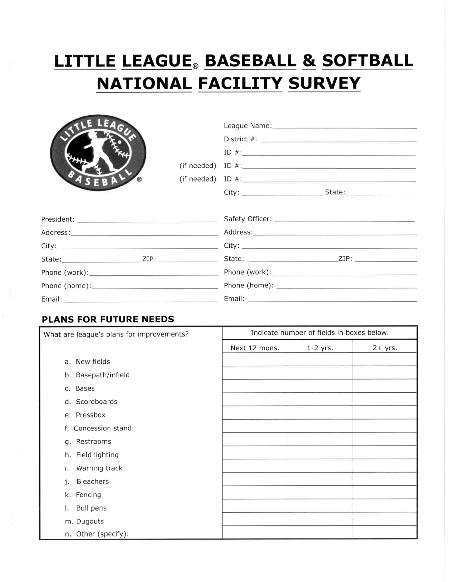

|  |  |  |  |
| --- | --- | --- | --- |
| **0** | **0** | **0** |  |
| **0** | **0** | **0** |  |
| **0** | **0** | **0** |  |
| **0** | **3** | **0** |  |
| **0** | **0** | **0** |  |
| **0** | **0** | **0** |  |
| **0** | **0** | **0** |  |
| **0** | **0** | **0** |  |
| **0** | **0** | **0** |  |
| **0** | **0** | **0** |  |
| **0** | **0** | **3** |  |
| **0** | **3** | **0** |  |
| **0** | **0** | **3** |  |
| **0** | **0** | **0** |  |
|  |  |  | 46 |

|  |  |  |  |  |  |  |  |  |  |  |  |
| --- | --- | --- | --- | --- | --- | --- | --- | --- | --- | --- | --- |
| **Hughes Field** | **4.50** | **190.00** | **200.00** | **200.00** | **20.40** | **23.00** | **18.00** | **24.00** | **25.00** | **25.00** | **11.00** |
| **Katies** | **4.00** | **160.00** | **170.00** | **160.00** | **10.00** | **10.00** | **10.00** | **10.00** | **10.00** | **10.00** | **10.00** |
| **Maxwell** | **4.00** | **200.00** | **215.00** | **200.00** | **10.00** | **10.00** | **10.00** | **10.00** | **10.00** | **10.00** | **10.00** |
| **Pauls** | **4.00** | **200.00** | **210.00** | **185.00** | **20.00** | **15.00** | **15.00** | **15.00** | **15.00** | **15.00** | **15.00** |
| **Teeter Field** | **8.25** | **163.00** | **200.00** | **200.00** | **18.50** | **18.83** | **19.83** | **19.83** | **20.00** | **20.00** | **17.00** |

**Little League International PO Box 3485**

**Williamsport, PA 17701-0485**

**Little League International 539 US Route 15 Hwy**

**S. Williamsport, PA 17702**

**Early Bird Date: April 01, 2018**

**Final Deadline Date: August 01, 2018**

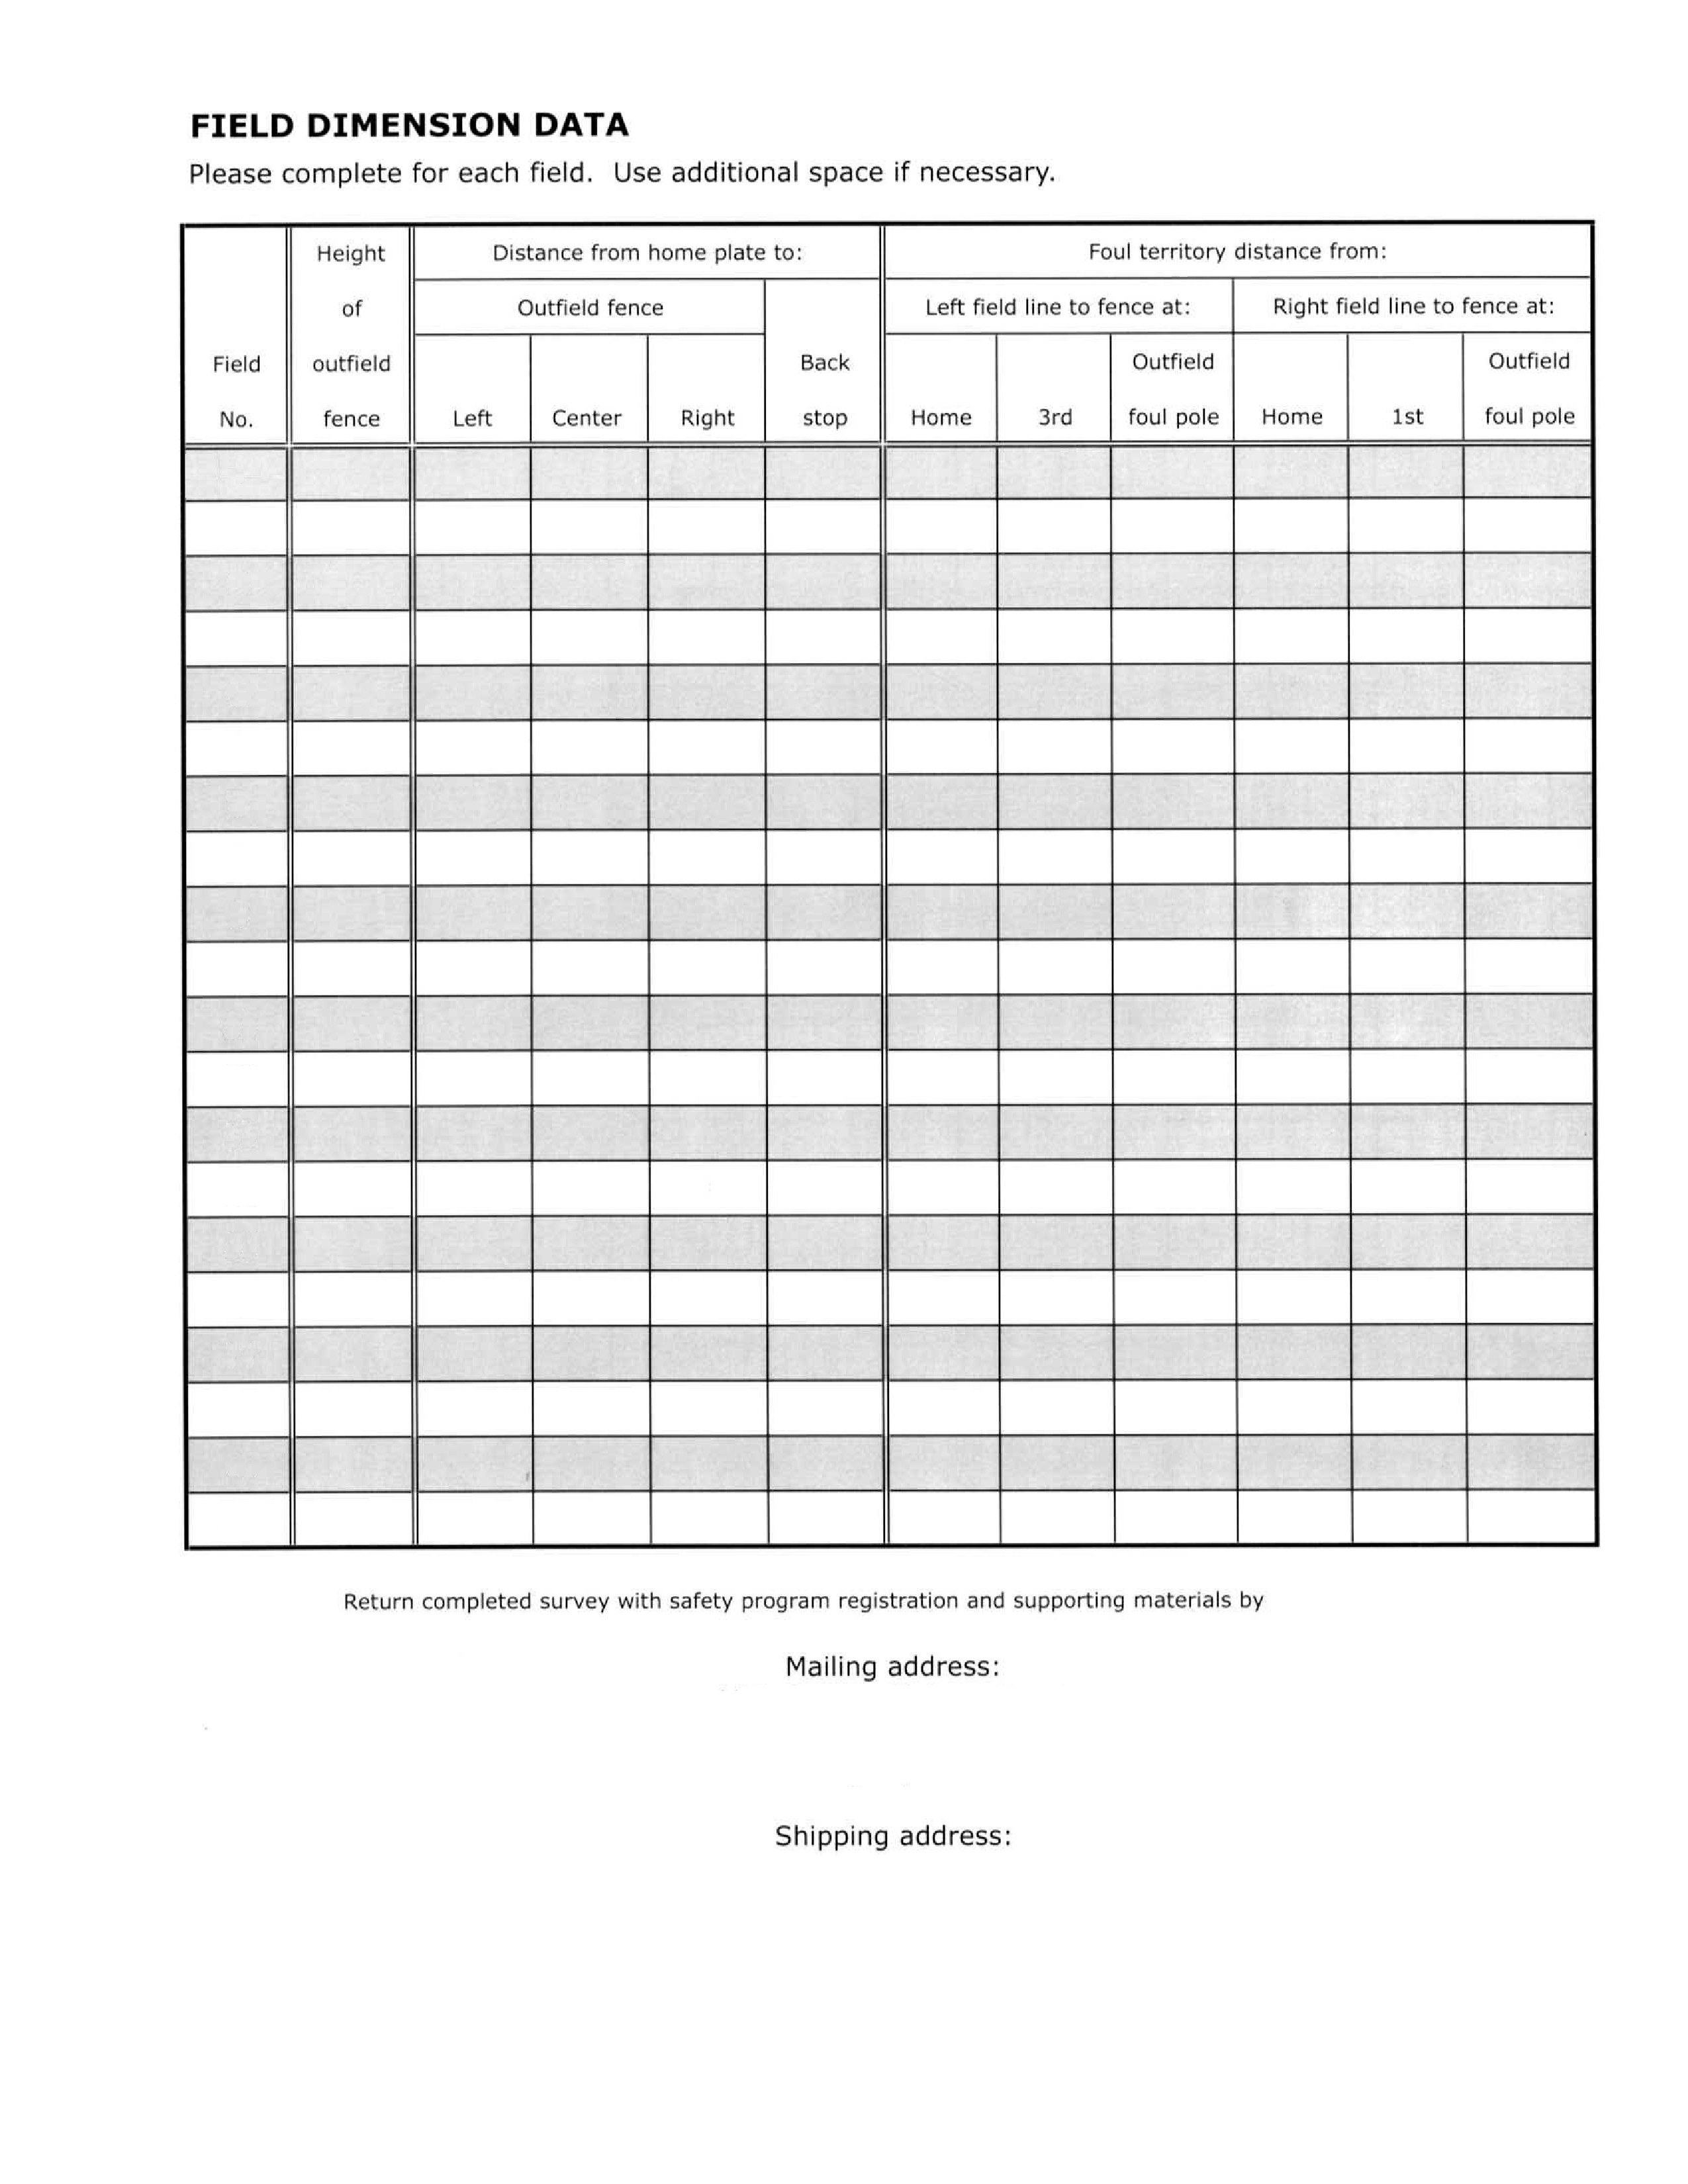

47



|  |  |  |  |  |  |  |
| --- | --- | --- | --- | --- | --- | --- |
| **No.** | **Questions** | **Hughes Field** | **Katies** | **Maxwell** | **Pauls** | **Teeter Field** |
| **1** | **How many cars can park in designated parking areas for this field?** | **1-50** | **1-50** | **1-50** | **1-50** | **101 or more** |
| **2** | **How many people will your bleachers seat for this field?** | **1-100** | **1-100** | **1-100** | **101-300** | **1-100** |
| **3.a.** | **Are the bleachers made of wood on this field?** | **No** | **Yes** | **Yes** | **Yes** | **No** |
| **3.b.** | **Are the bleachers made of metal on this field?** | **No** | **No** | **No** | **No** | **No** |
| **3.c.** | **Are bleachers for this field made of material other than wood or metal?** | **Yes** | **No** | **No** | **No** | **Yes** |
| **4** | **If bleachers are made of metal, is a ground wire attached to a ground rod?** | **No** | **No** | **No** | **No** | **No** |
| **5** | **If bleachers are made of wood, are they inspected annually for safety?** | **No** | **Yes** | **No** | **Yes** | **No** |
| **6** | **Is there a safety railing at the top/back of bleachers for this field?** | **Yes** | **No** | **No** | **Yes** | **No** |
| **7** | **Is there a handrail up the sides of bleachers for this field?** | **Yes** | **No** | **No** | **No** | **Yes** |
| **8.a.** | **Is permanent telephone service available for this field?** | **Yes** | **No** | **No** | **Yes** | **Yes** |
| **8.b.** | **Is cellular telephone service available for this field?** | **Yes** | **Yes** | **Yes** | **Yes** | **No** |
| **9.a.** | **Is a permanent public address system available for this field?** | **Yes** | **No** | **No** | **Yes** | **No** |
| **9.b.** | **Is a portable public address system available for this field?** | **No** | **No** | **No** | **No** | **Yes** |
| **10** | **Is there a pressbox for this field?** | **Yes** | **No** | **No** | **Yes** | **Yes** |
| **11** | **Is there a scoreboard for this field?** | **Yes** | **No** | **No** | **Yes** | **Yes** |
| **12** | **Are adequate bathroom facilities available for this field?** | **Yes** | **Yes** | **Yes** | **Yes** | **Yes** |
| **13** | **Are permanent concession stands available for this field?** | **Yes** | **No** | **No** | **Yes** | **Yes** |
| **14** | **Are mobile concession stands available for this field?** | **No** | **No** | **No** | **No** | **No** |
| **15** | **Is this field completely fenced?** | **Yes** | **Yes** | **No** | **Yes** | **Yes** |
| **16.a.** | **Is the fencing made of chainlink on this field?** | **Yes** | **Yes** | **No** | **Yes** | **Yes** |
| **16.b.** | **Is the fencing made of wood on this field?** | **No** | **No** | **No** | **No** | **No** |
| **16.c.** | **Is the fencing made of wire on this field?** | **No** | **No** | **No** | **No** | **No** |
| **17.a.** | **Is the basepath material on this field is sand, clay or soil mix?** | **No** | **No** | **No** | **No** | **No** |
| **17.b.** | **Is the basepath material on this field is ground burnt brick?** | **Yes** | **Yes** | **Yes** | **Yes** | **Yes** |
| **17.c** | **Is the basepath material on this field other than sand, clay, soil mix or ground...** | **No** | **No** | **No** | **No** | **No** |
| **17.d** | **If yes to other material, what is the basepath material on this field?** |  |  |  |  |  |

48

|  |  |  |  |  |  |
| --- | --- | --- | --- | --- | --- |
| **No.** | **Questions** | **Hughes** | **Katies** | **Maxwell Pauls** | **Teeter** |
|  |  | **Field** |  |  | **Field** |

* 1. **Is non-caustic lime used to mark the baselines on this field?**
  2. **Is spray paint used to mark the baselines on this field?**
  3. **Is commerical marking used to mark the baselines on this field?**

**No No No No No**

**No No No No No Yes Yes Yes Yes Yes**

1. **Is the infield surface grass? Yes No No Yes Yes**
2. **Does this field have a conventional dirt pitching mound?**
3. **Does this field have a temporary pitching mound?**

**Yes Yes Yes Yes Yes No No No No Yes**

1. **Are there foul poles on this field? Yes No No Yes Yes**
2. **Is there a backstop behind home plate on this field?**
   1. **Is there an outfield warning track for this field?**

**Yes Yes Yes Yes Yes**

**No No No Yes No**

* 1. **If yes, what width is the warning track? 0.00 0.00 0.00 4.00 0.00**

1. **Is there a batter's eye (screen/covering) at center field on this field?**
2. **Is there a pitcher's eye (screen/covering) behind home plate on this field?**
3. **Does this field have protective fences in front of the dugouts?**
4. **Is there a protected on-deck batter's area on this field?**
5. **Are fenced limited access bull pens available for this field?**

**Yes No No Yes Yes Yes Yes Yes Yes Yes Yes Yes Yes Yes Yes No No No No No**

**No No No Yes No**

1. **Is a first aid kit provided for this field? Yes Yes Yes Yes Yes**
   1. **Do bleachers for this field have overhead screens for spectator foul ball protec...**
   2. **Do bleachers for this field have fencing behind for spectator foul ball protecti...**
2. **Do your bases disengage from their anchors? (Mandatory since 2008)**

**Yes No No Yes Yes No No Yes Yes No**

**Yes Yes Yes Yes Yes**

1. **Is this field lighted? No No No No No**
   1. **Are light levels at/above Little League standards?**

**No No No No No**

* 1. **Light levels on this field are not known? No No No No No**
  2. **Are there wood poles on this field? No No No No No**
  3. **Are there steel poles on this field? No No No No No**
  4. **Are there concrete poles on this field? No No No No No**

49

1. **Is the electrical wiring to each pole on this field is underground?**



**No No No No No**

|  |  |  |  |  |  |
| --- | --- | --- | --- | --- | --- |
| **No.** | **Questions** | **Hughes** | **Katies** | **Maxwell Pauls** | **Teeter** |
|  |  | **Field** |  |  | **Field** |

1. **Are there ground wires connnected to ground rods on each pole on this field?**
   1. **Was the electrical system on this field tested/inspected in last two years?**
   2. **What month/year was electrical system testing done on this field?**
   3. **Were the light levels on this field tested/inspected in the last two years?**
   4. **What month/year was the light level testing done on this field?**
   5. **Was the electrical system on this field tested/inspected by a qualified technici...**
   6. **Were the light levels on this field tested/inspected by a qualified technician?**
   7. **Does field have limitation on amount of time for practice?**
   8. **Does field have limitation on number of teams or games?**
   9. **Does field have limitation on scheduling and/or timing?**

**No No No No No**

**No No No No No**

**No No No No No**

**No No No No No No No No No No Yes Yes Yes Yes Yes**

**Yes Yes Yes Yes Yes Yes Yes Yes Yes Yes**

* 1. **Is this field owned by a municipality? Yes Yes Yes No Yes**
  2. **Is this field owned by a school? No No No No No**
  3. **Is this field owned by a league? No No No No No**
  4. **Municipality is responsible for operational energy costs on this field?**



* 1. **School is responsible for operational energy costs on this field?**
  2. **League is responsible for operational energy costs on this field?**
  3. **Municipality is responsible for operational maintenance on this field?**
  4. **School is responsible for operational maintenance on this field?**
  5. **League is responsible for operational maintenance on this field?**
  6. **Municipality is responsible for improvements on this field?**
  7. **School is responsible for improvements on this field?**
  8. **League is responsible for improvements on this field?**
  9. **Other group is responsible for improvements on this field?**
  10. **Is T-ball and Minor League baseball played on this field?**
  11. **Is Major division baseball played on this field?**
  12. **Is Junior, Senior and Big League baseball played on this field?**

**No Yes Yes No No**

**No No No No No Yes No No Yes Yes**

**No Yes Yes No No No No No No No**

**Yes No No Yes Yes No Yes Yes No No**

**No No No No No Yes Yes No Yes Yes**

**No No No No No Yes Yes Yes Yes Yes**

**Yes No No Yes Yes**

50

**No No No No No**

|  |  |  |  |  |  |
| --- | --- | --- | --- | --- | --- |
| **No.** | **Questions** | **Hughes** | **Katies** | **Maxwell Pauls** | **Teeter** |
|  |  | **Field** |  |  | **Field** |

* 1. **Is Challenger League baseball played on this field?**
  2. **Is T-ball and Minor League softball played on this field?**
  3. **Is Major League softball played on this field?**
  4. **Is Junior, Senior and Big League softball played on this field?**
  5. **Is Challenger League softball played on this field?**

**No No No No No**

**No No No No No No No No No No No No No No No No No No No No**

**47 Will tournaments be hosted on this field? Yes No No Yes Yes**



51

**This page confirms the completion of the 2018 online Facility Survey**



SONOMA LITTLE LEAGUE

**League Name**

35

**District #**

405-35-13

**League ID #**

**Submit this page with your hardcopy ASAP plan rather than the completed 2018 Facility Survey**

*52*

**2018 Qualified Safety Program Registration Form**



**Registering your qualified safety plan is as easy as 1, 2, 3!**

1. Complete all four sides of this Registration Form;
2. Complete the 2018 Facility Survey for all fields your league uses (DO NOT copy last year’s form);
3. Submit **both** forms ***with*** your complete safety plan — including ***all 14 minimum requirements clearly detailed*** — with

a **postmark** no later than ***April 1, 2018*** This will register your safety program with Little League International (see pages 2.1-2.3 for more information). Due to the volume of plans received, plans may be submitted ***starting Jan. 1, 2018***

Approved safety plans will win your league a cash award based on the number of teams your safety plan covers, if you carry Little League Chartis Insurance. In addition, your program will automatically be entered in the 2018 ASAP Awards!

**District Administrators:** To earn the district incentive for ASAP participation, a district’s league plans must be ***received at and* approved *by Little League International by March 13*.** This is different than the league deadline and requirement.

Districts with **88%** or better of their leagues that LLI received a qualified safety plan by March 14 will earn a **$350 credit**. Districts with **70%-87%** of their leagues that LLI received a qualified safety plan by March 14 will earn a **$150 credit**.

**This Registration Form MUST Accompany Safety Plan Submission**

SONOMA LITTLE LEAGUE 04053512

League Name

League I.D. #

City SONOMA

State CA

League I.D. #

(If board operates more than one charter, please list **all**:) League I.D. #

Jay Gruendle

League Safety Officer Nate Reynes

League President

222 Boyes Blvd.

Address 608 Barcelona Dr

Address

Sonoma

City Sonoma

City

CA 95476

State Ca Zip Code 95476

State

Zip Code

Work Telephone Work Telephone

7079398422

Home Telephone 707 935-8586

Home Telephone ( )

Cell/Pager # 707 953-0014

Cell/Pager Number 707 477-2782

[sonomapresident@gmail.com](mailto:sonomapresident@gmail.com)

Email nreynes@benziger.com

Items included with this application form:

Email

56

# of pages of league’s safety program outline:

# of non-returnable photographs: 0

Person submitting application (if different from above):

Name Title President

Address. City Sonoma

State Zip Code

Signature

Telephone 7( 074772) 782

Date

1/24/18

Name and signature of professional photographer to be credited and granting permission for reproduction of photographs (if applicable)

***Return this form and 2017 Little League Facility Survey, along with supporting safety manual, to:***

**Returned & Approved by March 13 for DA incentive or no later than April 1 for basic approval**

53

Over

|  |  |  |
| --- | --- | --- |
| Mailing Address: ASAP Award Program | or | Shipping Address: ASAP Award Program |
| Little League International |  | Little League International |
| P.O. Box 3485 |  | 539 U.S. Route 15 Hwy. |
| Williamsport, PA 17701 |  | So. Williamsport, PA 17702 |

These two pages contain the 14 minimum requirements for your safety plan to qualify for the cash award

if you take Little League Chartis player accident insurance. Page 4 provides a list of ways to improve on the minimum requirements. ***This form does not constitute a safety program.* Please submit the safety manual that was distributed to league personnel, this form and your facility survey**, as well as any other supporting pieces illustrating your safety program. Please specify all areas on which you wish your program to be judged (facilities improvements, safety equipment usage, etc.), and document to the best of your ability those changes (photos, forms, written procedures, etc.). ***Judging:*** All judging will be con- ducted based on the material submitted. Non-original safety plans will not be considered for the awards.

* Please list dates when training was/will be held; and where each requirement can be found in your plan.
* ***Please note: Leagues are required to conduct a background check for sexual abuse offenses for all applicable personnel. See Requirement 4.* This is a regulation for all leagues: See Regulation I(b), Reg. I(c)8 and I(c)9.** This begins with leagues using the Little League Volunteer Application Form.

**Please List Page Number Where Each Item Below**

**\***

**Is Located In Your Safety Plan**

*5*

1. **Have active safety officer on file with Little League International**
2. **PUBLISH and DISTRIBUTE a paper copy of the applicable safety manual to volunteers**
   * The intent is to print and distribute the safety plan to all staff: concession manual to concession workers, equipment policies to facilities crew, first aid to managers and coaches, etc. Keep copies in common areas for all volunteers.
   * While safety plans may be posted on the internet, individuals must be provided with printed copies to carry with them to the areas where their duties are performed.
   * Samples can be found in the example safety manuals on the LL web site.
   * Include all relevant material for coaches, including these minimum standards.
   * Keep a copy for your league. Send a copy to your DA or District Safety Officer. Little League International does not keep copies for leagues’ future use.
3. **Post and distribute emergency and key officials’ phone numbers**
   * Include emergency procedures for handling injuries and who to contact to track/report them.
   * Include emergency phone numbers for ambulance, police, fire department, etc.
   * Include league president and safety officer, consider head umpire, board members.
4. **Use 2018 Volunteer Application Form and check for sex abuse**
   * Managers, coaches, board members and any others, volunteers or hired workers, who provide regular services to the league and/or have repetitive access to or contact with players or teams **must fill out application form as well as provide a government-issued photo identification card for ID verification.** Check name spellings and numbers for accuracy.
   * Must conduct a search of the Department of Justice’s *nationwide* sex offender registry, using 2013 Volunteer Application Forms, on all applicable volunteers.
   * Information on running background checks that contain not only those on a sex offender registry, but other crimes of a sexual and non-sexual nature, can be found on the Little League website.
   * May conduct a supplemental criminal background check using resources such as *LexisNexis.*
   * Anyone **refusing** to fill out Volunteer Application is **ineligible** to be even a league member.
   * League president must retain these confidential forms for the year of service.
   * Do not send in volunteers’ forms; blank copy of league’s application form from correct year should be sent.
5. **Provide and require fundamentals training, with at least one coach or manager from each team attending (fundamentals including hitting, sliding, fielding, pitching, etc.)**
   * *It is not necessary for the first aid and training fundamentals to be held before the Safety Plan is*

*submitted. It is acceptable for scheduled dates/locations to be listed to meet requirement.*

1. **Page:**
2. **Page:**
3. **Page:**
4. **Page:**
5. **Page:**
6. **Date Was/**

i

4

10

i

2/2/18

* + Document date, location, who is required to attend and who did attend. Save copies of attendees to track their participation for future use. Intent is to provide training to ALL coaches and managers;

**Will Be Held:**

***minimum of one participant per team.***

**5. Date Was/**

2/2/18

* + Training qualifies volunteer for 3 years; but one team representative still required each year.
  + High school, college or experienced league coaches can be great resources.
  + Districts can assist by providing training sessions on a district-wide basis.
  + Training should be modified annually to meet the local needs of players and their facilities.

**Will Be Held:**

54

**2** October 2012

**6. Require first-aid training for coaches and managers, with at least one coach or manager from each team attending**

1. **Page:** 1
   * *It is not necessary for the first aid and training fundamentals to be held before Safety Plan is*

*submitted. It is acceptable for scheduled dates/locations to be listed to meet requirement.*

* + Due to their training and education, it is not necessary for licensed medical doctors, licensed registered nurses, licensed practical nurses and paramedics to attend first aid training in order to meet requirement; however, it is recommended that leagues utilize these professionals from their league/community to present the training.
  + Other individuals who attend various outside first aid training and courses are **not** exempt.

**6. Date Was/ Will Be Held:**

1. **Date Was/ Will Be Held:**

2/1/18

2/1/18

* + Document date, location, who is required to attend and who did attend. Save copies of attendees to track their participation for future use to show that they have had training in past three years. Again, the intent is to provide training to ALL coaches/managers; ***minimum of one participant per team.***
  + Training qualifies volunteer for 3 years, but one team representative still needed each year.

1. **Require coaches/umpires to walk fields for hazards before use**
   * Recommend leagues use form to track and document any facility issues needing to be fixed.
   * Common sense activity — look for rocks, glass, holes, etc.
   * Specify who is responsible for doing this — home coach, visitors, umpire, or all?
2. **Complete the 2014 ANNUAL Little League Facility Survey**
   * A requirement each year, can help leagues find and correct facility concerns.
   * Provided in the ASAP section on the Little League web site — facilitysurvey.musco.com or email [asap@musco.com](mailto:asap@musco.com)
   * Excel spreadsheet included for recording for future use and records.
   * **DO NOT** simply make copy of past year’s facility survey; physically review fields for changes and needs from prior year’s survey, and record changes/needs on 2014 form.
   * ***Keep a copy on file*** for future needs; Little League does not maintain copies of surveys.
3. **Written safety procedures for concession stand; concession man- ager trained in safe food handling/prep and procedures**
   * Local restaurant operators are good resources for training assistance.
   * Training should also cover safe use, care and inspection of equipment.
   * See concession suggestions: April and June, 2000, issues of ASAP News available on Little League’s website.
4. **Page:**
5. **Page:**
6. **Page:**

16

46-52

24,25

1. **Require regular inspection and replacement of equipment**
   * Inspect equipment before each use by coaches and umpires.
   * Don’t just discard bad equipment: destroy it or make it unusable to stop children from attempting to “save it” from waste.
   * Recommend use form to remind coaches and to track equipment needs.
2. **Page:** 6
3. **Implement prompt accident reporting, tracking procedure**
   * Accident forms to safety officer within 24-48 hours of incident is common.
   * Forms are available through Little League website.
   * Track “near-misses” as a proactive tool to evaluate practices and avoid future injuries.
   * Share information on accidents and “near-misses” with District staff.
4. **Require a first-aid kit at each game and practice**
   * Many leagues have a complex, but each team needs some form of first-aid kit for off-site practices or travel/tournament games.
   * Local hospitals and medical supply companies are good sources.
   * If necessary, fund through special drive.
5. **Enforce Little League rules including proper equipment**
   * Most Little League rules have some basis in safety — follow them.
   * Ensure players have required equipment at all times, even catchers warming up during infield.
   * Make sure coaches and managers enforce rules at practices as well as games.
   * Make sure all fields have all bases that disengage from their anchors, as required starting in 2008.
   * Remind managers, coaches they are not allowed to catch pitchers (Rule 3.09); this includes standing at backstop during practice as informal catcher for batting practice.
6. **Submit a qualified safety plan registration form with your ASAP plan.**
7. **Submit league player registration data or player Roster data and coach and manager data**
   * League player registration data or player roster data and coach and manager data may be submitted via the Little League Data Center at [www.LittleLeague.org.](http://www.LittleLeague.org/)
8. **Page:**
9. **Page:**
10. **Page:**
11. **Page:**
12. **Page:**

19

i

6,7,12,18

53-56

4/1/18

*55*

October 2012

* Highly recommended in 2017. Mandatory requirement for an approved ASAP plan in 2018 **3**

**Qualified Safety Program Registration**

**Highly Recommended Ideas**

***Looking to improve your program? Here are ideas pulled from the leading safety plans in the country:***

**ORGANIZATION**

1. **Conduct supplemental criminal checks on volunteers (i.e., thru *LexisNexis*) 16. Page:**
2. **Have your safety plan reviewed by your DA or DSO 17. Page:**
3. **Include the safety officer as a board position 18. Page:**
4. **Have team safety representatives (i.e. team parents) 19. Page:**
5. **Have player safety representatives (i.e. team safety officers) 20. Page:**

**Distribute ASAP News newsletters within league 22. Page:**

1. **Use local safety resources (i.e. police, fire dept., hospital staff) 23. Page:**
2. **Have league safety mission statement 24. Page:**

**TRAINING**

1. **Provide CPR/AED training to coaches, managers, board members, parents 25. Page:**
2. **Provide bicycle and traffic training to players 26. Page:**
3. **Provide drug education training to players and volunteers 27. Page:**
4. **Provide Parent Orientation Program on *Code of Conduct* 28. Page:**
5. **Teach coaches/managers about heat illnesses, warning signs 29. Page:**
6. **Teach coaches/managers about stopping play, breaks for weather: 30. Page:**
   * Stop play for lightning; take breaks between innings for water, shade in high heat
7. **Teach coaches/managers about sports fundamentals, like: 31. Page:**
   * Proper warm-ups, running safe practices and games
8. **Involve umpires in safety training and safety importance 32. Page:**

**FACILITIES AND EQUIPMENT**

1. **Complete annual LL Lighting Safety Audit for lighted fields 33. Page:**
2. **Complete a long-range facility plan for safety improvements 34. Page:**
3. **Use reduced impact balls, especially for younger ages 35. Page:**
4. **Use disengage-able bases (mandatory starting in 2008) for ALL fields 36. Page:**
5. **Use double-first base to avoid collisions of fielders, runners at first 37. Page:**
6. **Use warning tracks in the outfield to protect outfielders 38. Page:**
7. **Use protective/padded fence tops to protect fielders 39. Page:**
8. **Use fencing or netting to protect spectators from foul balls 40. Page:**
9. **Have a telephone available to all fields even for practices 41. Page:**
10. **Have back guard rails and side rails on taller bleachers 42. Page:**
11. **Have an AED (automatic external defibrillator) available for use 43. Page:**
12. **Have electronic weather detector to alert for approaching storms 44. Page:**
13. **Have guidelines for safe equipment usage (i.e. no riders on mowers, etc.) 45. Page:**
14. **Control speed and flow of traffic in and around facilities 46. Page:**

**ACTIVITIES**

1. **Encourage league input through ‘Safety Suggestion Box’ 47. Page:**
2. **Provide continuous safety messages through: 48. Page:**
   * Bulletin boards, newsletters, emails, meetings
3. **Encourage and recognize safety efforts from players: 49. Page:**
   * Safety poster contest, safety tips, player team safety officer
4. **Require/Encourage use of protective cups for players, esp. infielders 50. Page:**
5. **Require/Encourage use of mouth guards for players, esp. infielders 51. Page:**
6. **Require/Encourage use of face guards on batting helmets 52. Page:**
7. **Encourage all adults to sign up for Little League E-News 53. Page:**

6

1/24/18

*5*

-

-

-

-

-

2

-

-

18

26

14

15

i

-

-

-

-

6,46-52

-

46-5

46-5

46-5

46-5

46-5

-

-

-

-

-

-

-

6

-

-

- 56



© 2012 Little League International® and Musco Sports Lighting, LLC SPPA12

**4**

October 2012