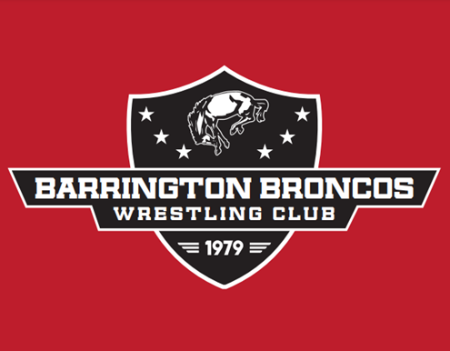

2025 BRONCO INVITE
February 16, 2025

Location: Barrington High School
616 W. Main Street, Barrington, IL 60010
(expanded parking with reconstruction – NO PARKING ON HART ROAD!)

Entry Fee: $35 per wrestler, with Tots at $25.

Registration: Pre-registration required. NO WALK-INS.

Deposit: $150 non-refundable deposit due 12/15/2024 (or total amount if less than 5 wrestlers)
Venmo - @Barrington_Broncos_WC (specify Club name in notes)
Square – Follow LINK (specify Club name in required field in checkout)

Final Payment: Balance due day of tournament.

Weigh-ins: Remote, per Ambrose Team Instructions.

Start Time: 3 Sessions- Start times are TBD based on the final count- More information to follow.
Session 1: 8:00 AM Tots/Bantam
Session 2: 11:00 AM – Intermediate
Session 3 1:00 PM - Novice/Senior/Elite

Divisions: Tot (6&U), Bantam (7-8), Intermediate (9-10), Novice (11-12), Senior (13-14),
Elite (open - no age group). Dedicated Boys & Girls Divisions.
**Please Note: In order to promote appropriate competition, the BBWC reserves the right to place wrestlers, at our discretion, into the elite division. Our guidelines: any previous season IKWF state qualifier (novice or senior) place winner (1st through 3rd) will be entered into the Elite division. Any wrestler may also choose to enter the elite division.

Format: • Tot & Bantam; 4-man brackets, blocked weights.
• Intermediate, Novice & Senior; 8-man brackets, blocked weights.
• Smaller brackets when necessary.
• Elite; 4-man round-robin brackets, blocked weights.

Awards: Tot & Bantam; 1st place horseshoe! 2nd-4th place medals.
Intermediate, Novice, Senior & Elite; 1st place horseshoe! 2nd-5th place medals.

Admission: $5 for adults and students, Kids under 6 and carded Coaches are FREE.

Concessions: Available all day.

Information: Contact Matt Hughes at BBWC.Matt@gmail.com

