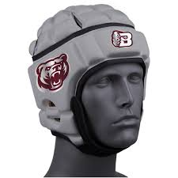
Bastrop Youth Football Equipment Agreement

Player’s Name:________________________________________________________________

I agree to be held financially responsible for all equipment checked out to my son/daughter. This includes equipment that may be lost or stolen during the time I am responsible.
All equipment is property of Bastrop Youth Football.
I agree to provide a security deposit to cover the replacement cost of all the equipment. I am responsible for in the amount of $20.00. I understand that my security deposit will be returned to me only upon returning the equipment to Bastrop Youth Football in the proper manner. Failure to return the equipment in a proper manner will result in Bastrop Youth Football retaining the $20.00 security deposit.
Issued Equipment:
⬜ Softshell Helmet (size) : ______________________________________________

BY SIGNING BELOW, I CERTIFY THAT I HAVE READ THIS AGREEMENT, THAT I KNOW AND UNDERSTAND THE MEANING AND INTENT OF THIS AGREEMENT
Parent/Guardian Signature: ________________________ Date:______________________

