HOCKEY INTERNSHIP OPPORTUNITY
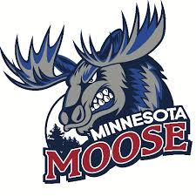
Minnesota Moose, United States Premier Hockey League
Part Time
Half Season (Sept-Dec, Jan-Apr) OR Full Season (Sept-Apr)
The Minnesota Moose Hockey Club, are moving in to the fourth year of operation and are looking for motivated, passionate interns to assist with operations during the 2020-2021 season. Moose internships are full-time or part-time and allow students the opportunity to gain valuable work experience within a sports organization through hands-on experience. A successful applicant will demonstrate strong organizational skills along with initiative, resourcefulness, and an ability to collaborate with team members for the achievement of team goals. In past years, interns working with Jr. A hockey teams have been successful in securing full time positions across a wide field of industries post-internship. Career mentoring is a central aspect to the Moose internship program.
Hockey Operations Internship
Equipment, Statistics, & Video
- Responsibilities
  - Daily practice/game setup of the locker room
  - Coordinate with opposing teams for any hockey-specific needs
  - Sharpen skates and perform minor equipment repairs
  - Monitor and track equipment
  - Inspect equipment daily to comply with USPHL league rules
  - Assist the Assistant Coach for practice or game tasks
  - Statistics/video breakdown as needed from coaching staff
- Qualifications
  - Strong knowledge of hockey
  - Skate sharpening skills preferred
  - Skating skills preferred
  - Sewing skills preferred
  - Strong communication and organization skills
  - Able to multi-task in a fast-paced environment

- To apply, please send cover letter and resume to mnmoosecoach@gmail.com

Jon Jonasson
Head Coach/ General Manager
952-457-0525
mnmoosecoach@gmail.com

