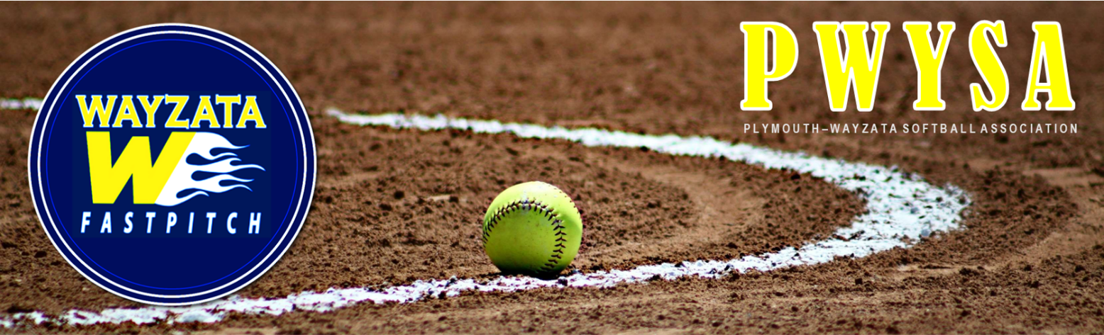

PWYSA COACHES’ CODE OF ETHICS | SIGN, SCAN/PHOTOGRAPH & EMAIL TO ANDY.STELLMACHER@TARGET.COM

As a Coach, I promise to:

- Be responsible for my own behavior and also the behavior of my team members, their parents, and fans during practices, games, and tournaments.
  - I will demonstrate positive support and encouragement for all players, coaches, and officials.
  - I understand that poor sportsmanship toward officials and/or coaches will not be tolerated by the PWYSA Board.
  - I will demonstrate respectful behavior toward opposing coaches, players, and parents.
- Never physically, verbally or mentally harm a child in my care.
- Lead by example and encourage my team members to play by the league rules and respect the rights of other players, coaches, fans and officials.
  - I will always encourage players to play their best and reach their greatest potential during games and tournaments.
  - At no time will I negatively affect the outcomes of games and/or tournaments to encourage playoff games in lower brackets to achieve perceived success.
- Provide a sports environment for my team that is free of drugs, tobacco, alcohol, and abusive language and refrain from their use at all sporting events and practices.
  - I will not consume alcohol or any other controlled substance while on the field, in the dugout or at the park, before and between games until after the last "Out" of the day when players are returned to the supervision of their parents for all events and practices, including traveling tournaments.
- Make every effort to improve my knowledge of coaching techniques so that I can teach the sport properly to my players.
- Obtain, read and abide by the rules and guidelines for the league, and teach these rules to all players on my team.
- Place all coaching efforts into developing fundamental skills, mental skills, and teamwork skills necessary to produce the most well-rounded softball player I can.
- Ensure that my players are supervised by myself or another designated adult and never allow my players to be left unattended or unsupervised at a game or practice.
- Never knowingly permit an injured player to play or return to the game without proper medical approval.
- Ensure that all equipment used by my players is safe and conforms to the rules of the game. I shall not allow illegal or unsafe equipment to be used.
- Respect the game and league officials and communicate with them in an appropriate manner.
- Begin and end practice on time.
- Ensure all players have an opportunity to improve their skills.
- Ensure all players have an opportunity to play in the games.
- Create a playing environment that is well-organized, professional, and FUN!

Violation of this code will result in a meeting (via in person, email, or phone) with at least one PWYSA Board Member. If the situation becomes extreme, this could result in my removal from coaching softball.

________________________________________
Signature Date

_________________________________________
Print Name

