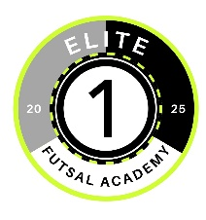
Elite 1 Futsal Academy
512 Roquefort St.
New Braunfels, TX, 78130
elite1futsal@gmail.com | 210-570-7765

Dear Community Supporter,
We are excited to introduce Elite 1 Futsal Academy, a youth sports program based in New Braunfels, TX, dedicated to developing young athletes through the fast-paced, skill-focused game of futsal. Our mission is to provide a positive, competitive environment where players can grow in confidence, discipline, and teamwork—on and off the court.
This fall, we are hosting open tryouts on November 15 and 29, 2025, from 5:00–6:00 PM at Gruene United Methodist Church. These sessions are free and open to youth of all skill levels, and we are committed to keeping our program accessible to all families, regardless of financial background. We are striving to break free from the pay to play format.
To make this possible, we are seeking support from generous individuals and businesses in our community. Your donation will help cover:
- Indoor court rental fees
- Equipment and uniforms
- Tournament registration costs
- Scholarships for players in need
As a sponsor, your name or business can be featured on team banners, social media, and event materials, showing your commitment to youth development and community engagement.
If you’re interested in supporting Elite 1 Futsal Academy, please contact us at elite1futsal@gmail.com or 210-570-7765. We would be happy to provide more information or arrange a time to speak with you directly.
Thank you for considering this opportunity to invest in our youth. With your help, we can build something truly special for the young athletes of New Braunfels.
For the Love of the Game!
Coach Bill
Executive Director of Coaching Elite 1 Futsal Academy
elite1futsal@gmail.com

