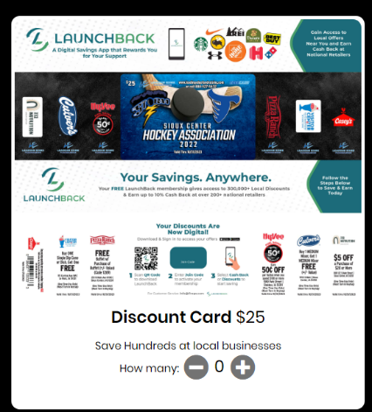
- Log in and Click on Place Order
- Change the quantity to how ever many you sold

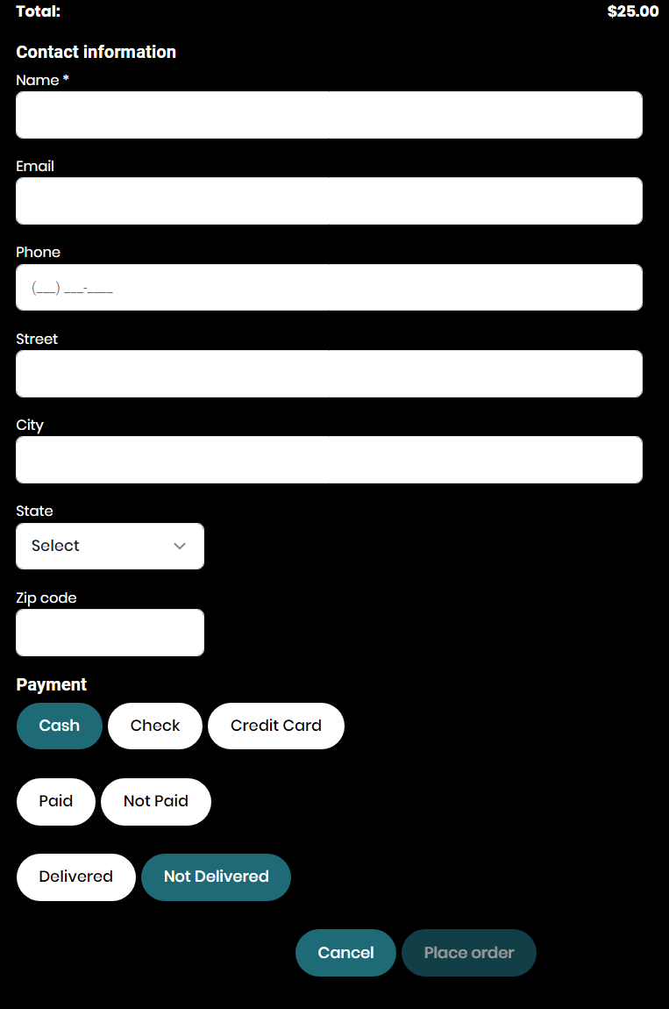
- Enter Name

- Choose Cash, Check, or Credit Card

- Select Paid or Not Paid

- Select Delivered or Not Delivered

- Click Place Order

