Registry Instructions for Returning Coaches
Below are step-by-step instructions for becoming an active member of the Coaches Registry.
Thank you for your interest in Coaching with HCRP. Without your help, we would not be able to provide such wonderful programs for Howard County youth.

Please follow the below steps to complete the Coaches Registry.

- Go to the volunteer website- https://hocovolunteer.org

- From the main page, scroll down to search for the coaching opportunity that you are interested in. You may select a specific sport by using the keyword feature, Example; type “soccer” as the keyword.
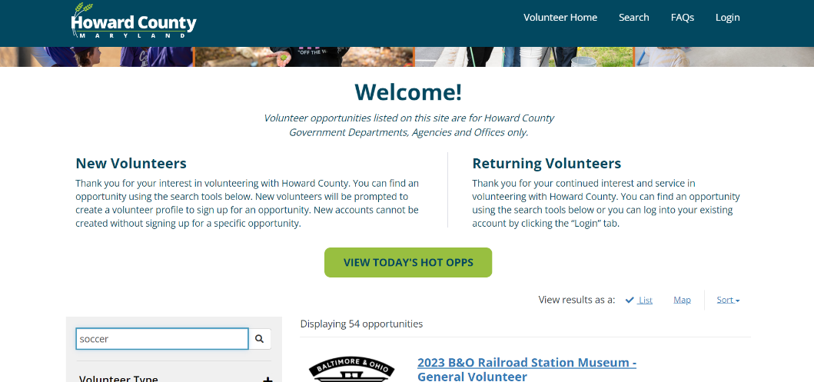

- Once you have located the coaching opportunity that you are interested in, click on the box that says “more details” to view the requirements for that opportunity.

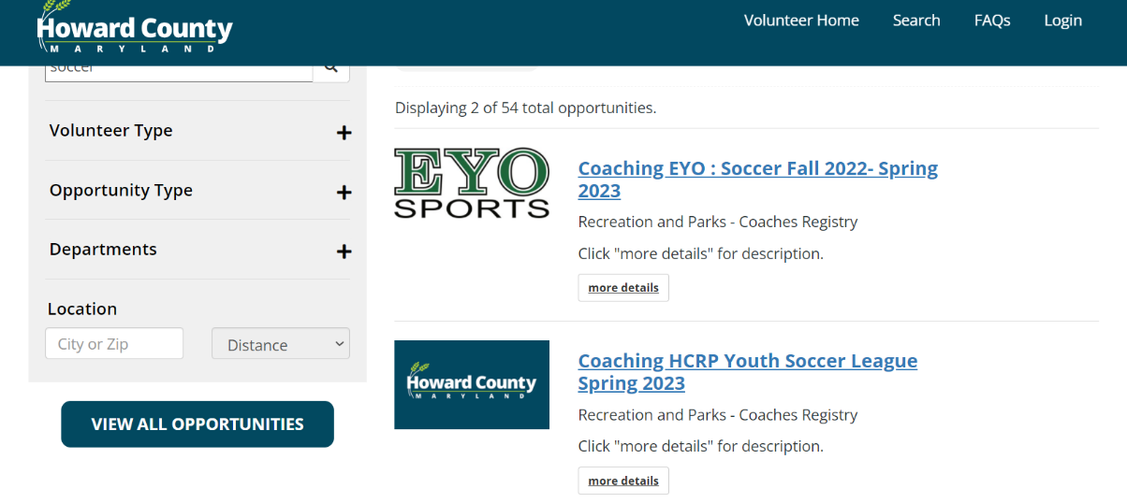

- After reviewing the requirements for the opportunity, please click on the “sign up” button under the title of the opportunity, on the left side of the screen.

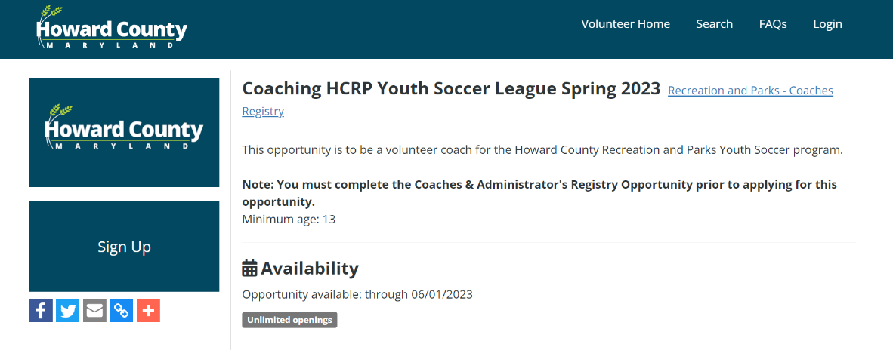

- Click Login to access your account.

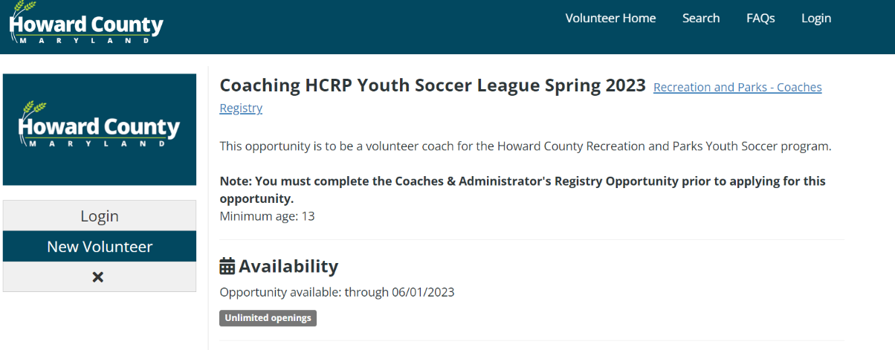

Enter your USER ID and password. Review Requirements for opportunity and click “Continue”.
You will receive a message stating that your opportunity sign up was successful.

If you have any questions or need assistance with the registration process, please email coaches@howardcountymd.gov for assistance.

We thank you for your interest in Coaching with HCRP.
Our programs could not happen without YOU!

