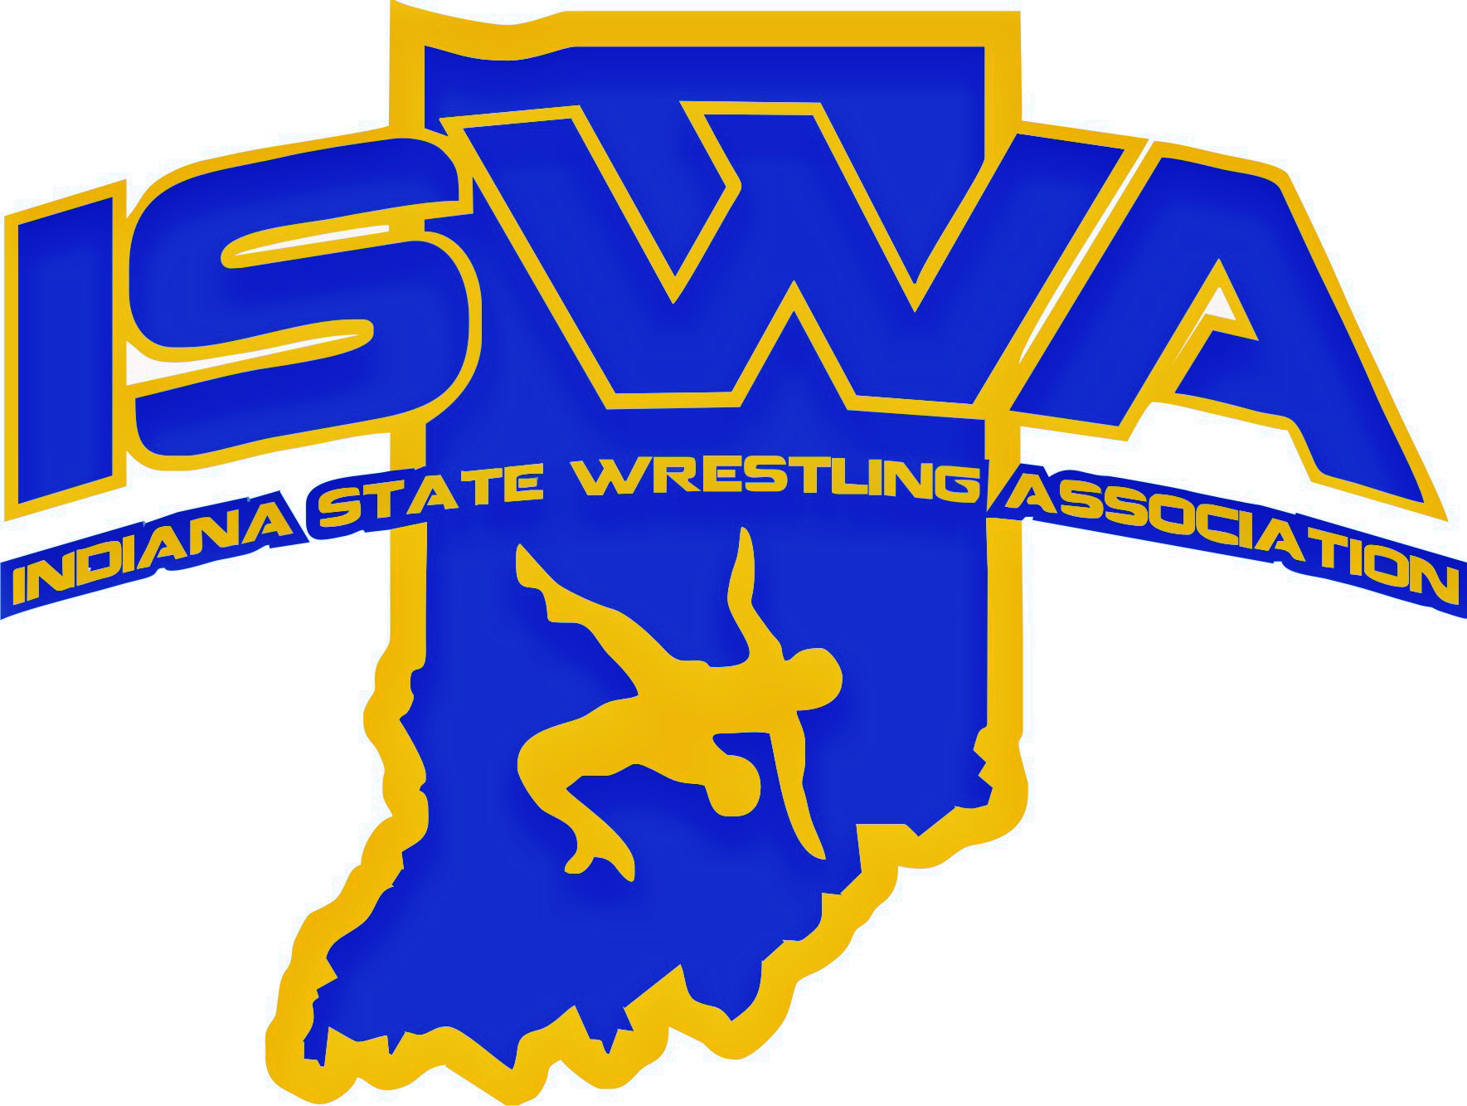
INDIANA STATE WRESTLING ASSOCIATION, INC.
P.O. Box 157, Beech Grove, IN 46107 Phone: 317-780-1885

September 2025

2025 Hospitality Report

The 2025 tournament season began in January with the Elementary Duals at Franklin Community High School in Franklin, Indiana.

Also, in January, the ISWA hosted the Folkstyle Nationals and Middle School State Duals at the Ft. Wayne Coliseum. Any National tournaments that are hosted in Indiana will also have a Social for VIPs and Officials. As always, the ISWA and hospitality team are thrilled to host the social event for the VIPs and officials. The social was catered by the Ft. Wayne Coliseum staff, which did a great job.

In March, our next event was our annual Folkstyle and Girls State tournaments, which were held this year at Nexus Park in Columbus, Indiana. This was our first year at this venue, and it turned out to be a good event. Our hospitality venue was in a good area.

Our Freestyle and Greco State were held at Avon High School again on the first weekend of May. I would also like to extend a big thank you to the coaching staff, who made sure we had ice when needed. You may not be aware, but having ice at an event is very important. It helps us ensure that the volunteers and staff stay hydrated and helps keep food cold when there is no refrigeration.

In June, we held the USAW 14U/16U and Junior Women's Duals in Westfield, IN, at Grand Park. It was a pleasure to host this event and provide hospitality services to our VIPs and Officials. I want to extend a big thank you to Grand Park for helping us feed our staff, VIPs, and officials. Also, since this was a national event, we held it at Grand Park this year. It seemed like the VIPs and Officials enjoyed their time at the Social. The food was provided by Big Hoffa’s BBQ in Westfield.

Also, before the Women’s Duals started, I catered the camp for the Indiana Women's team. I was very proud to help with the camp by feeding the girls.

On August 3rd, the ISWA hosted its Annual Awards Banquet. This year, it was held at Center Grove High School. There were over 200 youth and their families who attended this event. The attendees were served with a continental-style breakfast. Seeing the smiling faces and excitement of the attendees was heartwarming. Thank you, Center Grove, for hosting this event for us, and great job!

I would also like to thank the ISWA Board/Directors for their support. I would also like to send a very very special thank you to the Officials for their kind words and thanks (at every turn, they showed their appreciation).

I cannot express how blessed I am to have Kandace, Charlotte, and John Miller helping me again this year. My niece Lauren Terry was also instrumental in helping us with hospitality again this year, especially with the USAW 14U/16U and Junior Women's Duals. God bless each and every one of you who is associated with the wrestling programs in the state of Indiana, and PLEASE keep me in your prayers! I have been a part of wrestling for over 25 years and am very proud to be part of the Indiana State Wrestling Association.

Again, Thank You for Your Support,
Linda Robinson
Hospitality Director

PS: A lot of you probably are not aware, so I am going to take this opportunity to inform you. At the ISWA Folkstyle and Freestyle/Greco tournaments, we hold a chapel service, which this year was conducted by my husband, Dr. Claude Robinson Sr. If you have never attended this service, in 2026, I invite you to attend.

