
Player/Parent Meeting Agenda
November 12th, 2024

Introductions
Meet our Coaches & Board Members
Varsity Head Coach – Sara Junkermeier
4th grade – Tim Garry & Tonya Mortenson
5th grade – Cody Toothaker, Brian Kawecki, & Angie Toothaker
6th grade – Adam Garbers, Kent Larson, & Sara Edmundson
7th & 8th grade – Rick Ehlert & Dave Christenson
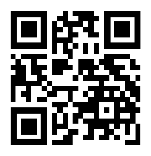
Website address – www.fairmontgirlsbasketball.com
Facebook Page – Fairmont Girls Traveling Basketball Association (Regular updates and reminders)
Player/Parent Handbook
QR CODE FOR HANDBOOK
**NEW** FGBA Eligibility Policy**
Friendly Reminders from our Association & Coaches
Fair Playing Time based upon Attitude, Effort, Ability, Good Teammate & Attendance
4th Grade – Fair Playing Time 5th Grade – Fair Playing Time 6th Grade – Fair Playing Time with a focus on winning7th & 8th Grade – Competitive
There’s a saying – “Players play, coaches coach, referees ref, and parents cheer!”
Practice Jersey
24-hour Cooling Period
Please use Door 17 (west side of school) for drop offs and pick ups
Locker Rooms – no personal items left in the commons area
Personal Hygiene
Streaming games on Facebook (Thank you parent reps!!)
Deposit Fees Due
$100.00 for uniform deposit fee & $100.00 for tournament deposit fee
Pay tonight or due at your next practice
Fairmont Girls Basketball Tournament – Saturday, February 1st
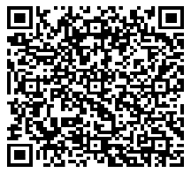
All families required to work one scheduled shift
Looking for donations for our tournament
FGBA Sponsorships
QR CODE FOR SPONSORSHIP
Looking for annual sponsorships for our association
Practice/League/Tournament Schedules
Coaches will be communicating all schedules and changes with their teams
Fairmont hosts league day on December 7th
FGBA Night at Home Varsity Games

4th grade – Tuesday, February 4th 5th grade – Friday, December 20th 6th Grade – Friday, January 10th
Clothing Order
QR CODE FOR CLOTHING
Orders due November 21st

Watson’s Warriors Fundraiser
Comments from Coaches and/or any questions??

Uniform Handout – 6th grade, 5th grade, 4th grade
Team Breakout Meetings while other teams are getting uniforms Parent’s Checklist
- Uniform Deposit Check - $100
- Tournament Deposit Check - $100
- Turn in Social Media/Handbook Form
- Daughter’s Uniform/Practice Jersey
- Meet Coach

