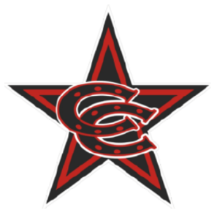

Spring 26 8U Premier Team Roster

Coppell Cowboys
Coach Drew Oosterhouse
- Eli Metz
- Grayson Holzrichter
- Ike Jones
- Lathian Pinch
- Mason Scott
- Paxton Bitter
- Soham Patel
- Sutton McMurtry
- Tyler Dunkelberger
- Zachary Johnson
- Zayn Patel

