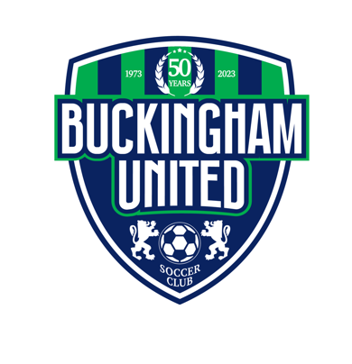
TRYOUT FAQ
2024-2025

WHAT IS THE PURPOSE OF TRYOUTS?

Tryouts are to help our coaching staff ensure the best developmental environment for every player. For current BUSC players, tryouts are the last phase of a year-long evaluation process and not based solely on the two tryout sessions.

Throughout the year and prior to tryouts, the coaching staff holds player progress meetings to discuss players and their performances on their current teams. These meetings help us to better understand who may be ready for the challenge of playing at a higher level as well as who may need to gain experience and confidence to reach their potential.

Our Directors of Coaching and Zone Directors are also heavily involved in the selection process. By evaluating players throughout the season in games and training sessions, this allows them the opportunity to share evaluations and suggestions with the coaches both throughout the season and tryout process.

The formal tryout is necessary as it allows us to evaluate players in game like situations and make comparisons. For players who have been with BUSC, this is the last step of the tryout process. This also allows the coaching staff an opportunity to incorporate players from outside the club and evaluate their level of play.

WHAT HAPPENS AT TRYOUTS?

The primary focus of tryouts is to see how players react when faced with decisions that they will come across on the field. For that reason, the majority of tryouts will be made up of small-sided and full-sided games. Our coaches will often move players around in different groups to see them compete against each other. This allows coaches the opportunity to better understand the level of play of individual players.

After tryouts, our coaches and directors meet to discuss player evaluations and place them on the developmentally appropriate team.

DO I NEED TO REGISTER?

Yes. Please register for tryouts here. There is a $20 registration fee that includes an Adidas Climalite training shirt.

WHAT AGE GROUP SHOULD MY PLAYER TRY OUT FOR?

Please note that BUSC is adhering to USSF guidelines related to birth year play. Please see the age chart below. If you have any questions, please contact john.adair@cbaasports.org .

Birth Year | 2021-2022 Age Group
2017 | U8
2016 | U8
2015 | U9
2014 | U10
2013 | U11
2012 | U12
2011 | U13
2010 | U14
2009 | U15
2008 | U16
2007 | U17

SHOULD MY PLAYER ATTEND BOTH TRYOUT SESSIONS?

Simply put…YES. While only one is required, attending both sessions gives the coaching staff a better opportunity to evaluate your player and place them appropriately. For this reason, we strongly recommend attending both tryout sessions whenever possible.

WHAT SHOULD MY PLAYER BRING TO TRYOUTS?

- Cleats
- Shin guards (Must be worn for the entire session)
- Plenty of water
- Weather-appropriate training apparel
  - A training shirt will be provided for you

WHAT DO COACHES LOOK FOR AT TRYOUTS?

All players are evaluated based on the four pillars of the game:
- Technical
- Tactical
- Physical
- Psychological

Players who exhibit a strong work ethic and display a respect for the game, coaches, and fellow players will show well.

WHAT SHOULD WE DO IF WE CAN NOT ATTEND TRYOUTS DUE TO VACATION OR INJURY?

For special circumstances, please contact john.adair@cbaasports.org .

WHEN DO I FIND OUT IF MY PLAYER HAS MADE A TEAM?

All players will be notified of their status within 72 hours of the age group’s final tryout session.

HOW WILL I BE NOTIFIED IF MY PLAYER MAKES A TEAM?

All players will be notified of team placements or age group status via email. BUSC will notify the email address used for tryout registration.

HOW LONG DO I HAVE TO ACCEPT A SPOT ON A TEAM?

New this year, players will have five days to accept their spot on a team. Positions not accepted within seven days can no longer be guaranteed.

WHAT CAN I EXPECT FROM A TYPICAL BUSC SEASON IF MY PLAYER IS SELECTED FOR A TEAM?

BUSC teams play year-round in leagues such as ICSL, EDP, and PAGS with seasonal breaks during the winter and summer. The start of the soccer year is August 1. While teams may elect to attend camps or train before then, most will begin preparing for the fall season during the late summer, including a week-long team camp.

Teams will typically play ten league games and 1-2 tournaments during both fall and spring seasons. After a holiday break from Thanksgiving through December, teams will begin winter training at our Indoor Training Center and/or other local facilities.

BUSC Time Commitment
Late Summer – Late November | Fall Season ; (2) 90 minute sessions weekly & 1-2 Games per week
January – Mid-March | Training 1-2x weekly & Futsal Games/Tournaments
April – Early June | Spring Season ; (2) 90 minute sessions weekly & 1-2 Games per week

