“How to Guides” for Membership Registration System (MRS)

- New Member Registration
“How To” Steps | Screenshots
Go to mrs.ontariovolleyball.org | 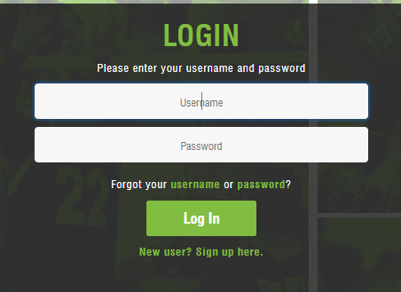
Select ‘New user? Sign up here.’ | 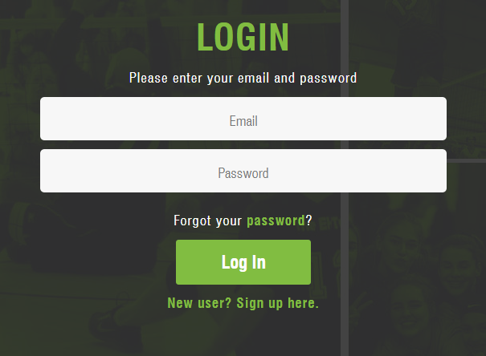
Enter the new member information (first name, last name, email address) | 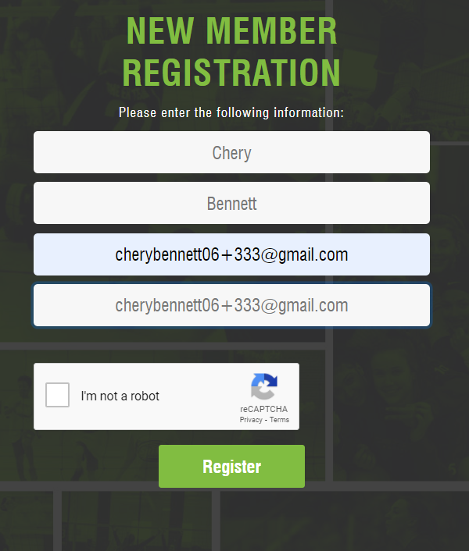
Click the reCAPTCHA box to verify the robot check | 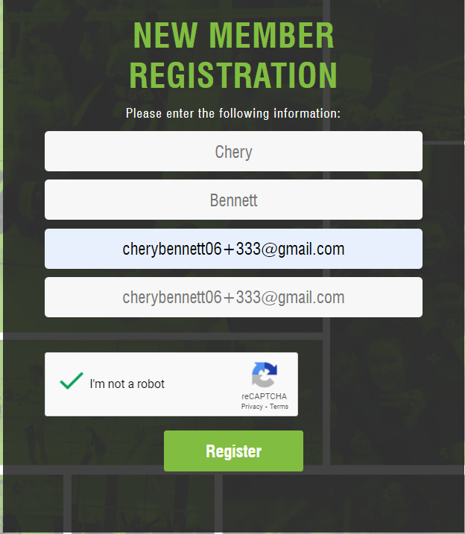
Click Register

Member should receive an email from OVA MRS – Email Address Confirmation with a link to verify the account | 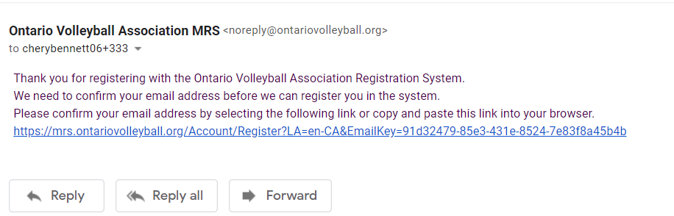
Click the link to verify the account
Fill out the required information needed to create the profile in the registration system (username, password, first name, last name, birthdate, gender, security question/answer, phone number, address, city, postal code, PTA, region, province, emergency contact information) | 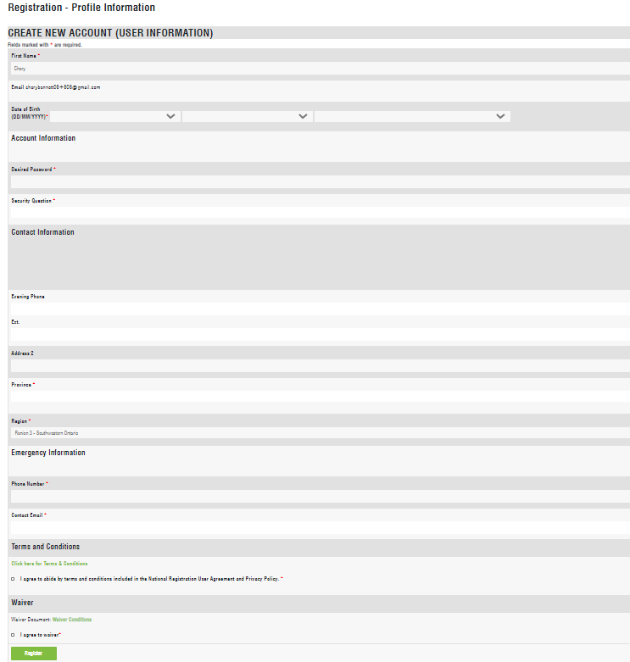
Agree to the terms and conditions, waiver and click register | 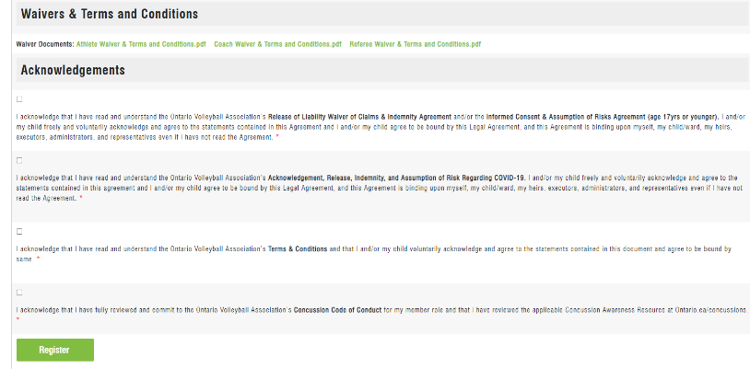
Select the appropriate role(s) from the list by checking the box(es)  Select the appropriate role(s) from the list by checking the box(es) | 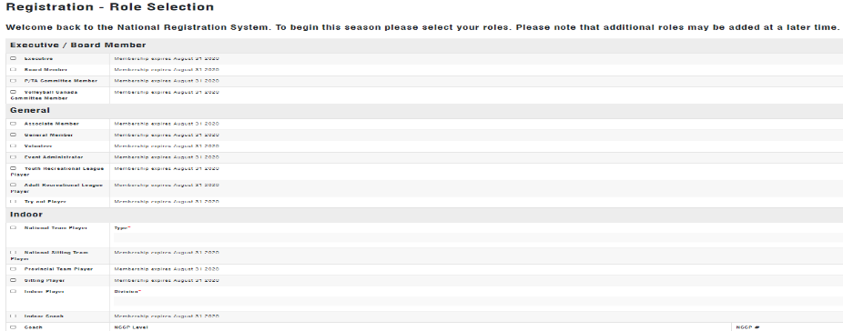
 | 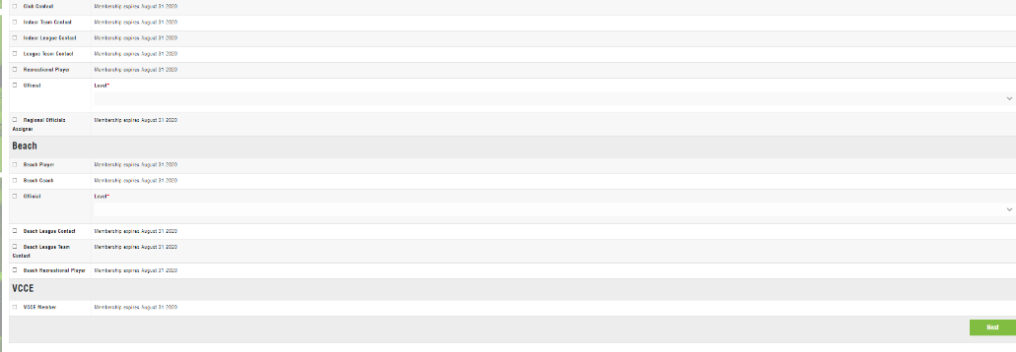
Click Next | 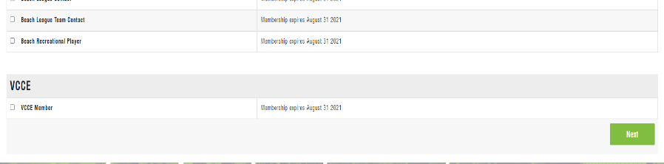
Fill out the required information for the Screening documents | 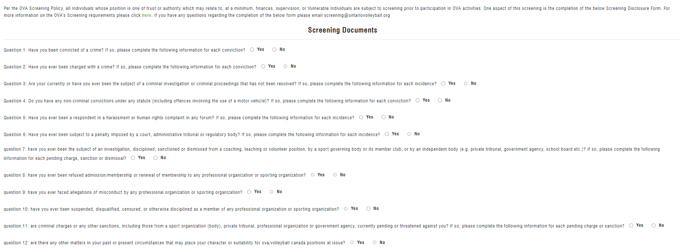
Agree to the Privacy Statement and Certification and click ‘Next’ | 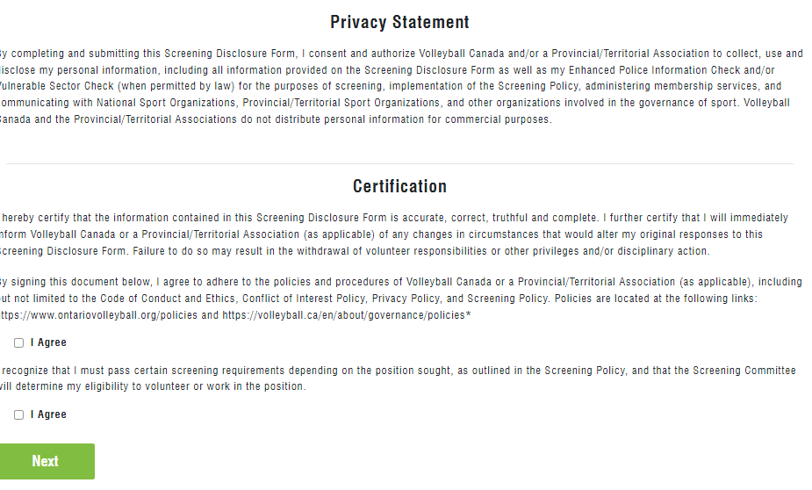
Enter credit card information and click ‘validate card’ | 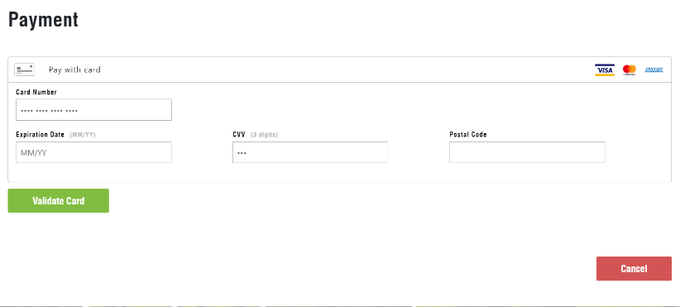
Select ‘Place Order’ | 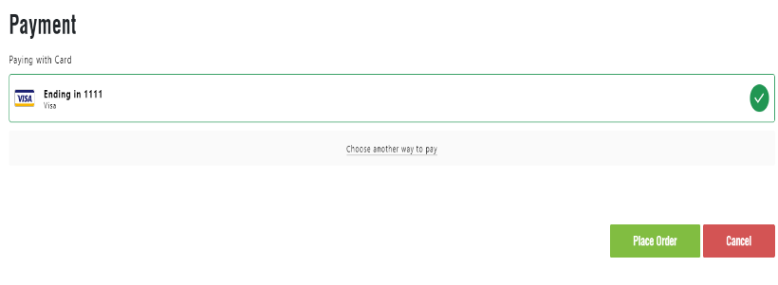
Review the completed order and the receipt.  Click ‘Continue’ | 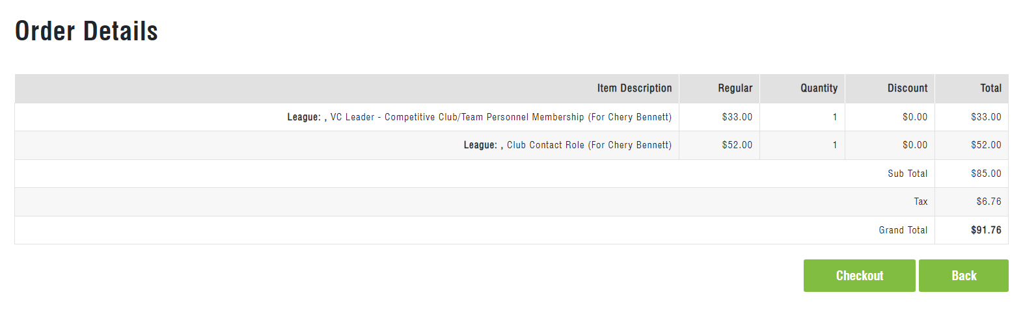
Congratulations! You are now registered as a member of the Ontario Volleyball Association Membership Registration System.  The selected role(s) will appear on the home page under ‘My Organizations’ | 