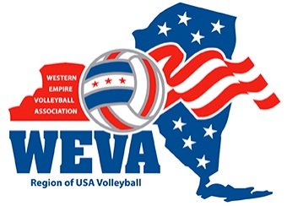
WEVA BOD Meeting Agenda

Date: Monday, January 6, 2025
Location: T.F. Brown’s, Batavia, NY
Time: 6:00 PM

Meeting Minutes from November 2024 Meeting – Sent via email
Approved via email vote: 10 - 0 - 0 approved on 11/XX/2024

President’s Report (Lucci)
- Attended AVCA Convention, Louisville, KY Dec. 18-22, 2024
- John Speraw Clinic – Roberts Wesleyan Univ, Jan. 3-4, 2025

Registrars Report (Page)

Financial Report (Page)

Tournament Report (Praller)

Officials Report (Cwiklinski)

Beach Report (Majeski)

Serve & Receive Grant Awards (S&R Grant Committee)
- 2024 cycle concluded, award money sent, follow-ups forthcoming

Junior Business Report (D’Errico)

Old Business
- VFX sport courts – contract finalized? WEVA payment?
- WEVA Handbook update – action item
- Boys Volleyball
- Recruiting / Spirit of WEVA

New Business
- Automated External Defibrillator (AED) Requirements for Youth Sports Leagues (Schneider)
- Gosleeves, VKTRY Performance insoles – partnership, discount code on web (Praller, Lucci)

Adjourn Board Meeting
Next BOD Meeting
- March 3, 2025 @ 6:00 p.m.
- Location: T.F. Brown’s Restaurant, Batavia, NY

