SportsEngine Website Guide:
https://help.sportsengine.com/en/articles/2876176-website-guide

- You will need “admin” access to edit the website. Current board members can give this access.

- Go to the SSRLAX website: https://www.sartellsaukrapidslax.com/home

- Sign in to SportsEngine

- Turn on “Edit Mode” (left side of screen)
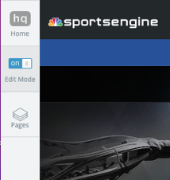

- While in “Edit Mode” it will look like this. Basic upkeep of website includes these tools:
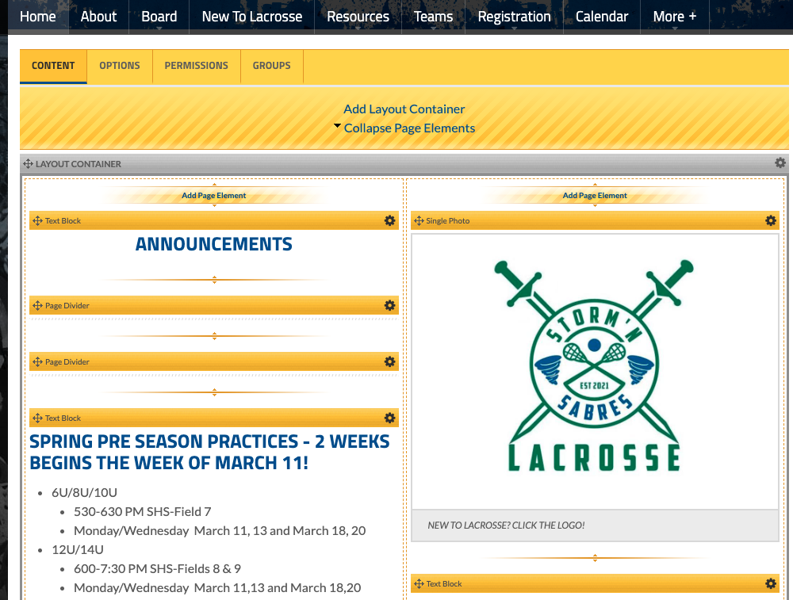
The layout container holds multiple page elements. Recommended to have more layout containers with fewer page elements for easier editing.
Options: allows you to copy, move, delete and edit the PAGE details

Permissions: You can set specific pages to “Disabled, Private, or Public” depending on who should have access to that page.

Allows you to add additional sections (elements) within the layout container.

This tool will allow you to edit that specific page element.

- Refer to online user guide for advanced features (see link above)

