***Attention Softball Parents***
Rehoboth Thunder Summer
All-star Team Tryouts for 2021
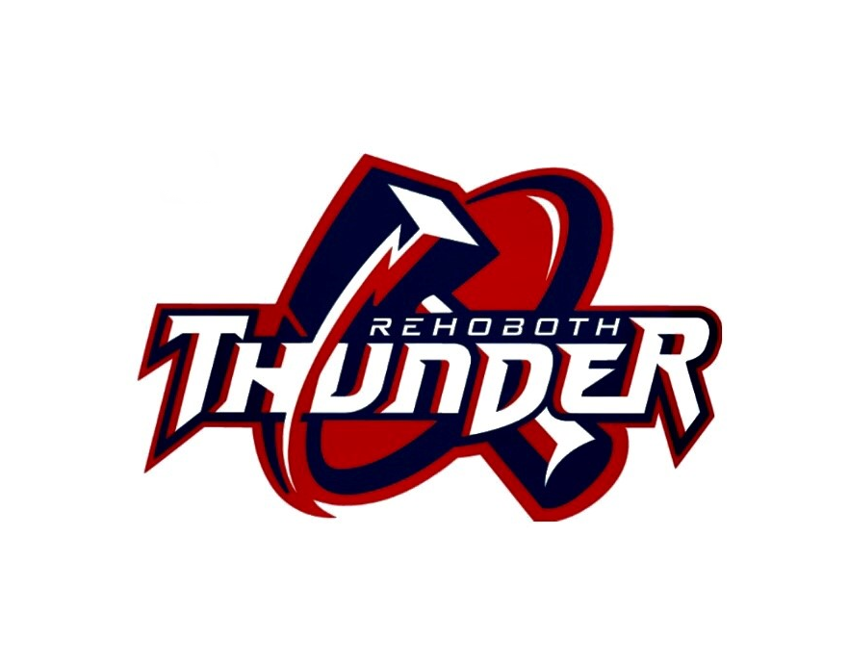
Come and join us on Friday, August 14, 2020 for the Rehoboth Thunder 10U & 12U All-Star team tryouts for the upcoming 2021 season.
Players from ALL surrounding communities are welcome. Become part of a growing, fundamentally driven program no matter what town you live in. The RYBSA complex is located at 42 Martin Street Rehoboth, MA 02769.
10U Thunder tryout located on field 5 check in is at 6:30pm.
12U Thunder tryout located on field 6 check in is at 7:00pm.
If you’re interested in trying out for the team but can’t attend the tryout or if you have questions, please email tomrm67@yahoo.com. Rain date is Sunday, August 16, 2020, at the same location and times listed above.

