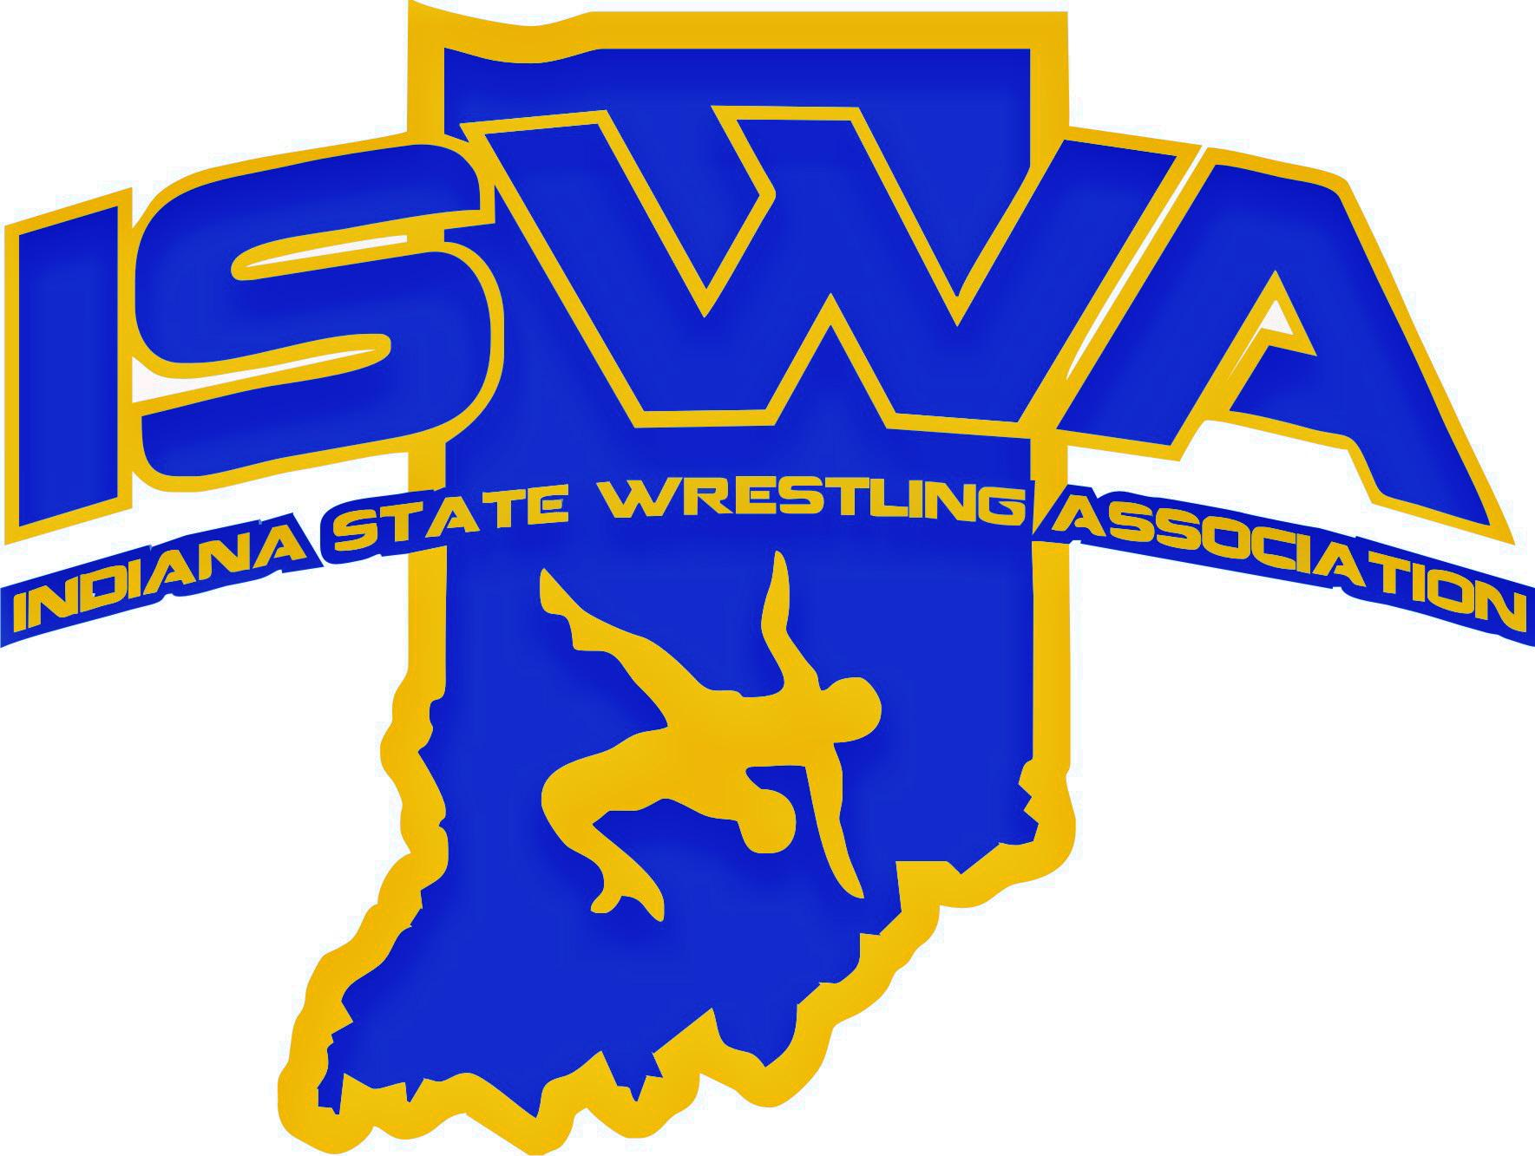
INDIANA STATE WRESTLING ASSOCIATION, INC.
P.O. Box 157, Beech Grove, IN 46107 Phone: 317-780-1885
Equipment Report

The 2024-2025 year kicked off quietly since both our in-state and national team gear vendor had been previously selected. That said, as an organization we were able to move straight into designs so that we can be prepared for all the upcoming events.

Ordering

Ordering was placed 8 weeks out and there was only one gear package to choose from this year.

Distribution

Gear was shipped to the ISWA office and it was pre-packaged by weight. For example, if the manufacturer stated a 106lb wrestler wears “XS” in singlets, ¼ zip, shorts, and shirt… then that is how it was packaged. The bags were packaged separately. Having the gear packs streamlined the distribution process and made things significantly easier for both the office staff and team leaders. There were extras for athletes to swap items out just in case they did not fit the specifications outlined by the manufacturer.

Vendor

Overall, the performance of 3X and Rudis was good this year. Rudis did run out of multiple items for the coaches (hats, polos, and t-shirts) causing us to either cancel an item or have to choose something that was close in color but not a 100% match.

Respectfully Submitted,

Jonah M. Odum
Equipment Director

