Kicking Notes
Aug 2019

Types of Kicking

- Kick-off
- Kicking for goal
- Penalty kick to touch
- Live kicking for field position
- Live kicking for catch and run-in

The field.

Ideally we should be discussing kicking in the context of the Rugby field. Unfortunately, we rarely play on rugby fields, we use football fields frequently instead. See the comparison diagrams on the next page. A full size rugby pitch is wider and longer than a football field. As a kicker you must know what the field is marked out as. If it’s a football field you have standard dimensions. If it is marked out as Rugby field at a tournament you should find out ahead of time what size they have set the fields to. You can get this from the tournament desk or the referees.

A football field is narrower and shorter than the maximum size of a Rugby field. For all of these notes and any practice we will discuss, the dimensions and markings of a football field are used except where the distance relates to laws of the game (the 22 meter line being the most significant)

Kicking as strategy
Rugby is different from football in that field position can be more important than possession. In football possession is king, this is why lateral passes are rarely ever done in football because the risk of losing possession is too high. In rugby we can put the opposition under considerable pressure by delivering the ball to them deep in their territory. We can also get out of trouble by kicking and staying confident that we can probably re possess the ball after a few phases. The laws of rugby also give an advantage to the team that can kick accurately. This occurs during penalties and under the laws that relate to the 22 meter line. High school teams are generally poor at strategic kicking. If we can develop good kicking skills, we gain a significant advantage and we protect our players and allow them more rest time.
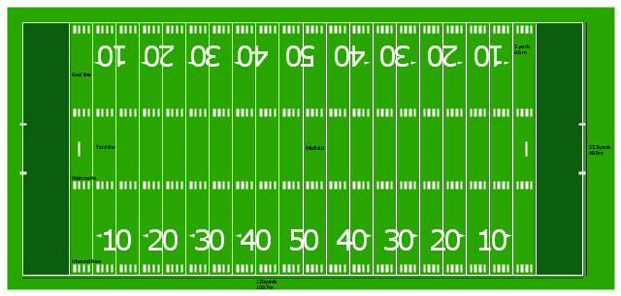
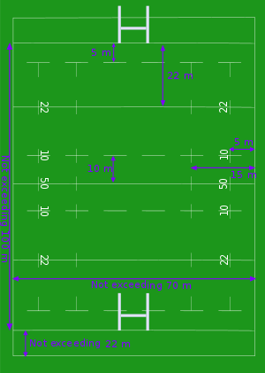

Kicking technique

As we go through different types of kicking we will refine the kicking technique. But most kicking has the same fundamental basics. The fundamentals are:
- Look at your target point and align your body so that you will approach the ball 45 degrees off from where you are aiming. Since your foot is going to swing across your body at impact at just about the same angle, and you want the inside big toe bone to hit the ball, the 45 degree angle starting point means you will line up to the target when you hit the ball.
- A solid and stable planted non-kicking foot arrives first and anchors the body.
- At the point of contact, head shoulders and torso are above and over the planted foot, not in front, not behind.
- Head down all the time, all the way through the follow through
- Raised hand and arm on the side of the planted foot to counterbalance the kicking foot
- Strong kicking action with a full follow-through that transfers the weight of the body into the ball. Good weight transfer gets power in the kick and is the key to controlled kicking
- Point your foot downwards and strike the ball with the bone above the big toe
- Strike the ball in the lower third of the ball
- Follow through, transfer your weight forwards and keep your head down

Kick-off

The Kick off requires a drop kick that goes at least 10 yards. So first let’s review the technique for the drop kick. Take a look at the Jacob McDonald video in the resources section for a quick video tutorial.
All of the items in the basic technique section still apply.
- A strong planted foot
- head and shoulders over the planted foot,
- head down,
- pointed foot
- strike the ball above your toe
- and follow through.
The key difference and the difficulty with the drop kick is dropping the ball and timing to kick. When you drop the ball, you want it to bounce up cleanly, so drop the ball on its pointed end, from a low height as this reduces the variation in how the ball will hit the floor and so how it will bounce back up. For the long drop kick you need to impact the ball just as it starts to bounce back up. For the higher kick you want to wait just a little bit longer so that the ball is higher in its bounce and your foot comes under the ball more.
There are many different strategies for kickoff in the professional game. But for high school let’s just focus on two.

- Kick for our team to catch
- Kick to put opposition under pressure

Kick to Catch

In a kick to catch the objective is to place the ball in a position where our team can run under the ball and catch it. This turns the kickoff into an offense play rather than a pressure defense play based on position. In a kick to catch the key attributes of the kick are:
- Hang time. The ball needs to stay in the air long enough for our players to get under it. This normally means the kick needs a high arc and from kickers foot to the point of the catch it needs about 4 seconds in the air
- Position. The easiest catch for our players to get to is a high arcing short kick. Unfortunately, that’s also the easiest for the opposition to catch. The position that the ball comes down needs to be over the heads of the first line of catchers and in front of, or on top of the second line of catchers. If the kick is too short the opposition gets an easy catch and can run straight back at us if the kick is too long our players cannot cover the distance fast enough and again the opposition gets the catch.
The picture below shows an optimum spot for the ball to land. Around the 25 to 28 yard line in the LHS or RHS of the field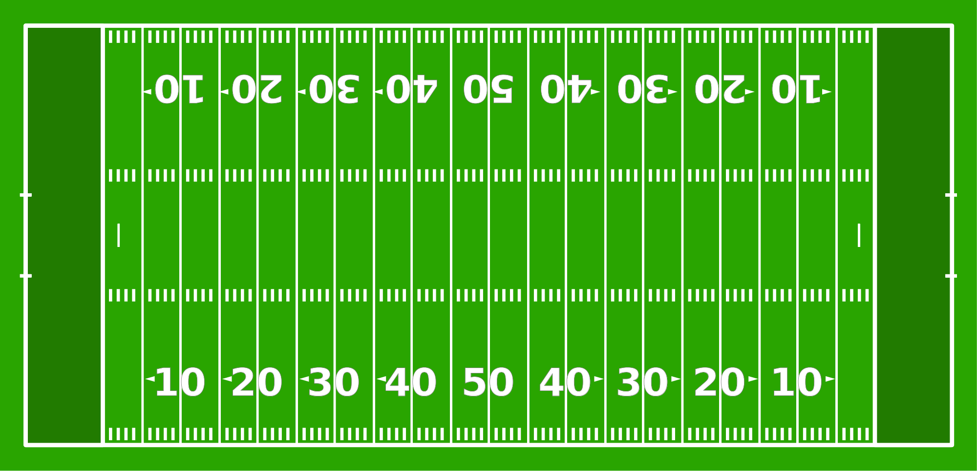
Their Half
Our Half
This requires a lofted kick and therefore your foot needs to get under the ball which means you need to strike the ball higher in its bounce. Try not to be tempted to lean back to get the lofting, that will result in a weak but high ball which won’t travel very far. You still need to ensure your head and shoulders are over the ball at the time your foot makes contact, but a less forceful follow-through and a more upward pointing foot will bring the ball on a steeper arc. The key to gaining the height is making contact with the ball later/higher in its bounce.

Practice points

- Place four cones in a square about 5 feet by 5 feet centered at the point you want the ball to land after you kicked it. So, on a football field that would be about the 28 yard line to the outside of the hash marks.
- Start at the center mark and try to kick to land the ball in the square. You are trying to get a high kick so the ball drops into the square but to start with just practice landing the ball in the square.
- Practice kicking both to the left hand side and the right hand side of the field
- Once you’re comfortable with being able to hit the square start to increase the hang time by delaying the time your foot hits the ball. This can be made easier if you also attempt a higher bounce, but be careful because higher bounces make a ball move left and right and make it hard to tout kick
- If you have a friend or coach available, have them time the hang of the ball. You are looking for 3.5 to 4 seconds hang time

Kick to put the opposition under pressure

If you can do a decent drop kick then kicking to put the opposition under pressure has little to do with kicking technique and most to do with observation. Key observation points are:
- Look for holes in the opposition line up. Holes can exist in the side to side lineup as well as the front to back line up
  - Side to side. Are the forwards heavily to one side and the backs heavily to another leaving the whole up the middle? Do their backs bunch in the middle of the field leaving the wings with lots of space?
  - Front to back. Is everyone lined up near the 10 yard line leaving any big gap behind them to the goal? Are forwards lined up deep but the backs lined up shallow?
- What do you know about the opposition? If you know who the most athletic players are don’t kick the ball to them. If you know there is a weak player in terms of catching or running you might want to choose that player as the target for the kick
- Where are you weak? If the opposition has a strong forward pack that is causing you trouble don’t kick the ball to them, if the opposition has fast effective backs don’t kick the ball to them
- If the opposition has a weak lineout capability and if you are very confident that you can get range and an in-the-field bounce then you might kick to the sidelines
If there is no obvious advantaged from the observations you have made then a strong kick for depth is probably your best option. You need to ensure that you kick over the first line of defensive players and cause the second line of players to backpedal. This disrupts the defensive alignment and gives your players time to run forward to the ball while also gaining ground on the opposition’s restart position. See the blue circle in the diagram below
Our Half
Their Half

Practice Points

basic
Using your cones set up a line the 25 yard line. Your goal is to ensure that the ball is still airborne when it passes that line. Cycle through target areas one kick at a time, starting on one side and going.
- Outside hash
- On the hash
- Down the middle
- On the hash
- Outside the hash
And then back again
In this practice , the follow through and keeping your head down are going to be key to gaining distance. You need to strike the ball just after it starts its upward journey after the bounce. Point your kicking foot and make firm contact at the bone of the foot and follow through, pivoting on your planted foot and stepping through the kick after impact to allow all your weight transfer into the kick.

Advanced
Once you can hit the cone line satisfactorily, work on the speed and guile of the pre kick. At the kickoff you don’t want to telegraph where you are kicking, so work on making your targeting decision before you line up and make your lineup swift and accurate.

Kicking for goal

In kicking for goal the basic kicking technique still applies but you have more time and you don’t have to bounce the ball like you do for a kickoff. Here is a step by step guide to kicking for goal
- Angle the ball on the kicking tee forwards so that you can see and hit it at about the lower one 3rd of the way up
- Place your non-kicking foot at the side of the ball about 1 foot away from the kicking tee
- Take a large step back. The reason the first step back is larger than your others is because when you return to the ball you last stride is going to be longer than the approach steps.
- You want to approach the ball from a 45° angle, so either walk away from the ball on a 45° angle or take the first three steps backwards and four steps sideways
- Once you reach your starting position look up at your target and think about your run into the ball and how you’re going to strike the ball. Focus on the center of the goal posts. Once you start your running and all the way through the kick your head is going to bent down and focused on the ball.
- Run into the ball position making sure your non-kicking foot gets planted first and firmly next to the ball.
- The upper torso and the head should be over the ball at the point you make contact with the ball. Try not to get ahead, or lean back.
- Power in your kicking does not come from how far back you start your foot, it comes from how well you transfer your weight in the follow through. So just take your foot back a comfortable distance and make sure your follow-through is strong.
- Strike the ball at the lower 1/3 and since you come to the ball from a 45 degree angle , as you swing your leg through, your foot will wrap around the outside portion of the ball
- Make contact with the ball with the bone on the crest of your foot, above the big toe. If you are unsure where this is, feel your foot and identify the solid ridge above the big toe area.
- At all times keep your head down
- As you strike the ball raise the arm on the side of the non-kicking foot to counterbalance the kicking foot.
- Use the planted foot as your anchor and as the kicking foot comes through the ball, pivot slightly up and outwards on the planted foot to bring your body weight through the kicking action.
- Follow through completely with the kicking foot and then plant firmly on the ground, almost like running through the kick.

The Kicking masterclass by Dave Alred on You tube does a great job of breaking down the kicking action in a 5 minute video. It is listed in the resources section. Also 10 pillars of goal kicking ( also in the resources section) is a great video, it’s a lot longer and it has women doing the kicking too !

Practice points

Basics.

If you are new to kicking or have concerns about your basic technique, just practice the basic kick straight at the posts. Practice the set up , step back, look at the target put your head down and kick through the ball. As in Dave Alred’s video, at first practice running through the kick, this will get you comfortable with the weight transfer. Don’t worry about range or accuracy yet, just get the timing and body balance right.

Advanced

In kicking practice makes perfect. You need to increase your range and your off-angle accuracy.
Range comes from the weight transfer technique and key to that is the accurate planting of the non kicking foot and using it as a stable platform to bring your weight through the kick.
Lifting the head is a source of poor accuracy. Lifting the head causes the body to straighten and changes the point of impact of the foot. It is crucial that you get used to the kicking body position so that muscle memory ensures consistency in the kick.

The Punt kick technique.

Outside of the kickoff and the placed kick, all other kicking takes place in the field of play and sometimes under considerable time pressure from the opposition. In these cases, the ball is not placed or bounced on the ground, it is thrown down at the kicking foot which impacts the ball before it hits the ground. There are a number of techniques for this but the one we’ll focus on is the end over end kick. Also, since these are more dynamic kicking techniques and we’ve been over the basic form several times, videos are the best explanation for these techniques. Jacob McDonald’s video on how to do the punt is excellent and breaks down the essentials for you. (see the resources section)

Basic form

For beginners we need to just get body position right. For this there is a good video that gives you a basic form to practice. It’s a little stiff for actual game play but once you master it you can go to Jacob McDonald’s video to get the full form. The video is by Matt Sherman from Stanford. Watch the first 5 minutes for the basic technique. The elements should be familiar.
- Hold the ball with two hands either side of the ball
- Solid plant of the non kicking foot
- Head down,
- head and shoulders over the ball at impact
- Counter balance with the arm on the non kicking side
- Bring your weight through the kick.

Advanced form

The Matt Sherman video sets up the basics and that will work fine if you have time and are just needing to get the ball up and out of the way, All forwards should at least be able to handle the basics. But for the backs, the full back and wings especially greater distance and accuracy is needed. For this you want to force the ball down to the kicking foot. This is more of an Aussie rules punt kick and can be done quickly and powerfully, but requires more skill. The Jacob Mcdonald video does a good job of showing that technique.

Practice points

Basic
Basic technique can be practiced with a friend or coach standing about 15 yards away and a pile of balls to kick to them. Just practice the form from the Matt Sherman video. You are trying to get repeated good strikes that land in the hands of your partner. Don’t try for distance. You want to get the feel for the technique. Force yourself to have your head down and your counterbalance arm up and pointing at the target at the end of the kick.

Basics in play
The basic method from the video, with a little more flow and freedom will serve you well in actual play. A brief pause in forward movement to allow the setup, and then drop the ball to the kicking foot, head down and follow through.
To adjust the height of the kick, adjust the point at which you drop the ball but keep the timing of the kick the same. The higher the drop point, the higher the kick will go. Practice this with a friend for a few kicks between you, don’t go for range, just get the feel of the height difference in the kick that comes from the difference in height when you drop the ball. Start with a drop point low to the foot and notice how the ball takes a long low flight. Keep the timing of your kicking leg the same but now adjust the drop point up about 1 foot at a time and notice how the height increases and the distance reduces.

Advanced

Now you want to take that basic technique and add in the downward throw of the ball to the kicking foot and a more explosive kick. Build this up slowly, get the timing of the downward throw and impact by again kicking a pile of balls to a partner about 20 yards away. Once you get comfortable with that timing start to open up the distance and extend your range while trying to keep accuracy.

Expert

In a game situation, especially for the full back, the kick often has to be made on the run. For this practice lay out a set of balls in a diagonal line starting on the 20 yard line and being space out about every 10 yards up the field, and either mark out or have an imaginary target to hit, as in the picture below

Start Here
- Start behind the first ball
- Run to the ball and pick it up
- Run to the second ball
- At the second ball you need to make your down field kick with the ball you are carrying.
- Then pick up the second ball and run to the third,
- Repeat until all the balls are kicked.

Punting for touch.

Kicking for touch can be a defensive move, during live play where you need to get out of trouble, or an offensive move when you have a penalty and have the opportunity to gain ground and own the resulting lineout. In both cases the end over end punt can be used.

Penalty kick to touch

In the case of the penalty kick the kicker has more time but the kicker must know the range they can hit from their point in the field. Failing to put the ball out of play squanders the penalty, but also putting the ball way out of touch does not optimize the distance advantage down field that could have been gained.

Practice points

The penalty kicker needs to know their 90% range at 5 points across the field. The 90% range is the furthest you know you can reach touch for 9 out of every 10 kicks you try. The 5 points are shown in the picture below

With a friend or coach and a set of balls for each position do the following.

- Comfortably kick the ball out to touch and mark the position it goes out to touch
- Now, from the same starting position try to kick to touch as far as possible. The ball must go out of touch before bouncing. Mark the spot that the kick goes out of touch.
- Now try to hit that point again, from the same starting point
- For every good kick to touch that does not go beyond the marker, bring the marker down the field towards you 1 yard. If you find you are failing even to get to touch bring your range in and kick and then adjust the marker
- For a good kick to touch that goes beyond the marker, move the marker to the point that the ball went out of touch
- Eventually you will end up moving the marker around the same couple of yard spread and you should note that as your range ( if you have a bunch of cones you could mark every good kick to touch and you will see your spread more easily but it gets messy to manage that many cones)

Each kicker who is going to handle penalty kicks for touch needs to know their range for each of these positions and should, in a game situation, be able to aim at the right spot on the sideline for the range. Also coaches who know the range numbers can sometimes stand at the sideline at the range spot to help. Remember consistently getting out of touch with a decent range is better than sometimes being able to do a massive kick to touch.

Live kicking for field position

During live game play (i.e not a penalty, goal kick or kickoff) you may need, or want to kick the ball to gain field position. For the fullbacks and wings especially the ability to kick deep into the opposition territory is a skill that can be used to get out of trouble, or open up advantages for your team. The advanced punt kick on the move and the practice described earlier for this is effective. Be aware always of the offside rules and the responsibility of the kicker to advance up the field after the kick
Sometimes the kick does not need to be long and high, but low and accurate. Slotting the ball between the opposition players at waist height or below and having it bounce and run forwards for your own players to contest is a powerful skill for the fly half and centers to use. For this the basic punt technique without throwing the ball to the foot can be used but with the kicking foot pointed directly down at the ground so that the kick and follow through force the ball almost parallel with the ground. To practice this, run with the ball, chose your target then drop your head, drop the ball to the foot, point the foot and strike the ball but with almost no follow-through, keep your head down until the ball is away, then head up and chase your kick

Live kicking to catch by your wing

This is a technique to be used by the fly half or centers to put the ball in the air for a fast wing to get under and run in hopefully for a try. This kick requires a degree of finesse. The ball needs enough height to go over the advancing defense but a short enough distance to allow the wing to get under the ball. Two techniques can be used.
- The chip punt, which is an end over end punt where the foot is pointed more upright at the point of impact and the strike is made for a gentle lofted ball rather than distance. For this the kicker may need to pause in their run and turn their body out towards the wing they are trying to deliver the ball to. Ideally this kick should be done while on the run, with no pause but that is quite an advanced skill
- The inside of the foot kick. This may be easier for many players, especially those who have played soccer. Here the ball is struck with the inside of the foot towards the ankle, like a short soccer pass. This ensures a more subtle and gentle kick that may be easier to catch and is also a little easier to do while running. Again you are looking to get some height but have the ball arrive in the hands of the running wing. Distance with this kick is limited though

Practice points

This kick is really for the experienced kicker who is confident in their kicking basics and can transition rapidly from a heads-up, field aware position to the punt kick. To practice this, you need a running partner (preferably two). The instructions here assume there are 2 partners.
- Line up as if you are backs in an offensive line. The kicker on the inside, then one player out behind them and a third player out behind them. The target receiver is the third player
- Place a set of cones across the field 20 yards ahead of you. This is your imaginary opposition
- The kicker starts with the ball and the line runs together towards the opposition cones. At about 10 yards from the cones the kicker angles their body out towards the wing and places the punt kick, aiming to land just behind the line of cones but directly in the path of the third player who is running on to the ball
Good communication and possible a visual sign to the wing is needed here. Again, practice makes perfect.

Resources.
There are a lot of videos on You tube covering kicking. Unfortunately, the quality on some is terrible both in terms of the basic video but also in breaking down the kicking technique. I really like the series from Jacob McDonald, and he has more on You Tube than the set I list below so you may want to check those out. Here are the ones I think are useful. If you know of others, please let me know.

Goal Kicks
- 10 pillars of goal kicking. An excellent 32 minute breakdown of goal kicking.
https://www.youtube.com/watch?v=ajE6swNllQM

- Total Rugby Dave Alred’s goal kicking masterclass. This does a good job of going through the basic kicking mechanics quickly and does a very nice job of explaining the importance of weight transfer
https://www.youtube.com/watch?v=qClWlvA-WLQ

Drop Kicks

- Jacob McDonald, how to do a drop kick. There are two versions of this. The newer has better video but here are links to both.
New: https://www.youtube.com/watch?v=p3NYqlZNZaw
Old: https://www.youtube.com/watch?v=YEL9sjeDvgM

Punts

- Jacob Mcdonald how to do a punt kick. Jacob has done two videos on punting and this is the newer and better version.
https://www.youtube.com/watch?v=_hXCTWfiiAw

- Matt Sherman Rugby Kicking technique. The quality of the image isn’t great but the first 5 minutes give a good tutorial on basic body mechanics for the punt.
https://www.youtube.com/watch?v=Bahkz6VGJ0s

