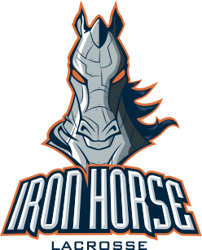

Iron Horse Packing List:

Very Important: All long sticks/Goalies will need an airline approved carrier for your stick. You can buy an airline approved fishing pole container at Bass Pro Shops or buy a bag for your pole at any lacrosse specialty store. Short sticks can easily fit in your lacrosse bag. For all players, heads will need to be unscrewed prior to flight and your heads will need to be carried on and not stowed in the baggage compartment (this is to prevent warping).

- If flying on coaches flight to destination, please wear khaki’s and polo or oxford (high school only)
- Screwdriver
- Lacrosse bag with all equipment and 3 lacrosse balls bag to use as warm up balls.
- An extra mouth guard Mandatory!
- An extra head Mandatory!
- Iron Horse Uniform Carry on do not pack in checked luggage
- 4 pairs game socks (you get one pair of IH socks with your uniform package you should pack other socks as well)
- 4 dri fit shirts or under jersey shirts (please pack appropriately for the forecast, one short sleeve dri-fit comes with your uniform)
- Sliders to go under shorts to prevent chafing
- Gold Bond Powder (for if the above does not work)!
- Cleats
- Athletic Tape
- Rain gear for the player to wear in between games if necessary
- Sunscreen
- Any other clothes you will need for the weekend
- Towel in case of rain at the field
- 2 garbage bags for packing on return trip (dirty/wet clothes and shoes)
- Toiletries
- Any medications your player takes on a daily basis
- Pedialyte packets for dehydration (powder packets your put directly in water bottle)
- Money for return trip to check bags! Remind your player that they will need to save some money for this.
- Itinerary
- Petty cash for vending and purchases.

Tips for packing: You can fit a small folding chair and small cooler in your players lax bag for the flight.

Warm Weather:
Frog Togg cooling towel or other cooling towel

Cold Weather:
Please pack medical latex gloves that fit your player’s hand well (they wear under gloves to help keep their hands warm)
Beanie hat for head between games
Cold Gear Under Armour
Sweatshirts/Sweatpants

