WNS SCORESHEET & PRE-GAME INSTRUCTIONS (Varsity and JV)

Scoresheet Visual
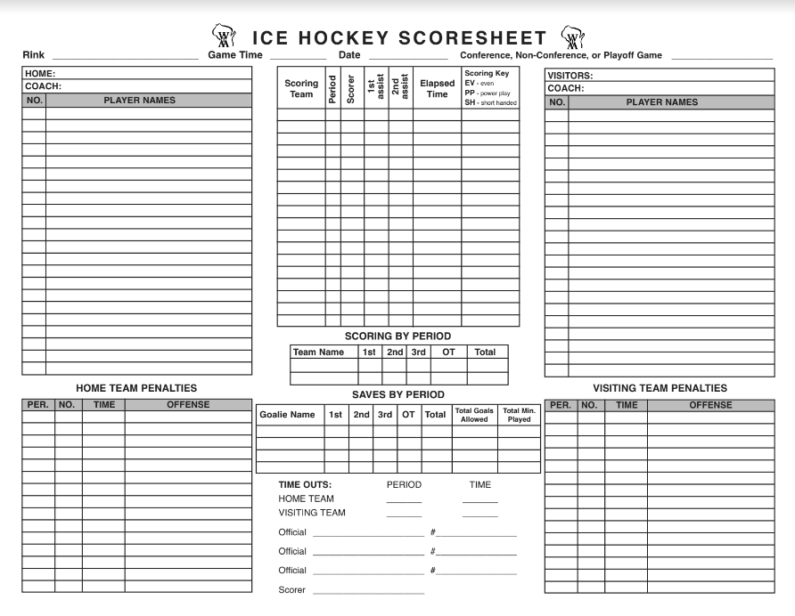
6
5
3
3
Visiting Coaches Fill-in
WNS Coaches Fill-in
2
1
INSTRUCTIONS:
NOTE: Coaches are responsible for ensuring that game pucks and warmup pucks are at the rink before the game starts. However, Scoresheet volunteer should verify that this has been done

BEFORE GAME
- Confirm Pucks are at rink: When you arrive go to booth and bench area to see if coaches have put game pucks (min 3) in booth or on ice in front of booth. Also confirm if warmup pucks (green bucket) are on the ice or bench area. If they are not there:
  - Game pucks are in WNS storage locker (first locker after vending machines in locker room area. Pucks are in orange bin labeled “WNS Game Day”. Take 3 pucks and place in booth on glass so refs see they are there.
  - Warmup pucks are in green bucket. Take the green bucket to rink and place on ice in front of home bench/penalty box.
  - Note after game: If there is a varsity game, leave game pucks in booth and bucket on home team bench or ice in front of bench. If there is not a game, return pucks to the WNS storage locker.
- Get Scoresheet: The WNS coaches will add the home roster and will typically get the visitor roster from the visiting coach added. They will then leave the scoresheet in the booth. It is also possible that the completed sheet is in the tunnel between locker rooms, so you can check there if you don’t already have the sheet 10-15 minutes before the game.
SCORESHEET INSTRUCTIONS
- Pre-Game Info: ENTER information on top. Home Team (WNS); Visitor Name, Date, Rink Name, Conf or Non-Conference (Cedarburg, Homestead and West Bend are the only Conference games).
- Goals: Referee will come to scorer booth to give jersey # of goal scorer, and jersey # of who assisted. Write it in the order given. Ex: ref will say something like "#16 from #5 and #39." Goal scorer is always stated first. ENTER all columns of the scoresheet. For scoring team, ok to abbreviate team name (Cedarburg = Ced). NOTE ON "ELAPSED TIME PER DANO" you enter the time AS IT APPEARS ON THE SCOREBOARD
- Penalties: Referee will come to the booth to tell you what the penalty is (ex: Interference) and time. You'll see who it is on as they skate to penalty box. ENTER Period, Jersey #, TIME THE PENALTY OCCURRED AS IT APPEARS ON SCOREBOARD PER DANO. Ref will specify if it is a 5-minute or 10-minute major (or a 2 + 10). Majors should be noted in the penalty description. See referee penalty signals at bottom of this sheet.
- Tracking Shots on Goal: A shot is defined as any puck that would have gone in the goal if the goalie didn’t save it. Examples: A strong shot that hits the pipe and doesn’t go in is not a shot. A very weak shot from ½ ice that the goalie stops is a shot. Just do your best to determine. Generally when in doubt and the goalie makes a save, credit it as a shot and save.
YOU need to determine how you want to track shots. You have three options:
  - OPTION 1: ask each penalty box volunteer to track shots on the goal closest to them. Give them a piece of paper and pen/pencil if you choose this option.
  - OPTION 2: You track all shots yourself. The most common way to do this is to use a blank piece of paper in the box and count shots as tick marks for each team. (If short pens/pencils, ask MSOE attendant if they have a couple to borrow)
  - OPTION 3 (Recommended): Tell scoreboard operator before game that you will ask for their input on some shots. Generally, the Scoreboard operator has good hockey knowledge and is happy to offer an opinion if you ask.
- Saves & Goals By Period: Enter the last name and # of the home and visitor goalie(s) in the ‘Saves by Period’ section. Shots minus Goals = Saves.
- Referee Signatures Post-Game: The refs will stop by after handshakes to sign the Scoresheet. Sign your name as Scorer. After signatures are completed, please find the visitor coach and give them the pink copy of the scoresheet. The white and yellow copy goes to the home coach. You might have to stick around a bit downstairs until they exit the locker room because they often go to the locker room before the refs sign the sheet.
- Announcing: The Music Volunteer is the default Game Announcer. However, they may prefer that Scoresheet Operator announces, which is fine.

REFEREE PENALTY SIGNS
