Deer Valley

Sponsorship Program |  | Become a deer valley football sponsor

business sponsorships
Interested in a corporate/business sponsorship? We are a 501(c)3. Your donations are tax deductible and will go 100% in support of DVHS athletes.
LEARN MORE ON PG. 2

in-kind donations
In-kind giving is a non-cash donation that can be made to the Deer Valley Football program and are tax- deductible
LEARN MORE ON PG. 3

other ways

to give
Employers Sponsor Matching Gift programs and volunteering your time.
LEARN MORE ON PG. 4

business

SPONSORSHIPS
 | SKYHAWK HERO  $1,000 | PLATINUM SPONSOR  $750 | GOLD SPONSOR  $500 | SILVER SPONSOR  $250 | BRONZE SPONSOR  $100
Advertising on Social Media | x | x | x | x | x
Home Game Recognition by Announcer | x | x | x | x | x
Recognition at DeerValleyFootball.org | x | x | x | x | x
Framed Team Picture | x | x | x | x
Football Stadium Banner | x | x
 | (3x8) | (3x8)

“We make a living by what we get but we make a life by what we give.”

IN-KIND DONATIONS
Thank you for thinking of us for your donations! Due to a lack of storage, we accept in-kind donations only by prior arrangement. Please contact deervalleyfootball@gmail.com for more information about our needs and how to coordinate a donation.

- Gift cards for Costco, Walmart or other retailers
- Gift cards for Fry’s or other grocers
- Gift cards for sporting goods stores
- Bottled Water
- Powerade
- Game Day Meals
- Camp/Tournament Sponsorships

If you would like to donate an item not listed here, let us know!

OTHER WAYS TO GIVE  Many employers sponsor matching gift programs and will match any charitable contributions or volunteer hours made by their employees. If your company is eligible, request a matching gift form from your employer, and send it completed and signed with your gift. The impact of your gift to Deer Valley Football Club may be doubled or possibly tripled!  Volunteering doesn't cost you a dime, and it is the "in" thing to do these days. More volunteers than ever, in all age groups and from all backgrounds, are finding their way to causes that inspire them. Whether you have one hour a week or one day a year to give, contact us to find your perfect volunteer opportunity. | 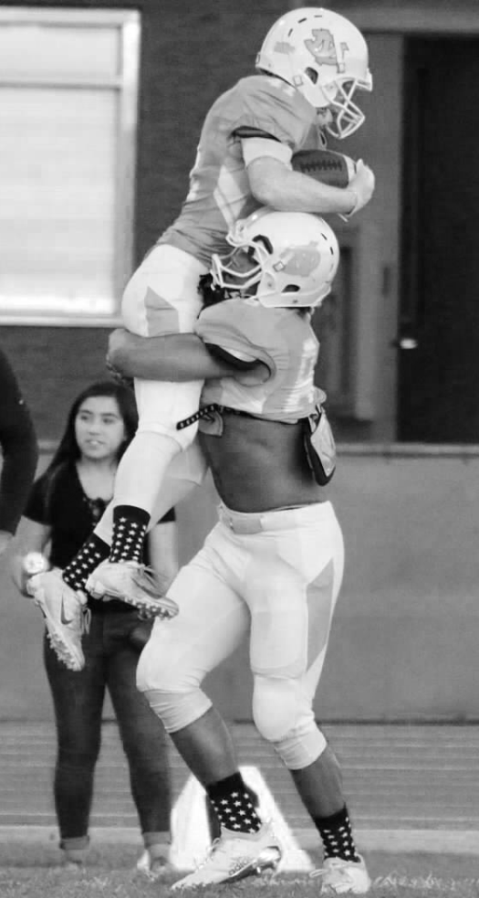
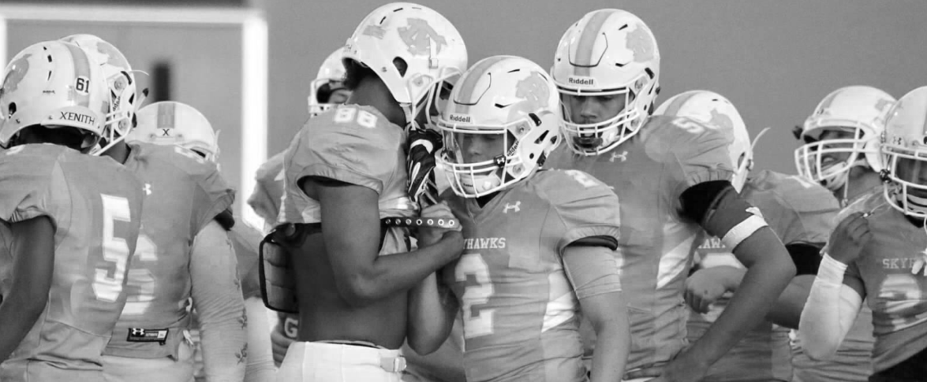

For a one time donation or sponsorship, please use the following document:

“IMPORTANT TAX DOCUMENT ENCLOSED”

Complete the forms along with a check. Please hand to your requestor or mail to:

DVHS Football Club
5350 W. Bell Road, Ste C122 #225
Glendale, AZ 85308

If applicable, please send your advertisement/logo for your banner to deervalleyfootball@gmail.com. ***Minimum requirement for banners are 300 DPI in CMYK color.

Thank you,
DVHS Football Booster Club

BUSINESS SPONSORSHIP/DONATION PROGRAM

Along with your payment, we will need an electronic file of your print ready advertisement. It will be used for your banner if applicable, on our website and for social media advertsing.

***Please note if you do not provide an advertisement, we will create one to the best of our ability using the name or logo of your business.

Minimum Requirements for Banners 300 DPI in CMYK color.

DVHS Athlete: ______________________________ Date: _________________________

Business Name: ____________________________________________________________

Contact Name: _____________________________________________________________

Contact Phone: _____________________________________________________________

Contact Email: _____________________________________________________________

Welcome to the DVHS Skyhawks Football Club!

IMPORTANT TAX DOCUMENT ENCLOSED

Date: _____________________________ Business Name: _______________________________________________________________

2021 DVHS Football Booster Club 5350 W. Bell Rd. Ste C122 PMB 225 Glendale, AZ 85308
Non-Profit Group EIN #26-3031199 Please retain this receipt for income tax purposes.

Business Address:

Street: ________________________________________________________________ Suite: ____________________________________

City: _________________________ State: _______________________________________ Zip Code: ____________________________

Thank you for your generous donation to Deer Valley High School Football Booster Club a Non-Profit Organization. Your Donation is detailed as follows:

Item(s) Value:

_________________________________________________________________________________________________________________
_________________________________________________________________________________________________________________
_________________________________________________________________________________________________________________
_________________________________________________________________________________________________________________
_________________________________________________________________________________________________________________

Total: __________________________________

This confirms that the item(s) listed above were given by the donor to Deer Valley High School Football Booster Club.
No items were received in exchange for this/these donation(s). Deer Valley High School Football Booster Club is recognized as a non-profit corporation under the IRS Code 501©3. Our EIN number is 26-3031199.

Sincerely,
Deer Valley Football Booster Club

