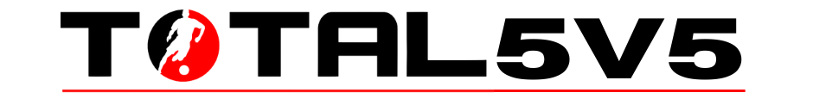

Assumption of the Risk and Waiver of Liability Kingdom Sports LLC. (“the facility”), will take all reasonable measures to protect the health and safety of you and your family. However, life has many dangers including bodily harm from soccer activity, random lightning strikes, and any and all bacterial, viral, and other infections. Kingdom Sports LLC. cannot guarantee that you or your child(ren) will be 100% safe. Participating in Facility activities could increase your risk and your child(ren)’s risk of bodily injury or contracting a bacterial or viral infection By signing this agreement, I acknowledge the potential for bodily harm during soccer practices and games, the possibility of being struck by lightning, experiencing dog or bat bites. I also acknowledge the contagious nature of bacteria and viruses and the risk of contracting these infections, including Lyme’s disease, Head lice, Common cold, Influenza (“flu”), Strep throat, Mononucleosis, Meningitis, Ear infection, Chickenpox, Measles, Mumps, Tuberculosis, COVID-19, or any new Coronavirus or other viral or bacterial infection. I voluntarily assume the risk that my child(ren) and I may experience any of the above and be exposed to or infected by bacteria or virus by attending Facility events and that such exposure or infection may result in personal injury, illness, permanent disability, and death. I understand that the risk of becoming exposed to or infected at the Facility may result from the actions, omissions, or negligence of myself and others, including, but not limited to, Facility employees, volunteers, and program participants and their families. I voluntarily agree to assume all of the foregoing risks and accept sole responsibility for any injury to my child(ren) or myself (including, but not limited to, personal injury, disability, and death), illness, damage, loss, claim, liability, or expense, of any kind, that I or my child(ren) may experience or incur in connection with my child(ren)’s participation in Facility events (“Claims”). On my behalf, and on behalf of my children, I hereby release, covenant not to sue, discharge, and hold harmless the Facility, its employees, agents, and representatives, of and from the Claims, including all liabilities, claims, actions, damages, costs or expenses of any kind arising out of or relating thereto. I understand and agree that this release includes any Claims based on the actions, omissions, or negligence of the Facility, its employees, volunteers, agents, and representatives, whether infection occurs before, during, or after participation in any Facility event.

Player Name _________________________________________________________

Parent(Guardian) PRINT ________________________________________________

Parent(Guardian) SIGN_________________________________________________

Date _______________________________________________________________

