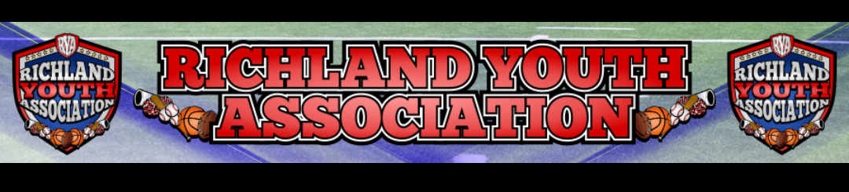RYA APRIL BOARD MEETING
Meeting Date: April 6, 2022
Attendees: Mike Cowan, Ben Earley, Blair Armfield, Richard Stutheit,
Lisa Willis, Eric Gomez, Chris Razo, Cody Barber
Absent: Marissa Jennings, Kevin Vorphal

General Board Items / Old News
- Multiple attempts were made to contact Kenneth West to inform him of his removal from the board
- Did not receive monthly check from Jennifer (not since November)
- Received $3,255 check from Kevin for last weekend’s tournament
- Need to (officially) add to position to bylaws: Director of Premier Baseball & Tournaments
Rec Baseball: Richard Stutheit
- Opening Day was successful, lots of positive feedback
- Some games were rained out
- Issues with uniforms; upset parents (48 phone calls)
- Discussion; scheduling games & the effect on concession stands, consider getting signs that indicate the concession stands are ‘OPEN’
- Officiating Agreement; pending correction & then requires Kevin & Blair’s signatures
Football: Eric Gomez, Chris Razo, Cody Barber
- Introductions: Eric Gomez, Chris Razo, and Cody Barber
- Need to create agreement regarding game day conduct & ejection for all coaches to sign
- Plan to do conditioning camps within next 2 weeks
- Would like to begin recruiting as soon as possible & open registration
- Plan for registration costs: $150 for tackle & $100 for flag
Cheer: Lisa Willis
- Waiting on Candise from Waxahachie to provide more information on cheerfest
- Getting uniform quotes from Champion & Omni Cheer
- Alternating uniform colors each year; plan to do red (pending football uniform colors)
Basketball: Blair Armfield
- No Updates to report
Premier Baseball: Kevin Vorphal (ABSENT)
- Left check for $3,255 in safe (for last week’s tournament)
Marketing: Marissa Jennings (ABSENT)
- Receiving a check for $175 from Kona Ice for 20% kickback
- Reached out to Cobb’s Barbershop for sponsorship opportunity

